Certification Project – Insure Me

Date of submission: -

Date of resubmission: -

Submitted by: -B. Narasimhappa

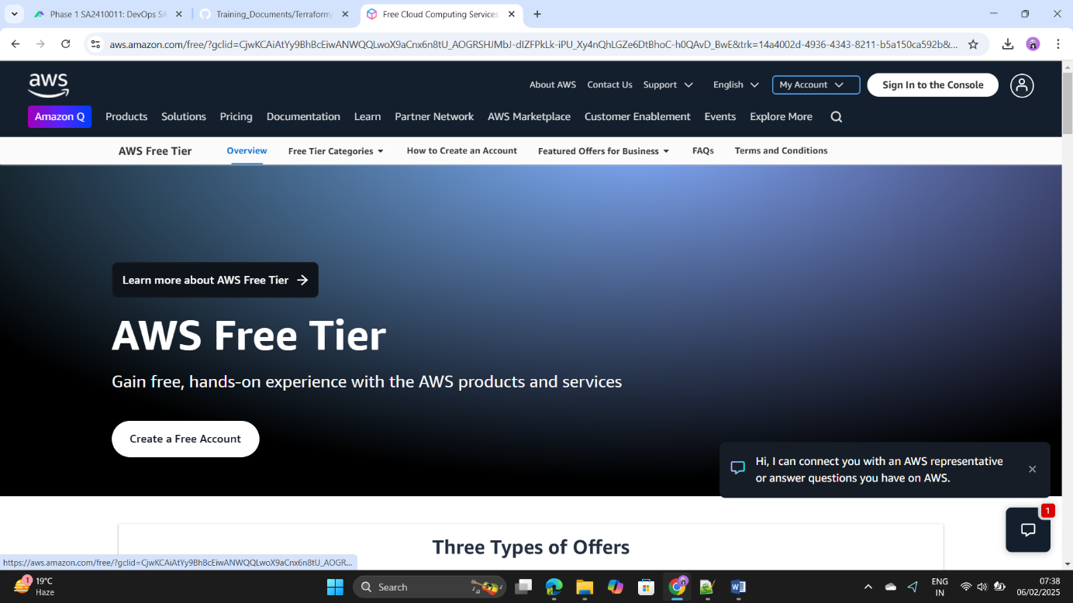Step1: - Login to the AWS console.

Step2: - Go to the Security Credentials tab.

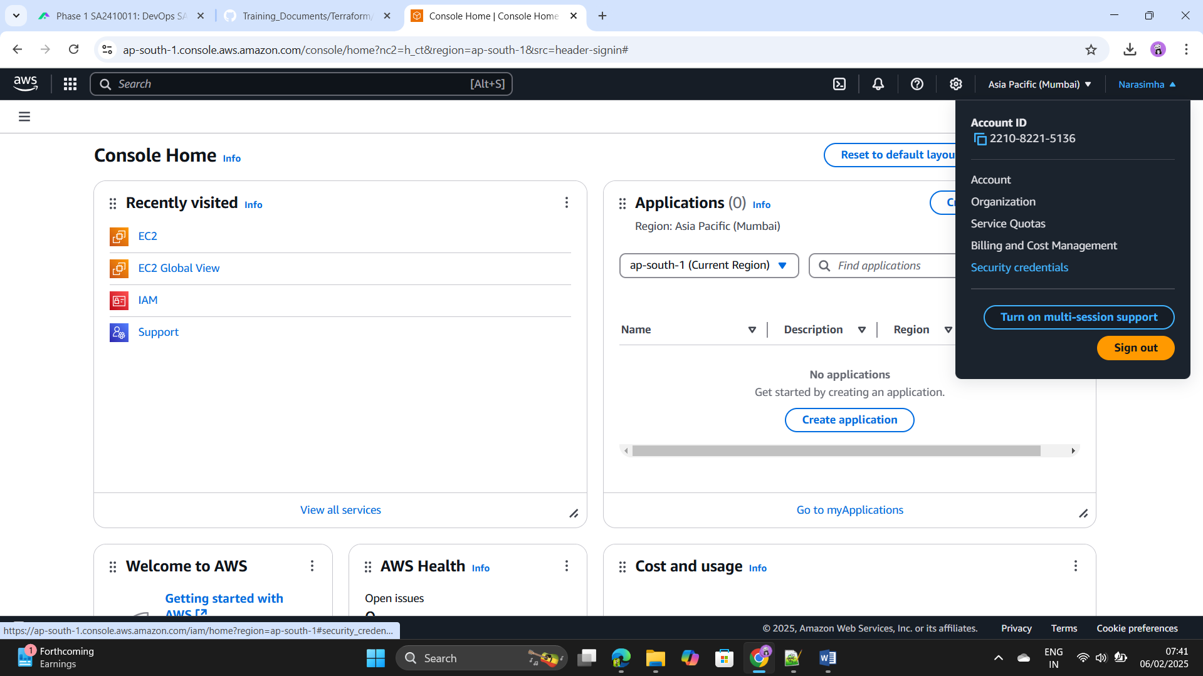

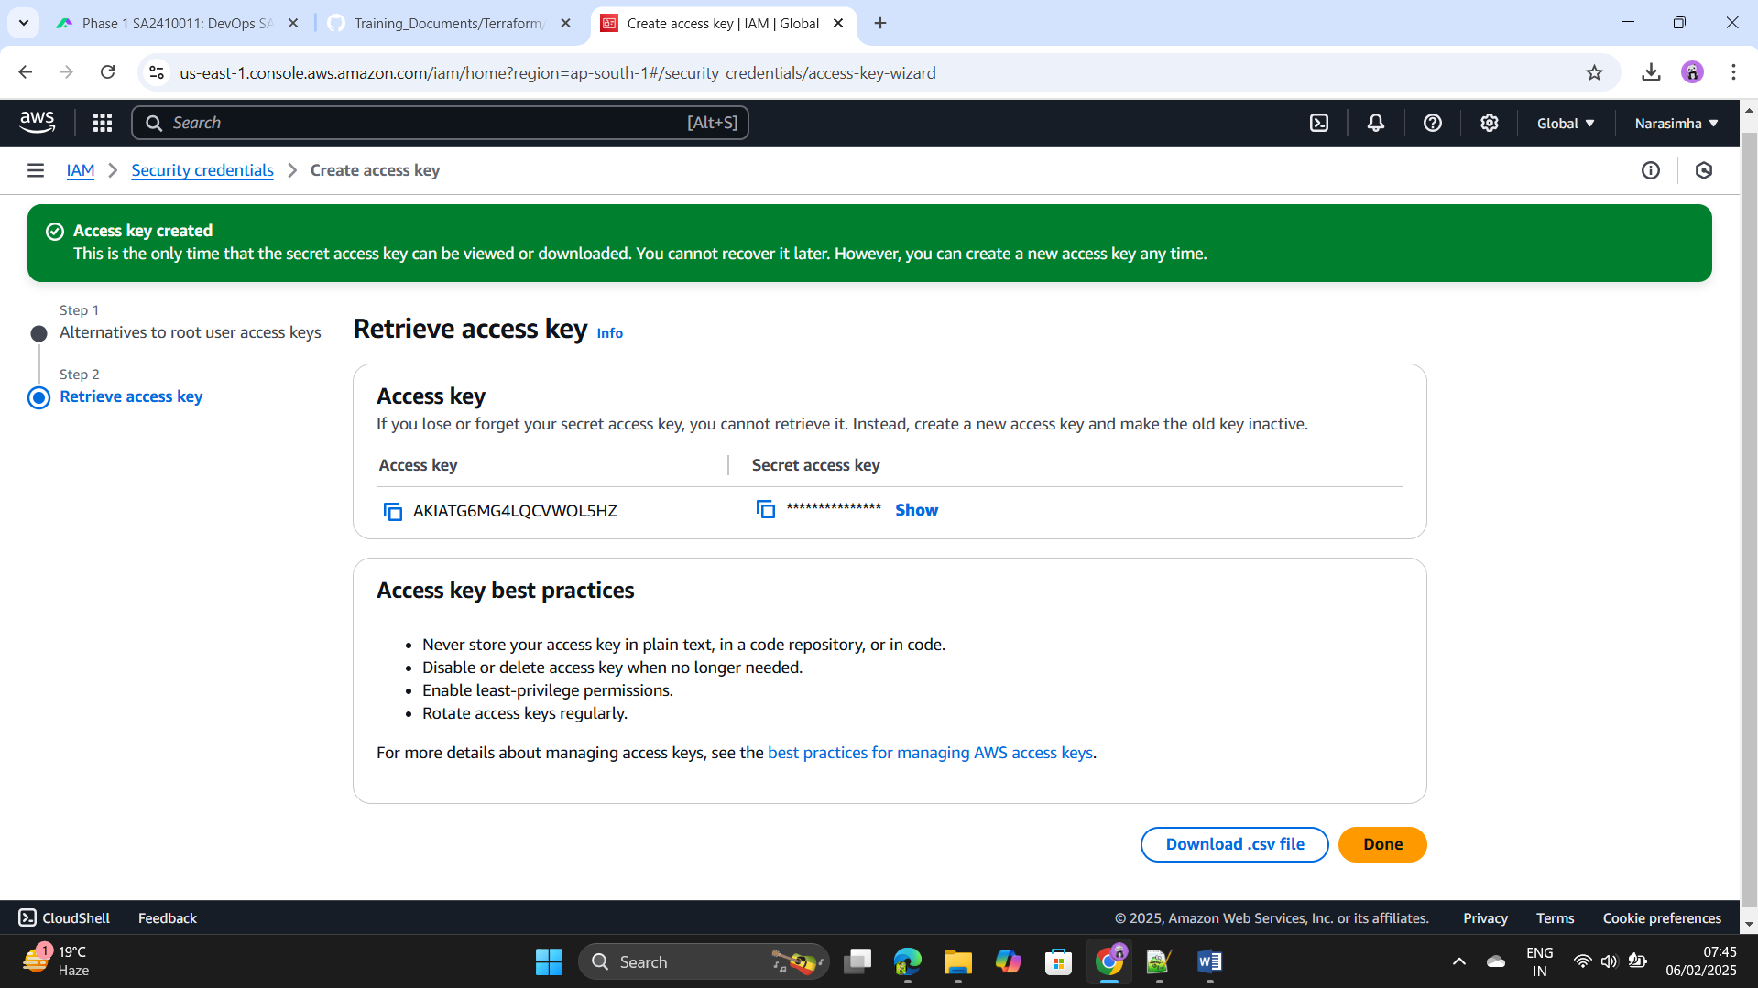Step3: - Click on the Create the Access key and create the access key save ++++++the access key and secrete key.

Step4: - Open the Visual Studio code and paste these access key secrete ++++++key there and launch the 6 instance by using terraform.

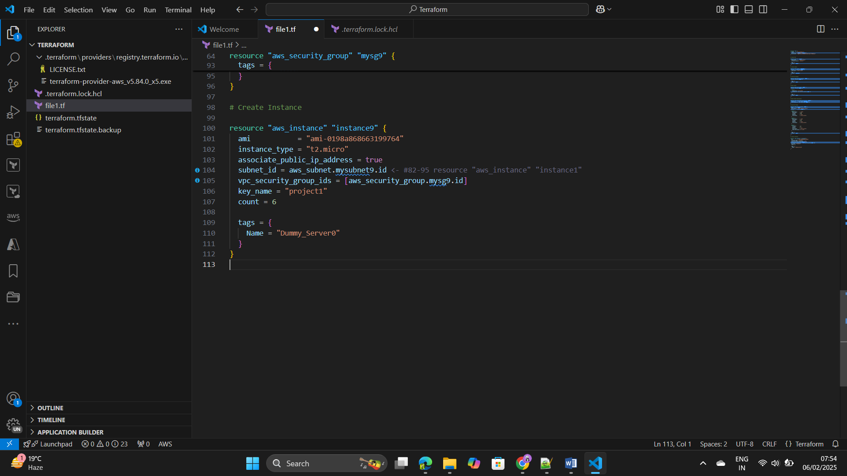

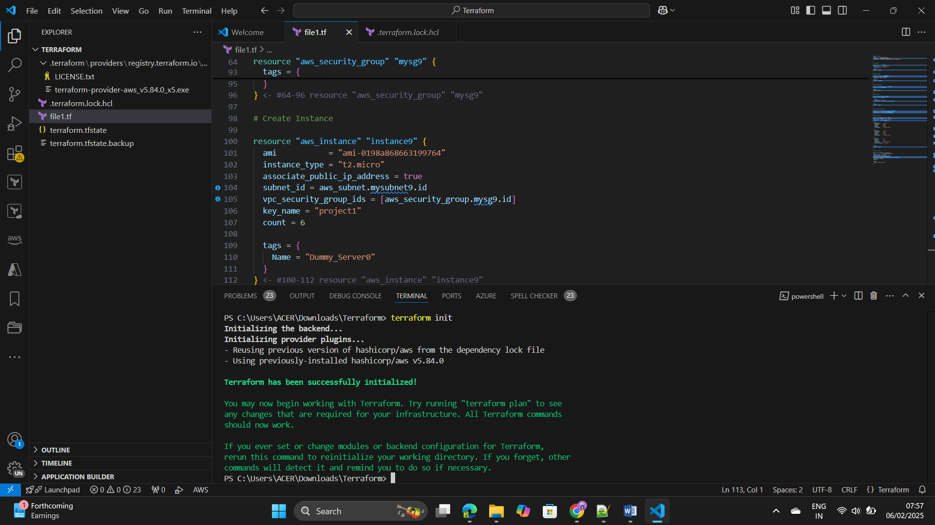Step5: - Execute the Code by using commands as terraform init and ++++++terraform plan.

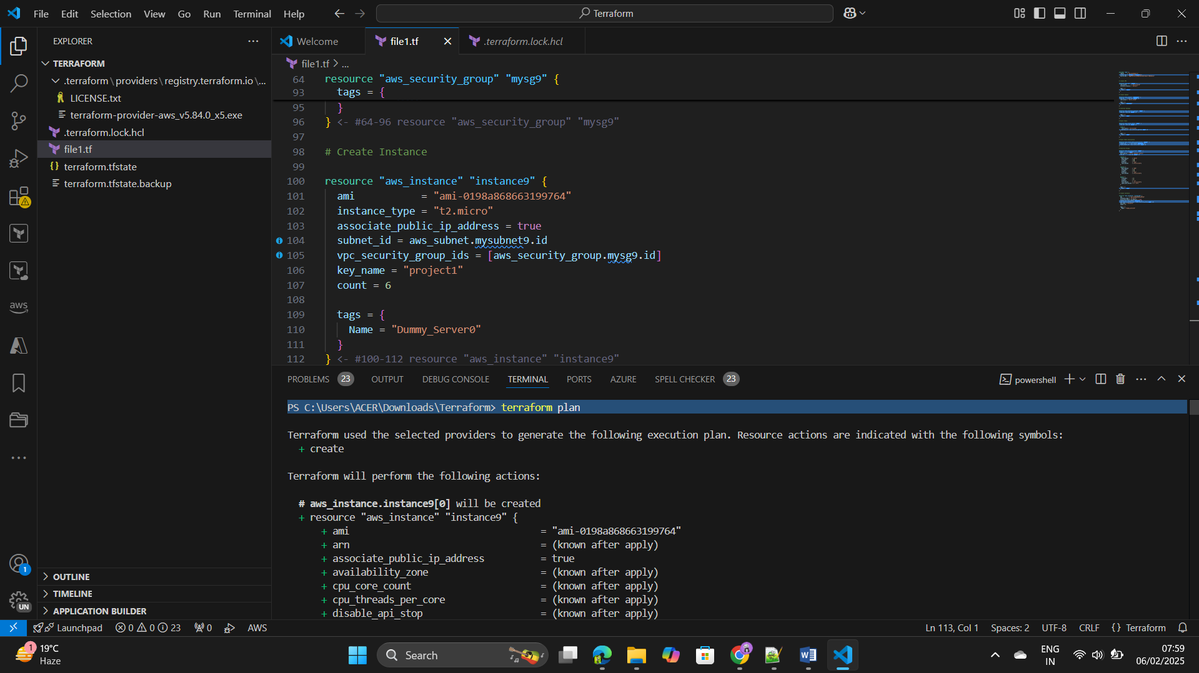

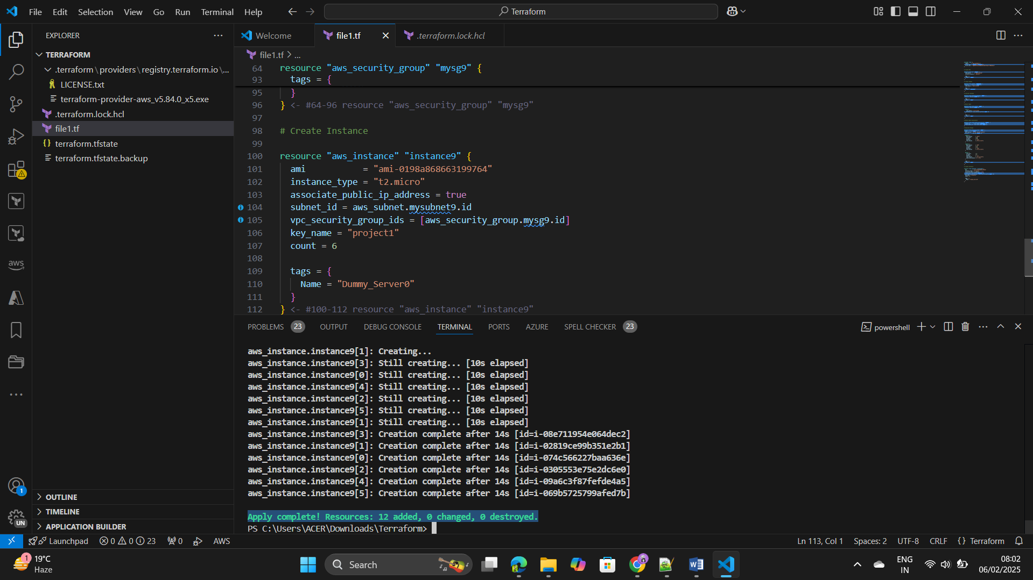Step6: - Use the Terraform apply command the instances has been created ++++++successfully.

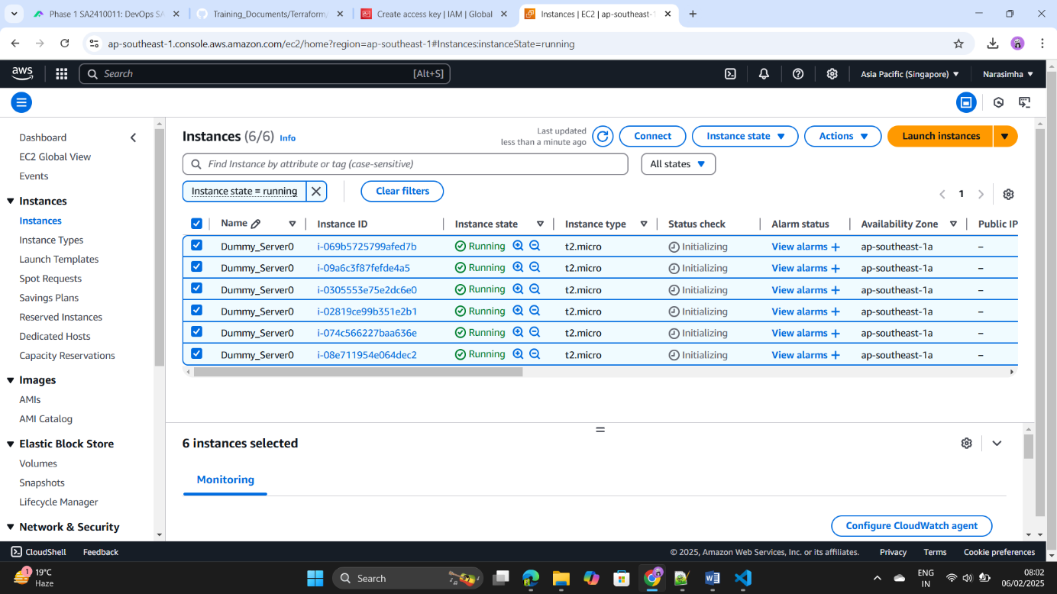

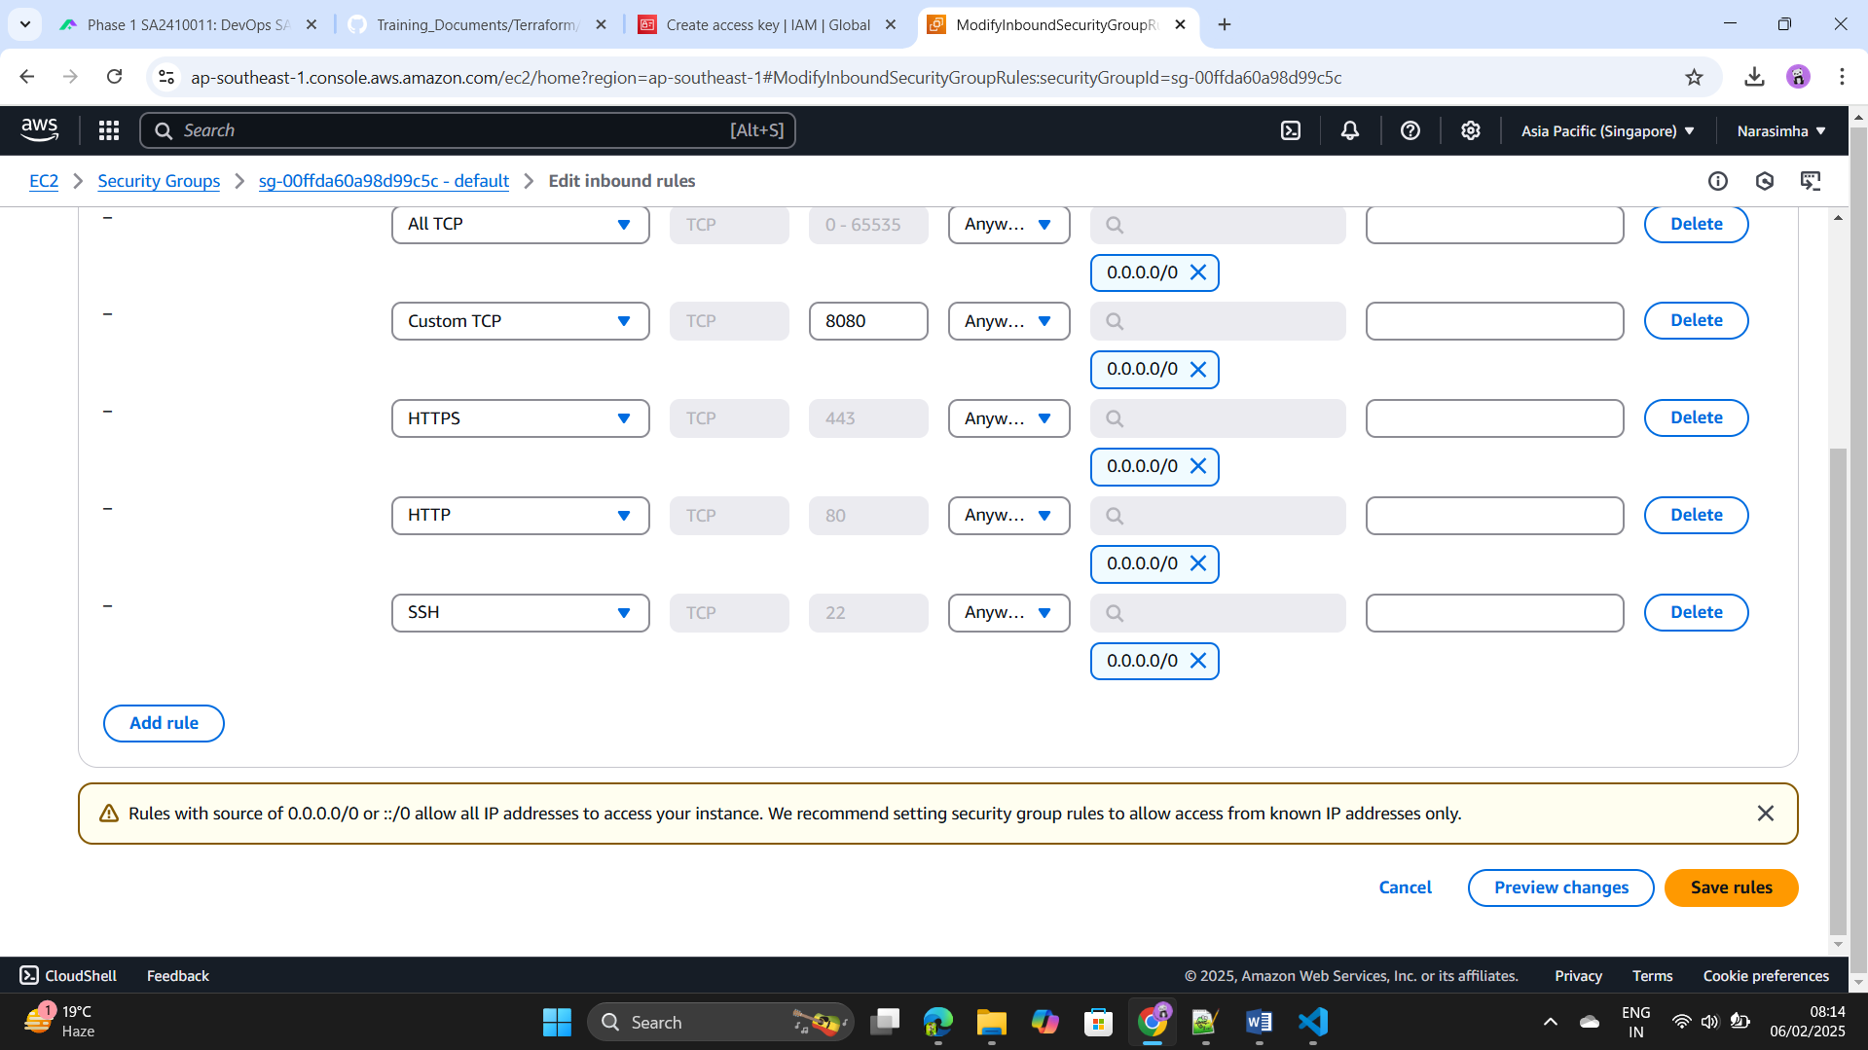Step7: - Update the security inbounds as enable the port 8080 & allow all ++++++the traffic in the all the instances.

Step8: - Connect the 2 ansible client nodes by using MobaXterm.

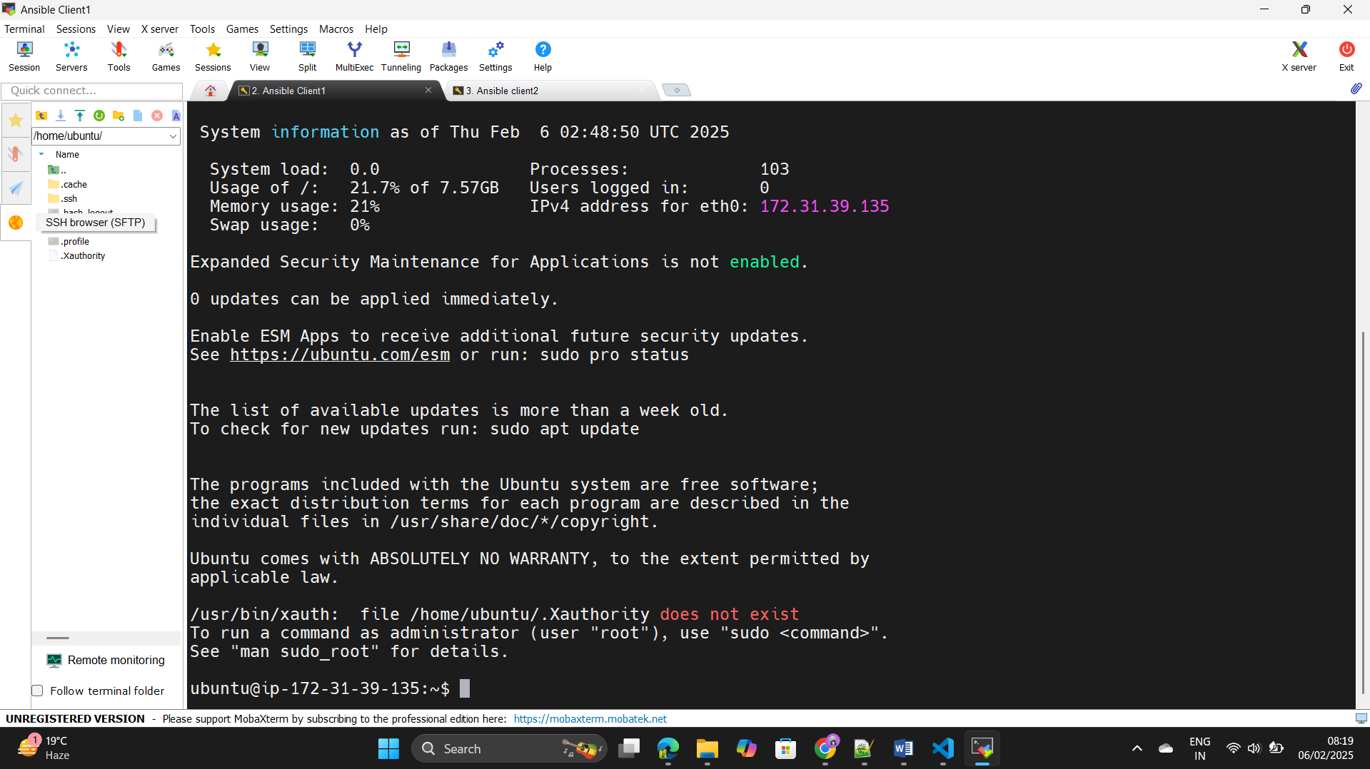

Step9: - Create the user in the 2 instances by using command as

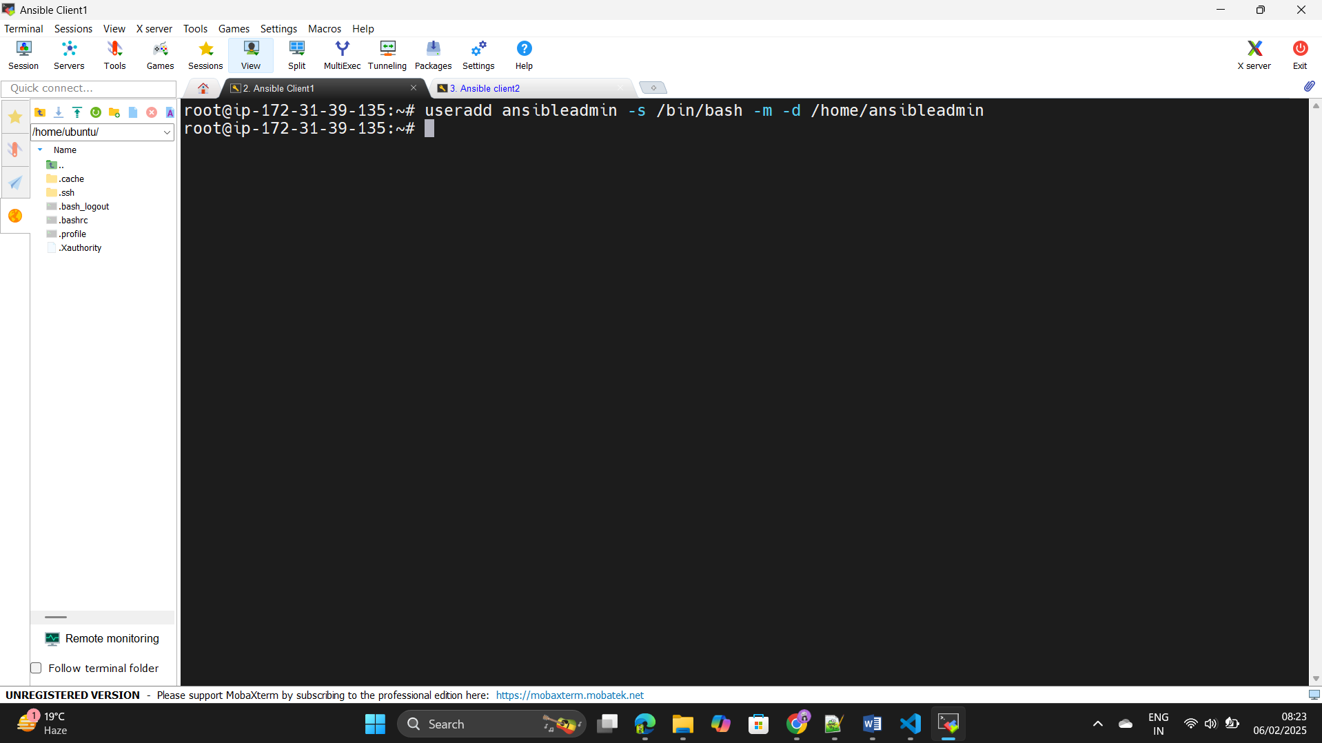 useradd ansibleadmin -s /bin/bash -m -d /home/ansibleadmin

Step10: - Edit the “ /etc/ssh/sshd_config” file and enable the password +++++++authentication to yes and save the file.

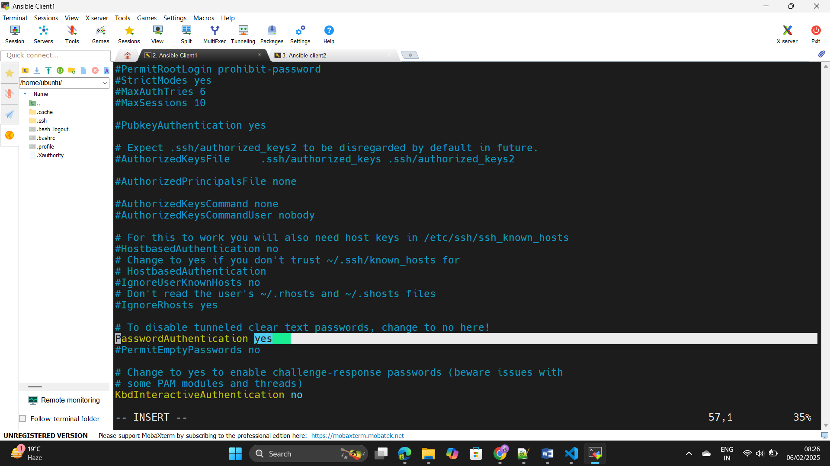

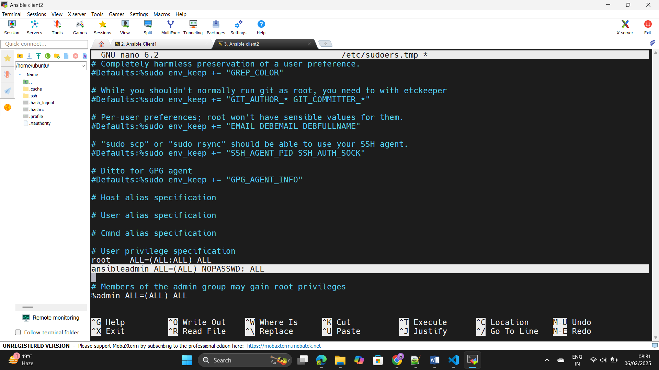Step11: - Edit the Visudo-file and add the user to give access to the root +++++++level.

Step12: - Go to the Ansibleadmin user and use the command ls –a ,we can +++++++see the root level access is there for the user.

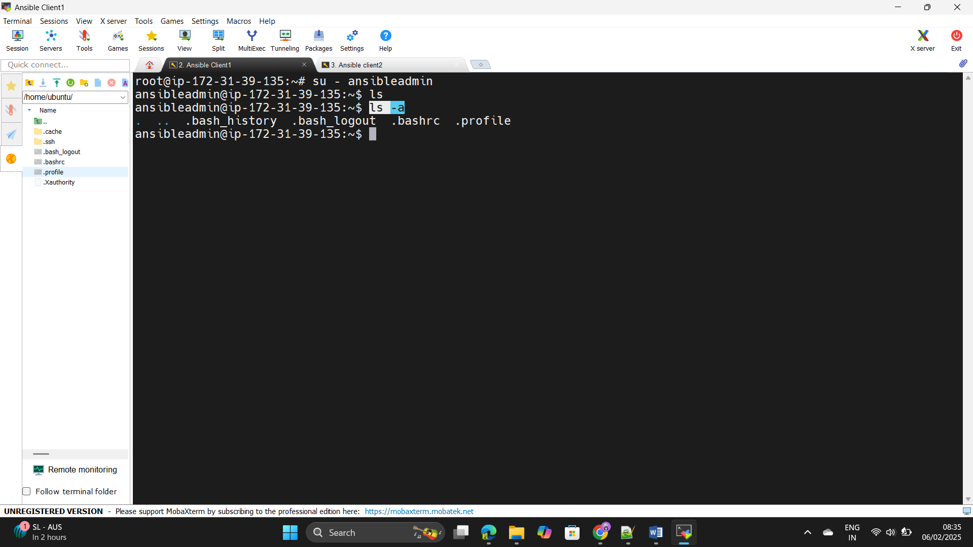

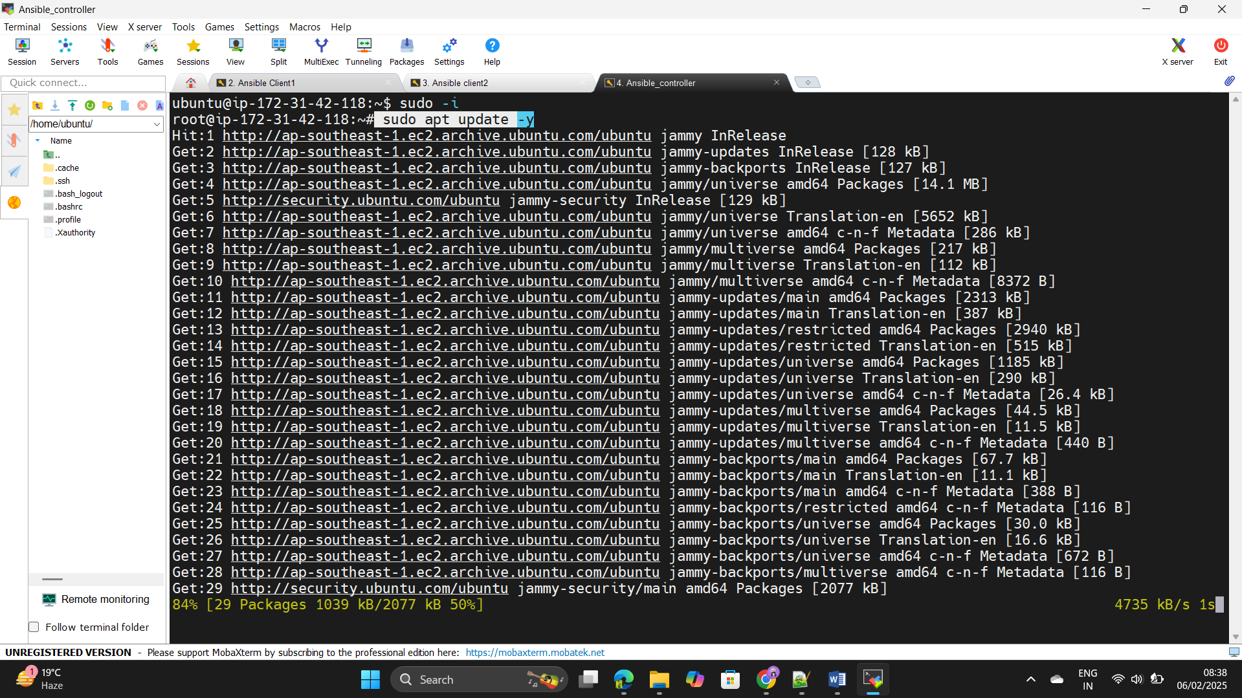Step13: - Login to the Ansible_controller instance and update the instance.

Step14: - Go to the ansible installation page on browser and copy and +++++++paste the commands from page to here.

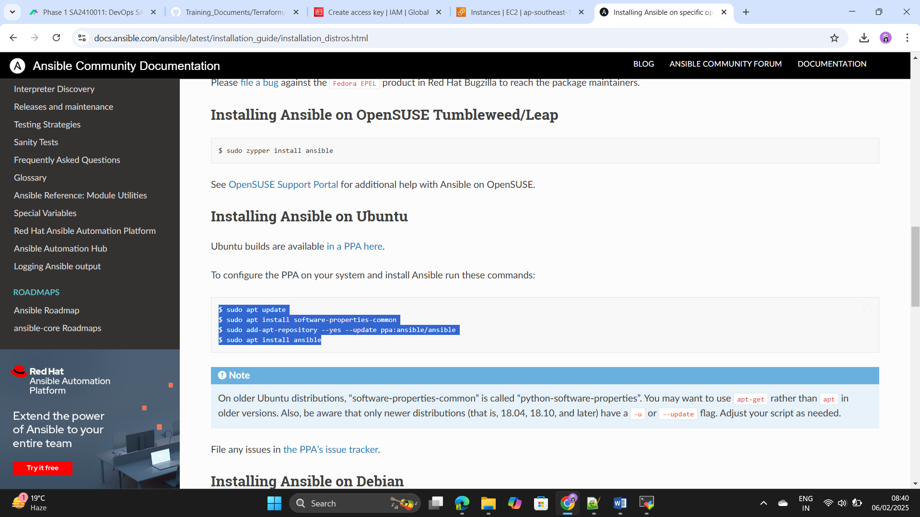

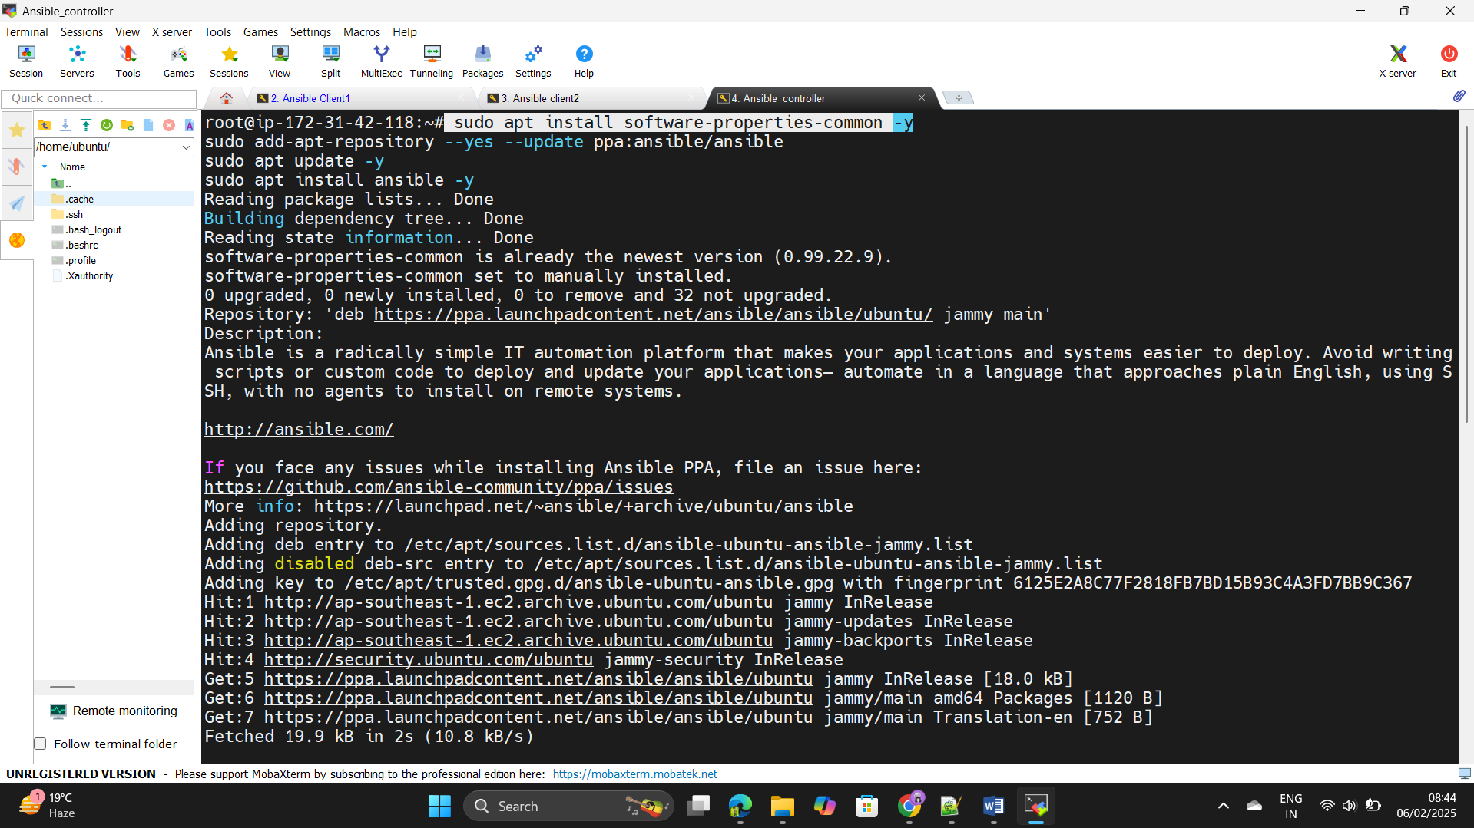Step15: - Execute the above commands in the Ansible Controller machine.

Step16: - Create the one user and create the SSH key in the user.

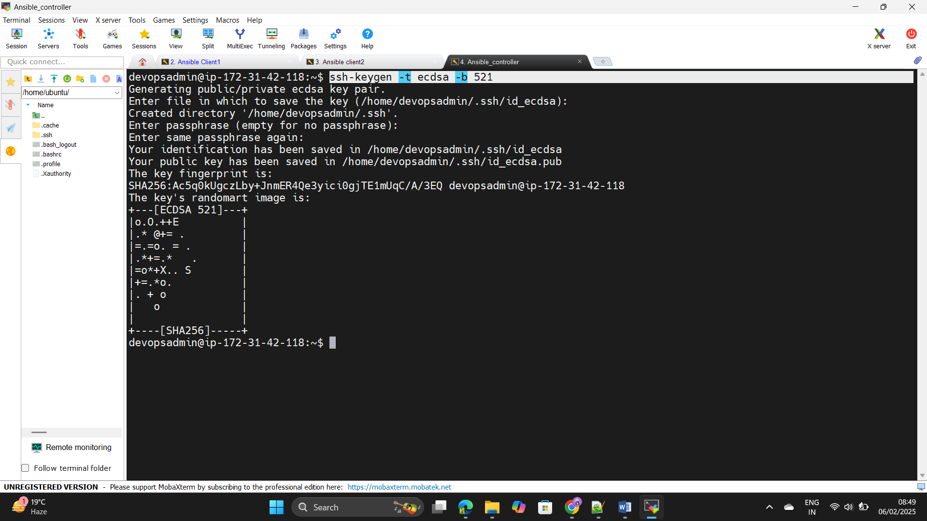

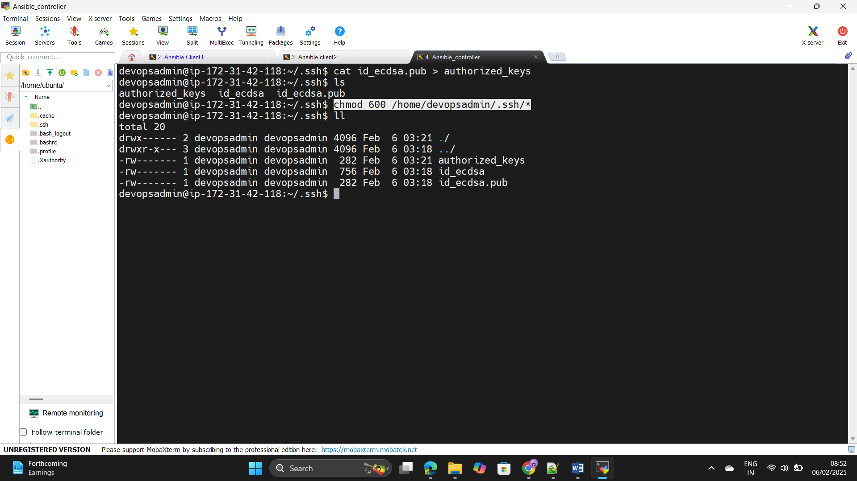 Step17: - Paste the id_ecdsa.pub into the authorized_keys & Change the +++++++access mod by using chmod 600 command.

Step18: - Copy the Authorized_key and paste in the Ansible client node.

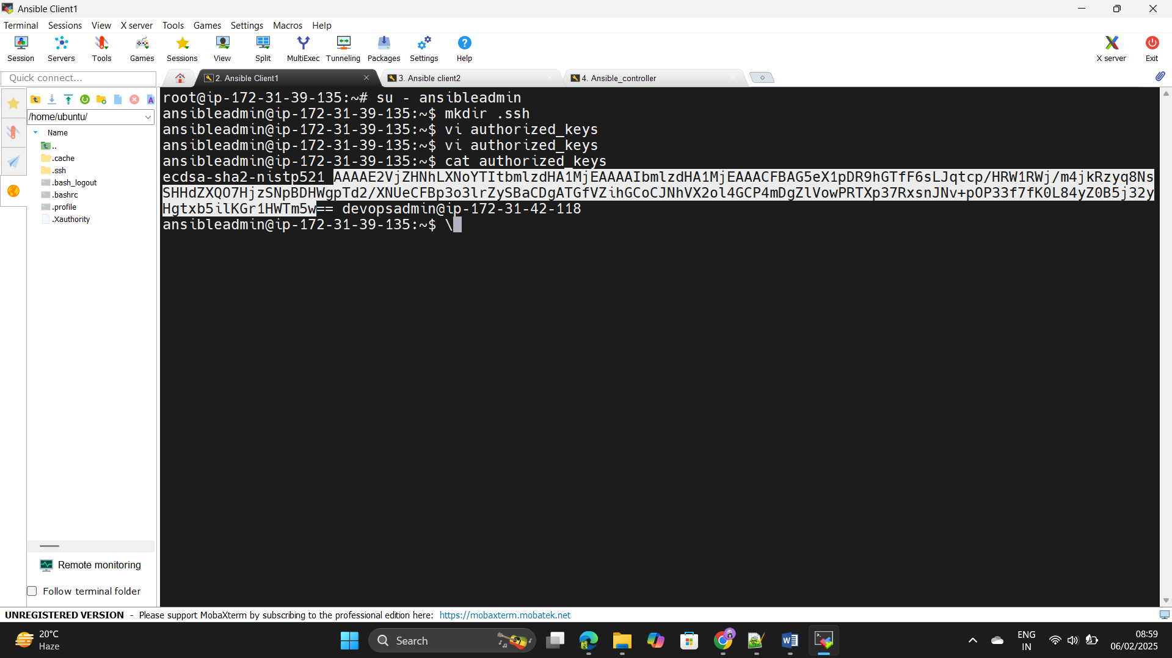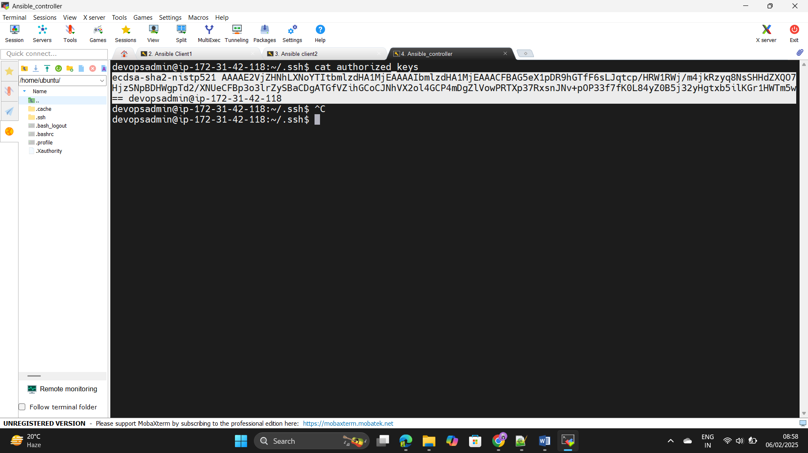Step19: - Connect the 2 client nodes by using command as

+++++++ ssh ansibleadmin@ 172.31.39.135

+++++++ssh ansibleadmin@ 172.31.39.68

#

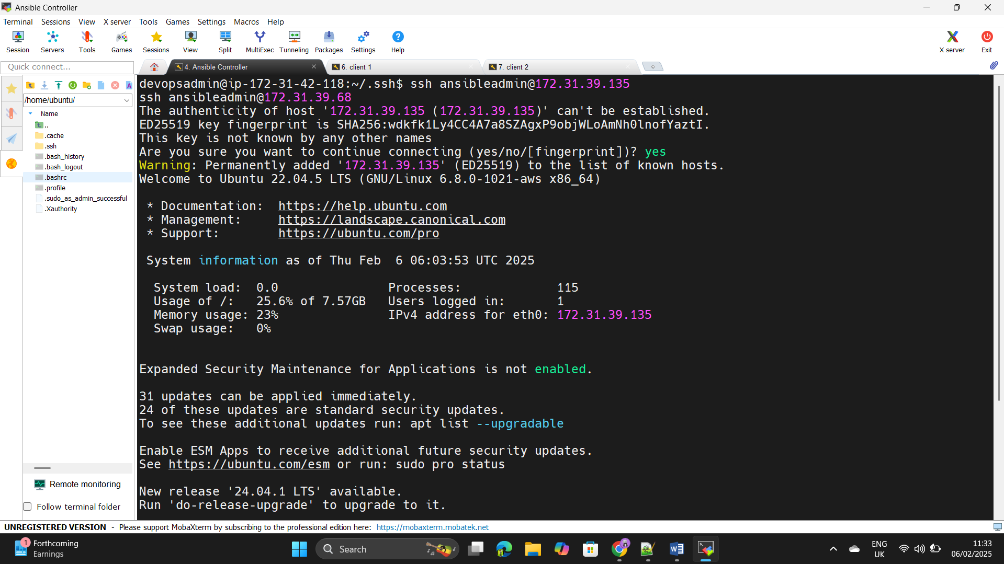

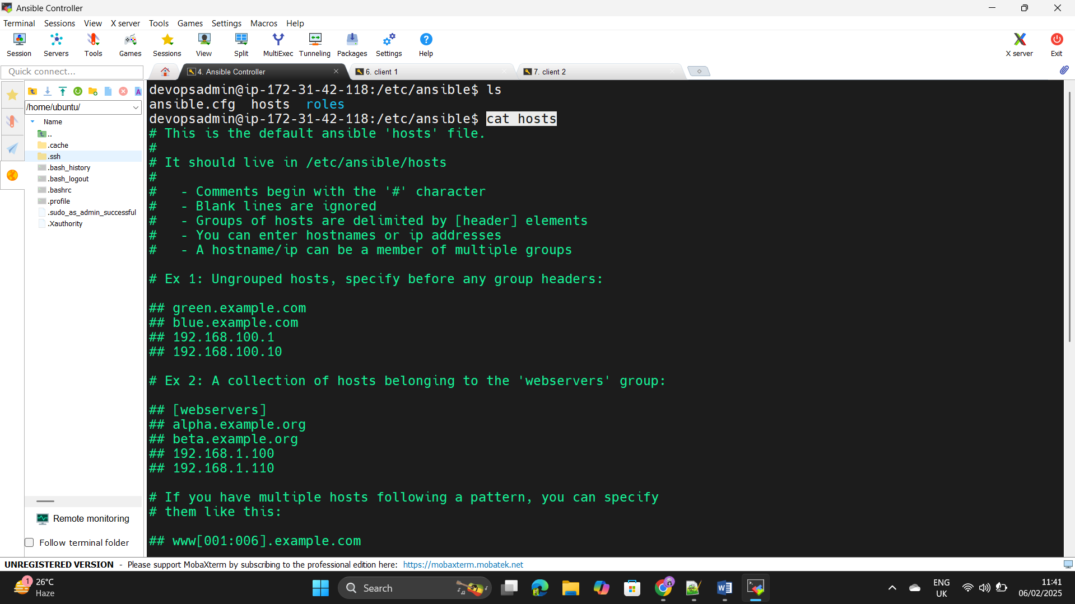Step20: - Edit the etc/ansible/host and add the client nodes in there as +++++++build server and Jenkins server.

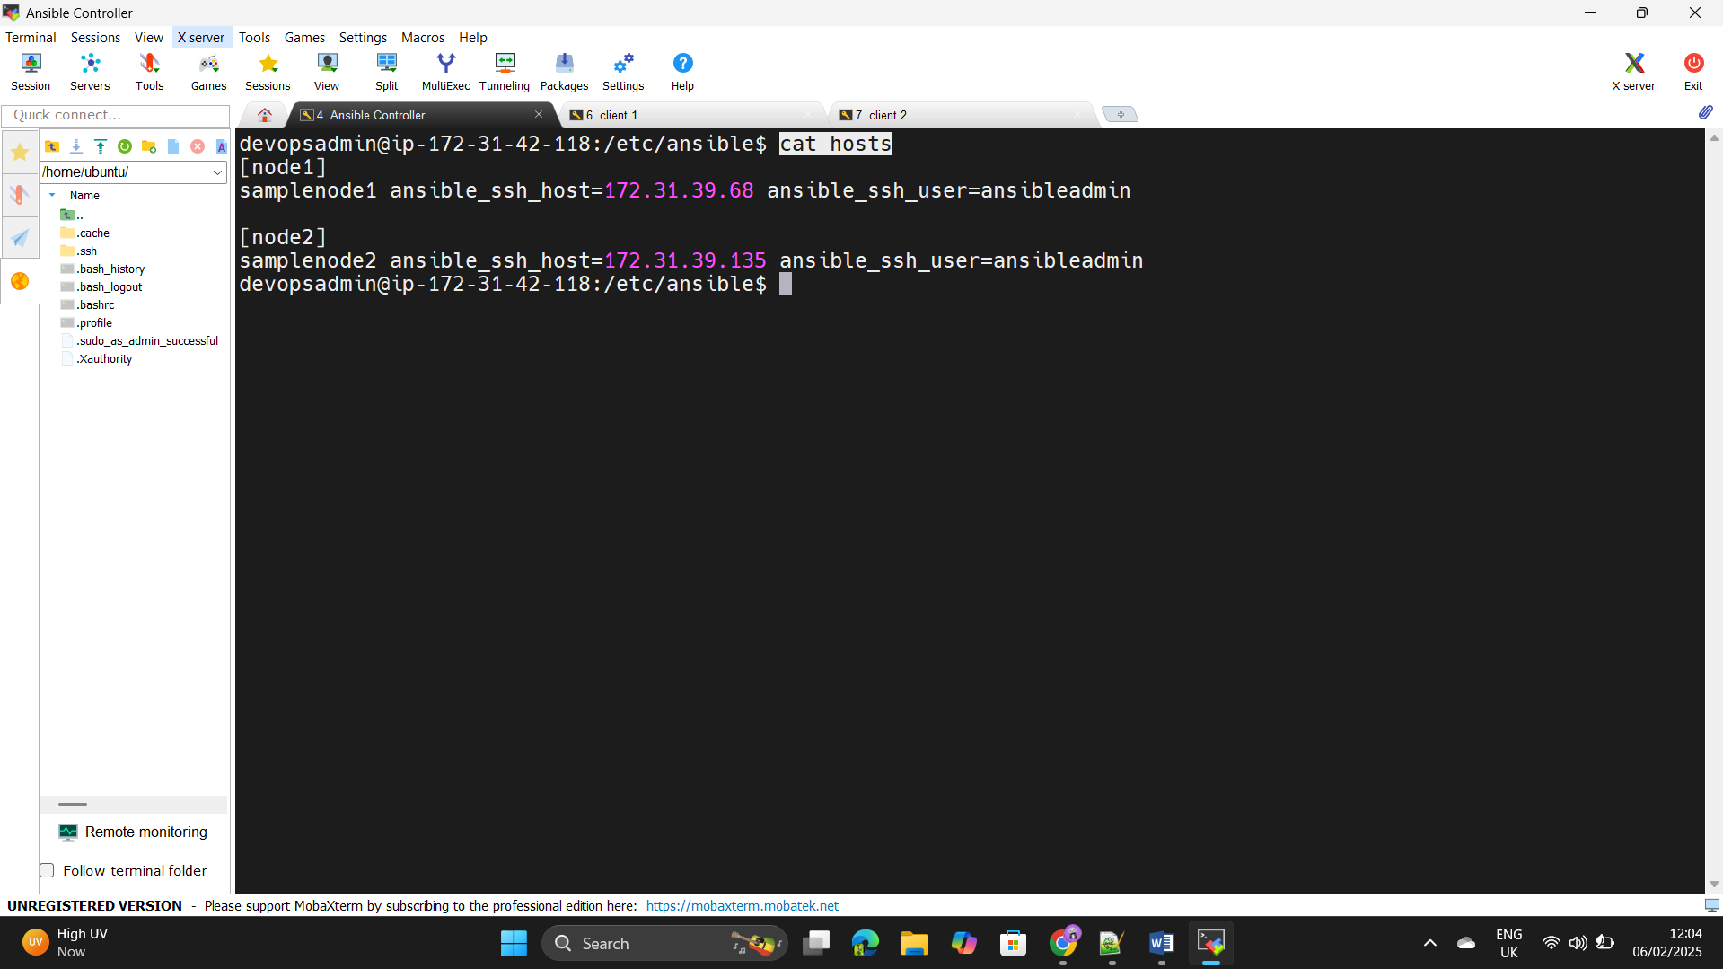

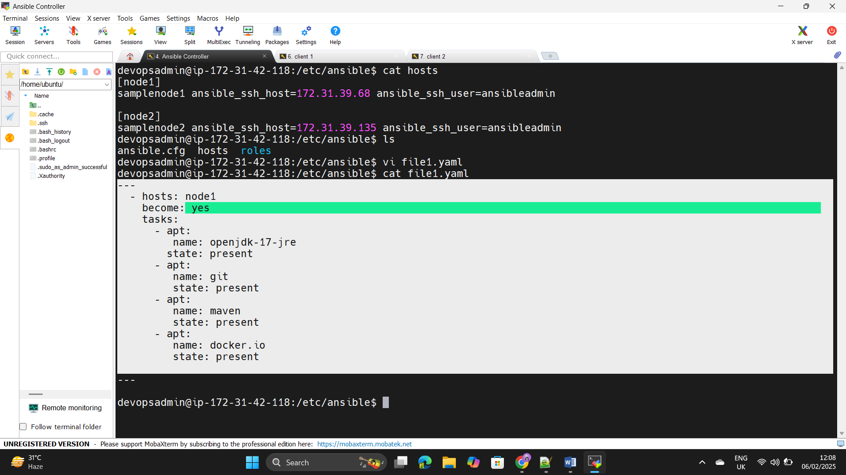Step21: - install the tools what we want in the node 1 as a build server of +++++++Jenkins install jdk,maven,git,Docker by using playbook.

Step22: - Execute the file2.yaml file the needed build tools has been +++++++configured the build server.

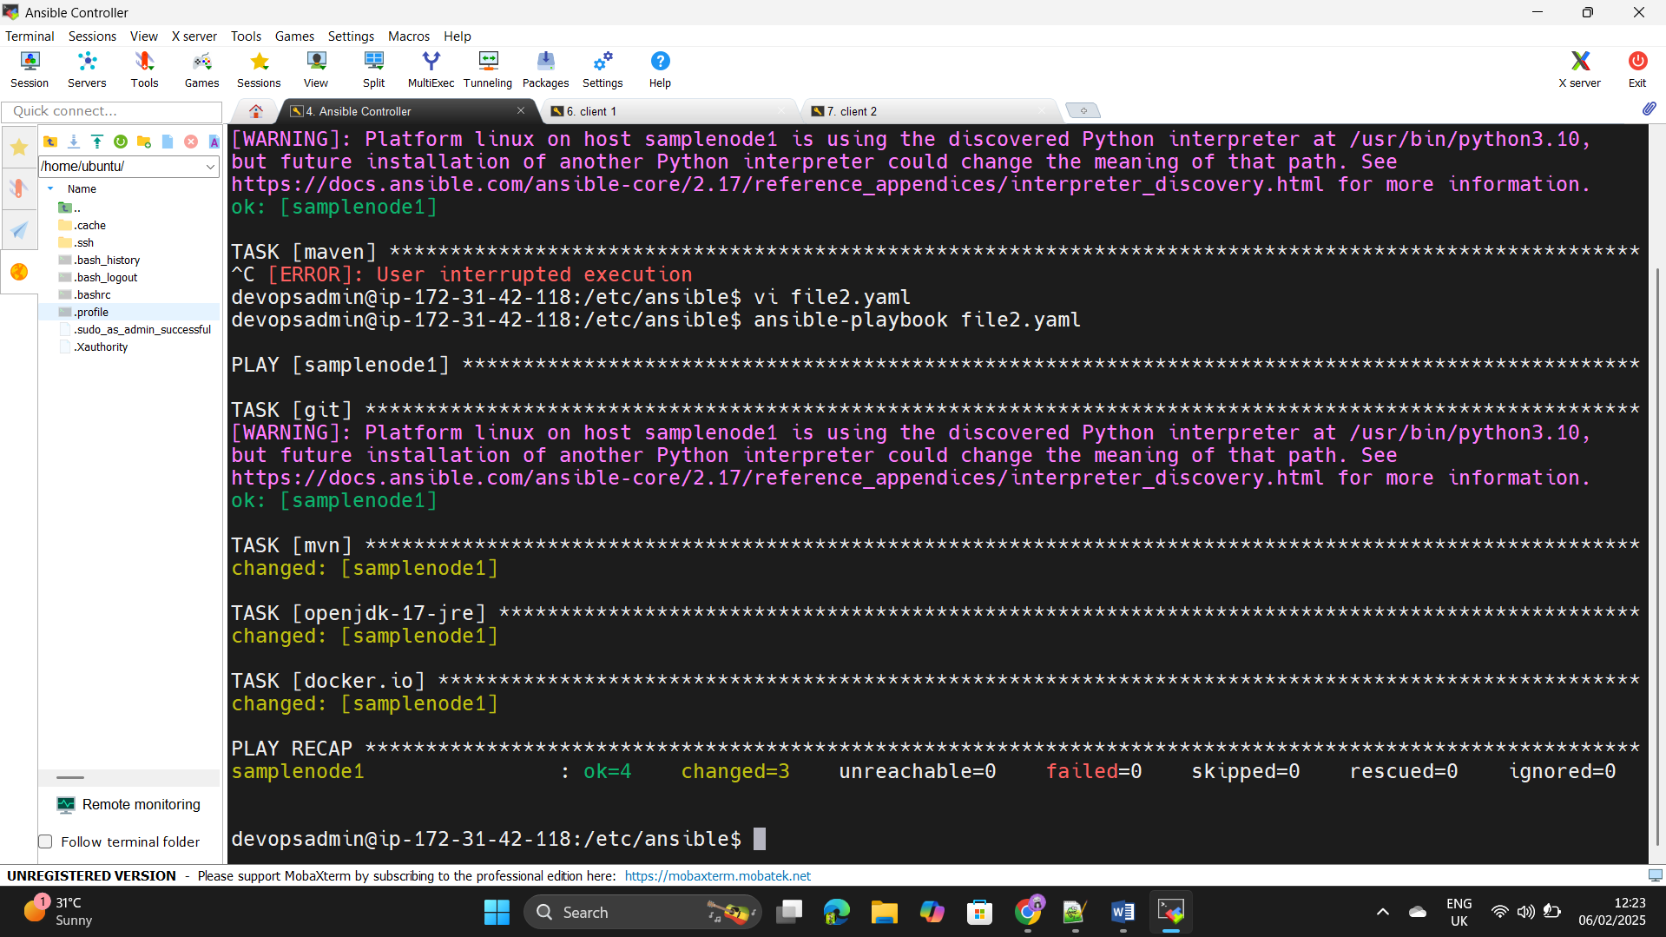

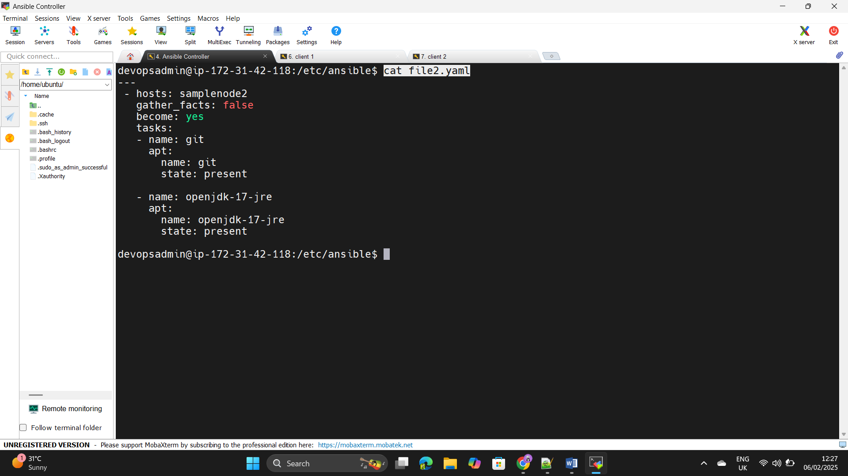Step23: - Same like as install git and java in the Jenkins Server (create the +++++++yaml file and execute via playbooks).

Step24: - Let’s get into the 2 instance and check the tools are installed or 6+++++not.

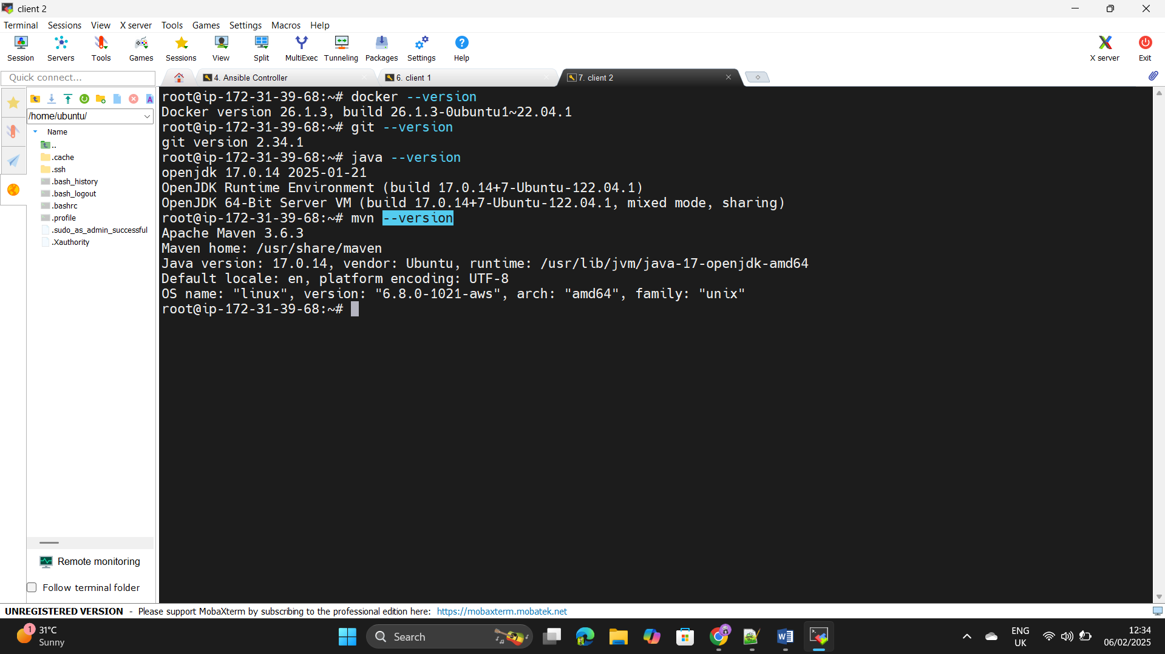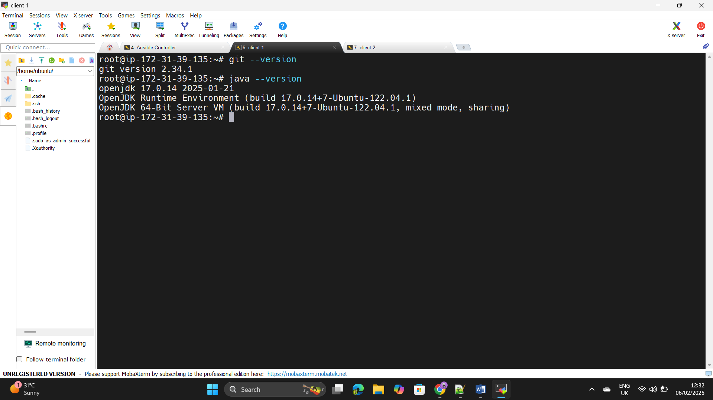

Step25: - Configuring of Build tools and Jenkins tools has been configured +++++++successfully by using ansible.

Step26: - Install the Jenkins by using the url< +++++++++++++<https://www.jenkins.io/doc/book/installing/linux/>>.

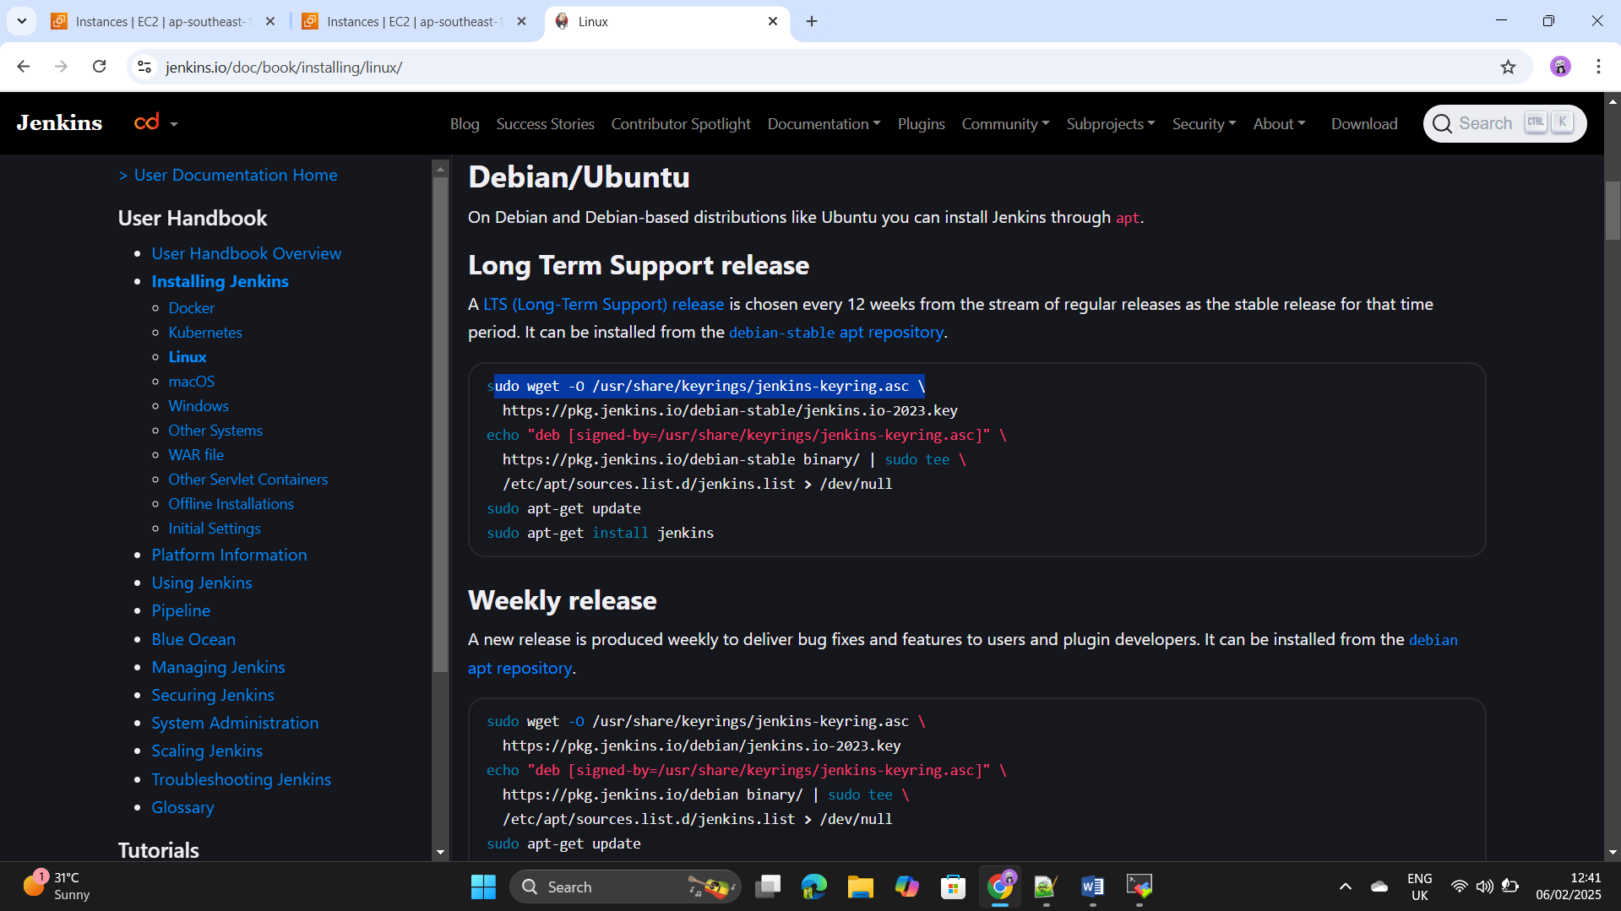

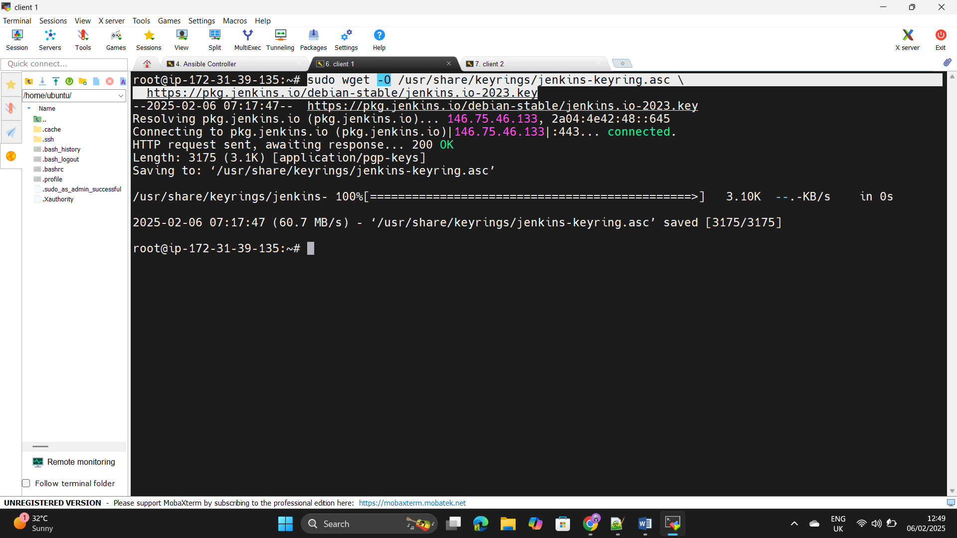Step27: - Execute the above commands in the client_server1 as Jenkins +++++++masternode.

Step28: - Enter the command as – “sudo apt-get install jenkins –y”

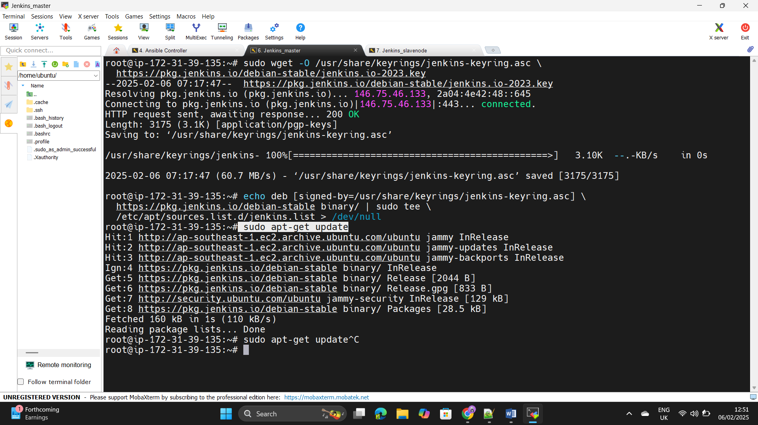

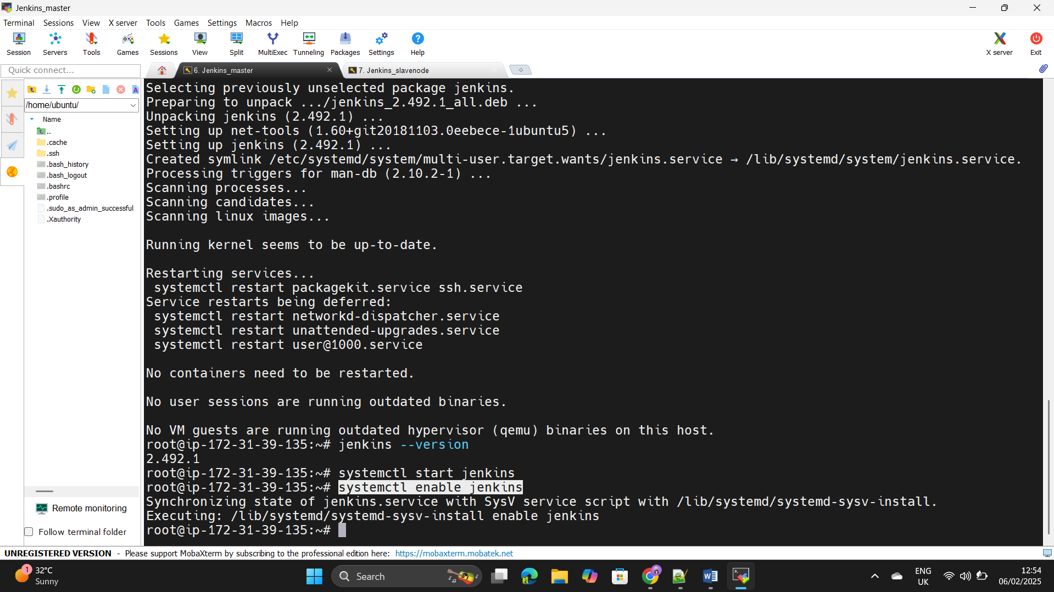Step29: - Enable the Jenkins using the command as systemctl enable +++++++Jenkins.

Step30: - Copy the Public Ip address of the Instance and paste in the +++++++browser and add the Jenkins port number as 8080.

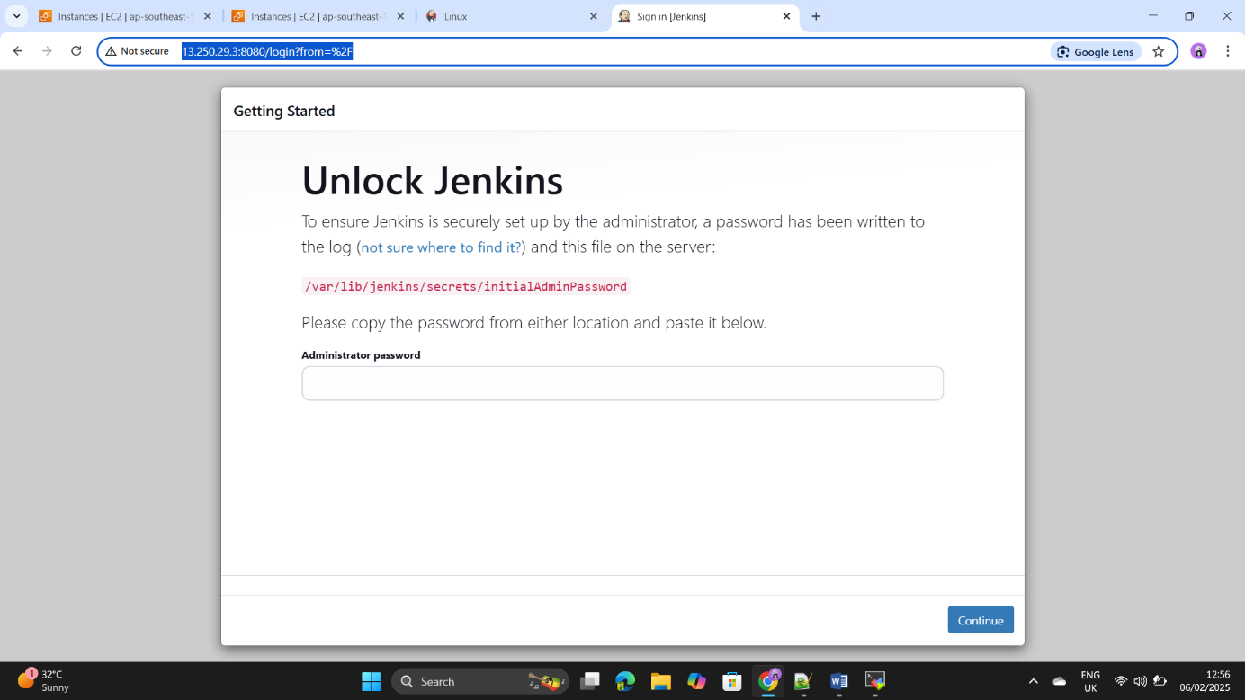

Step31: - use the command as

+++++++cat /var/lib/jenkins/secrets/initialAdminPassword

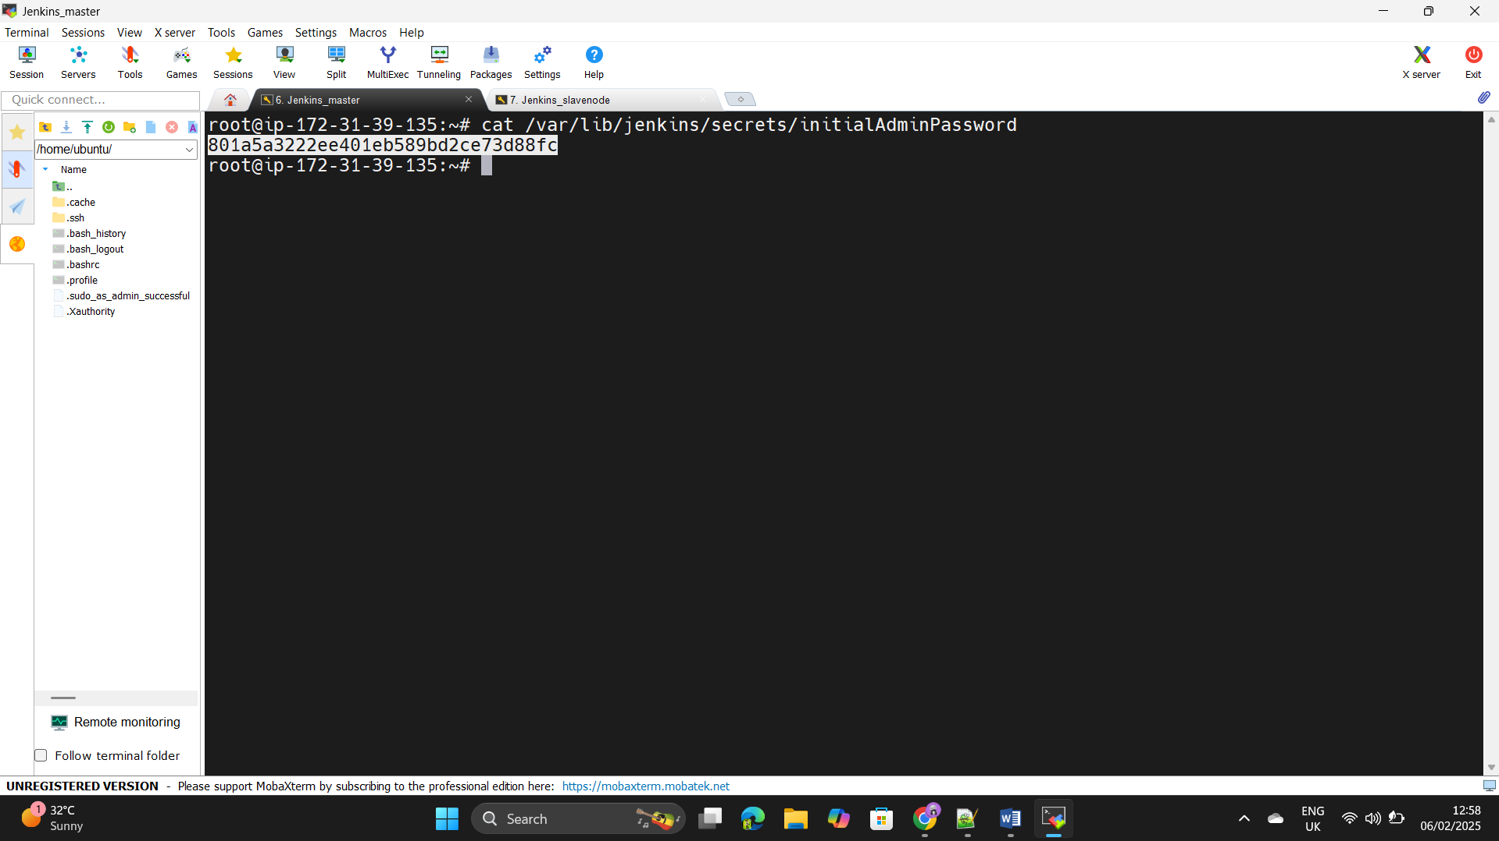+++++++we will get the password there paste in the beowser and login to +++++++the Jenkins.

Step32: - Go to the manage Jenkins and nodes ,click on create node.

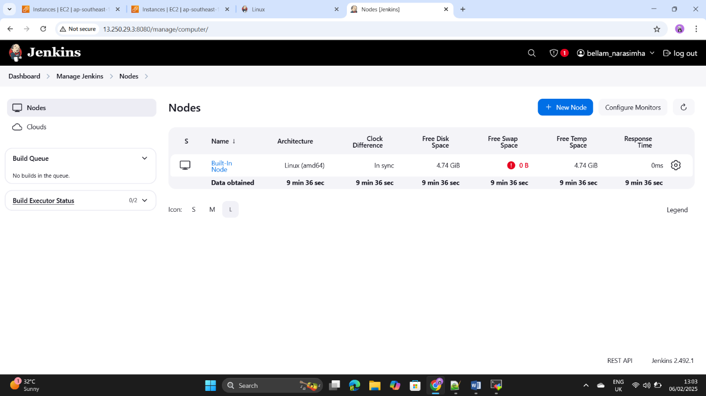

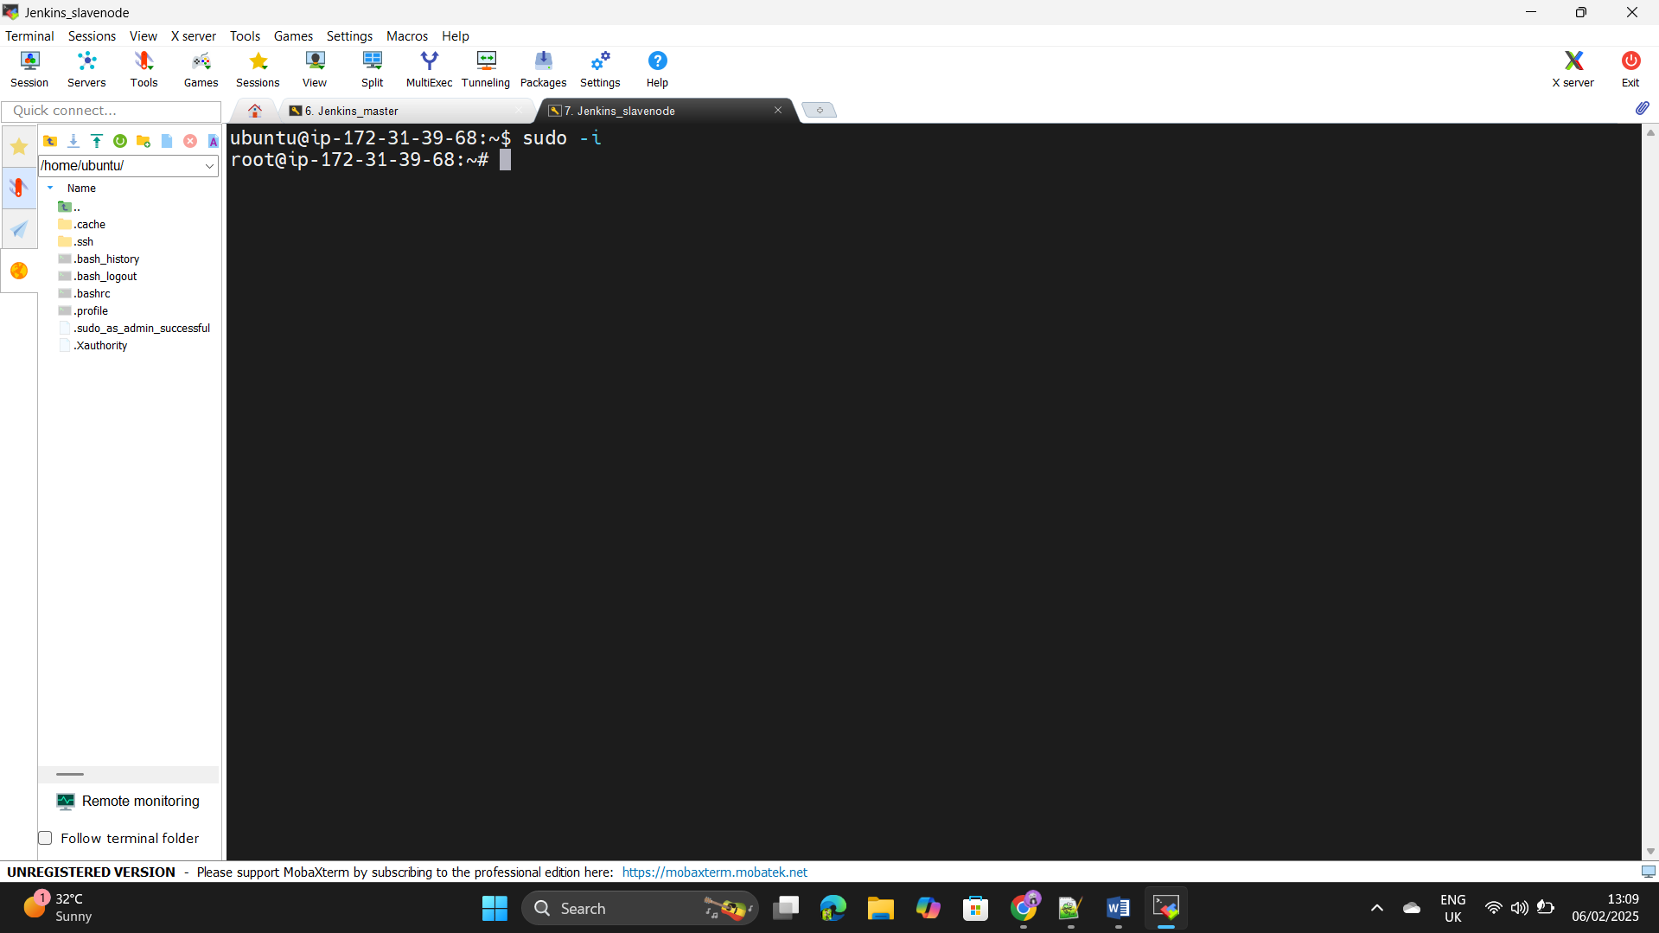Step33: - Login into the Client_server2 has a Jenkins_slvanode.

Step34: - Create the user and create the ssh key in that instance.

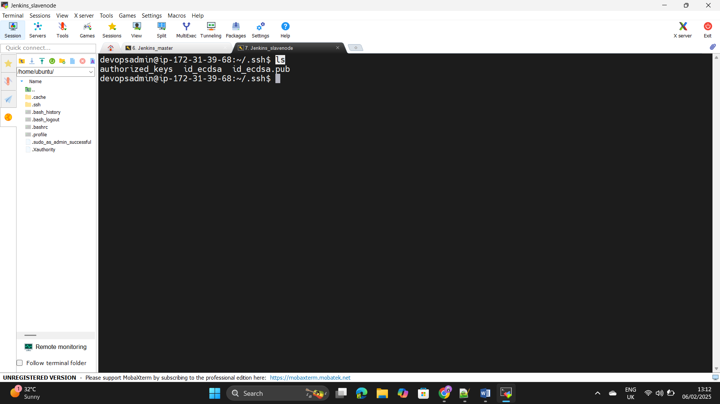

Step35: - Change the access mod of the file by using command as +++++++chmod 600 <file_path>

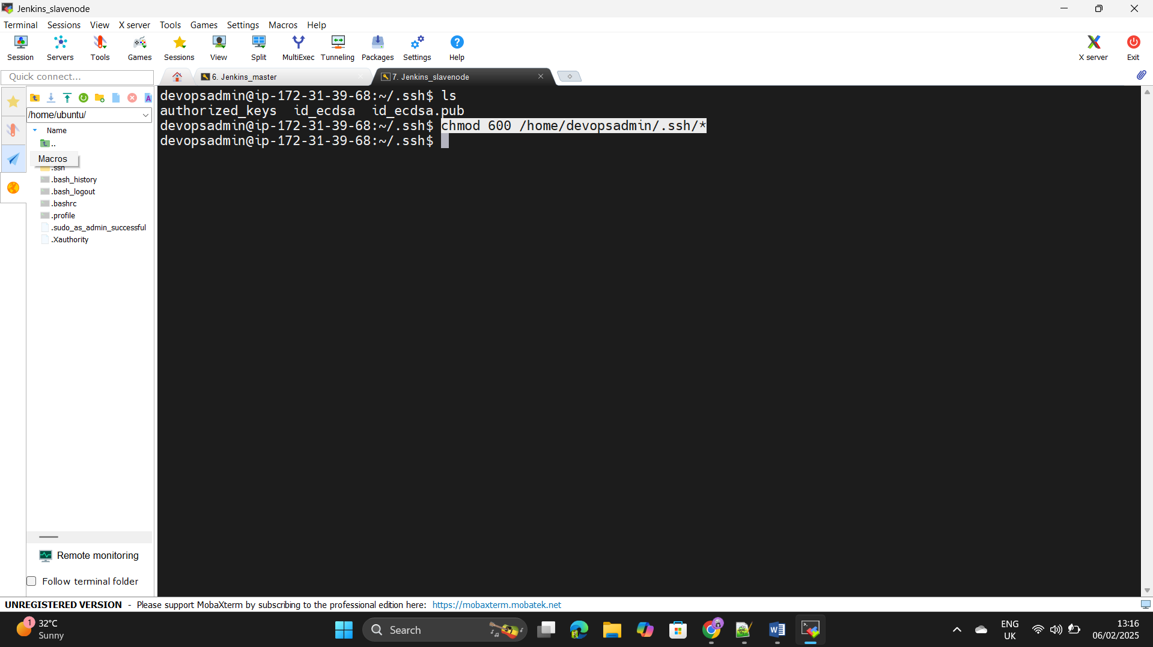+++++++ Use the command – usermod –aG docker +++++++devopsadmin(for docker purpose).

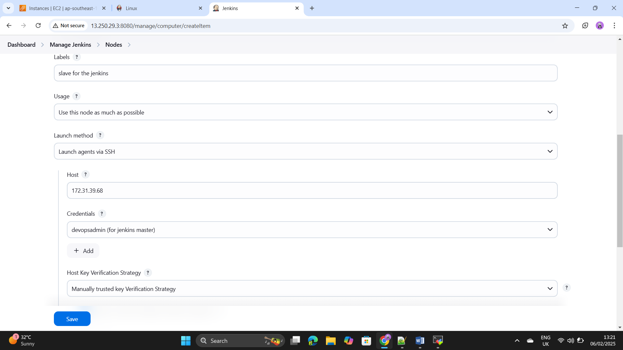Step36: - Go to Jenkins web browser and add the slave node to the +++++++Jenkins.

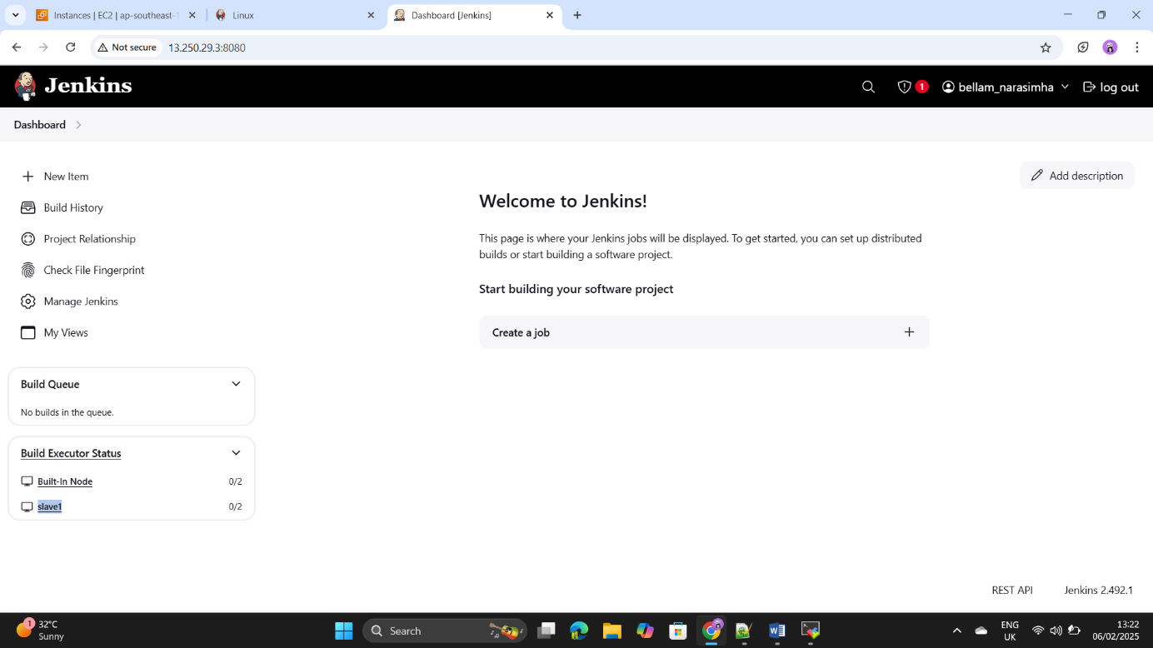Step37: - Jenkins slave node is ready for the build the code.

Step38: - Now connect the Docker hub through credentials, first login ++++++-to the Docker hub go to the account settings in that select +++++++the Personal access token click on that.

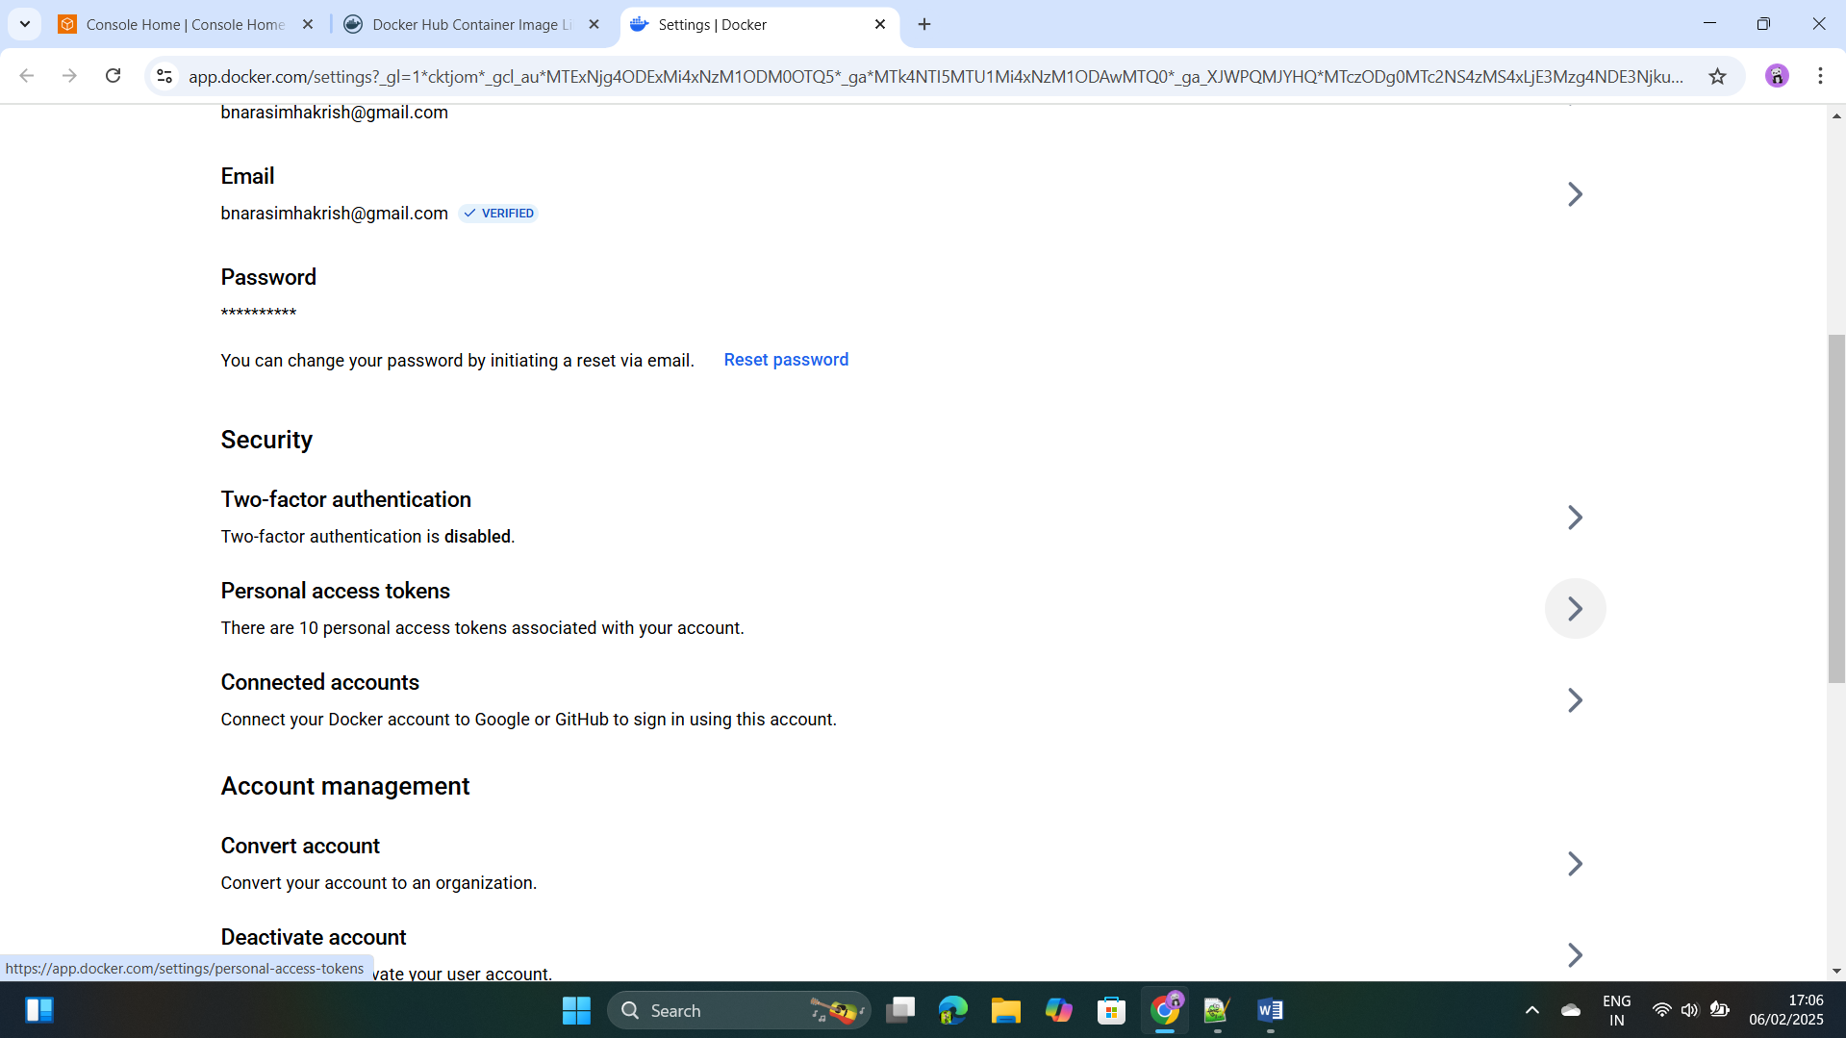

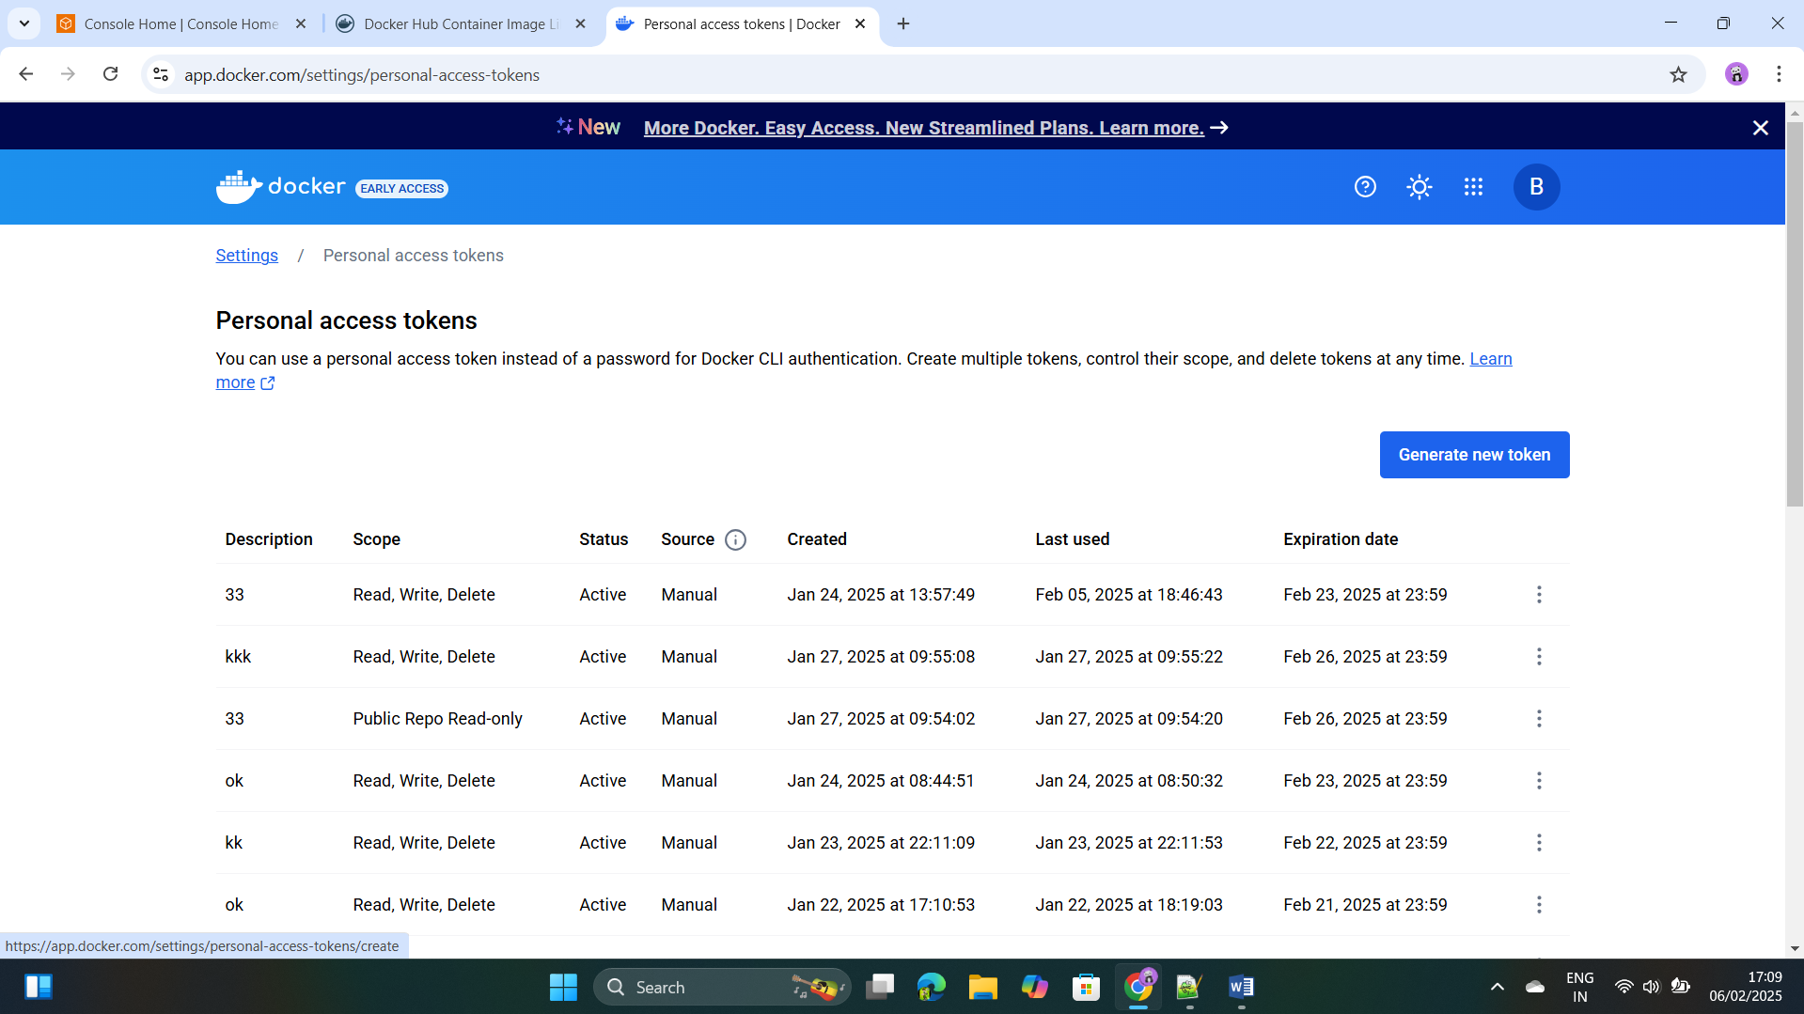Step39: - Select the Generate the new token and create the token.

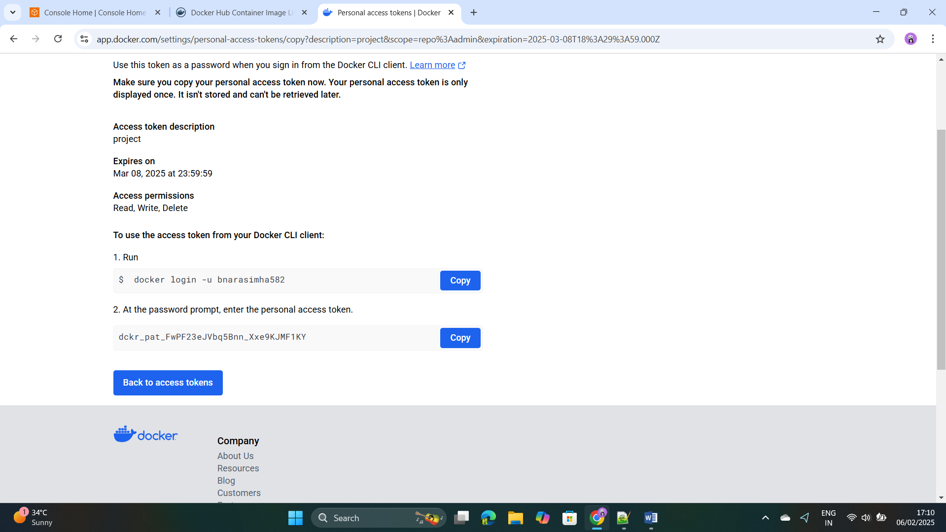

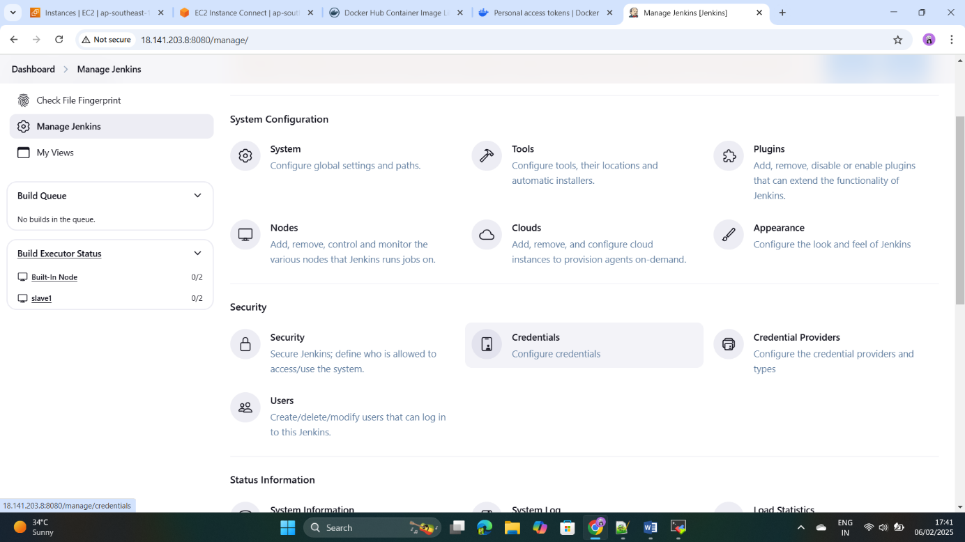Step40: - go to the manage Jenkins and select the credentials.

Step41: - Go to the credentials and click on add credentials.

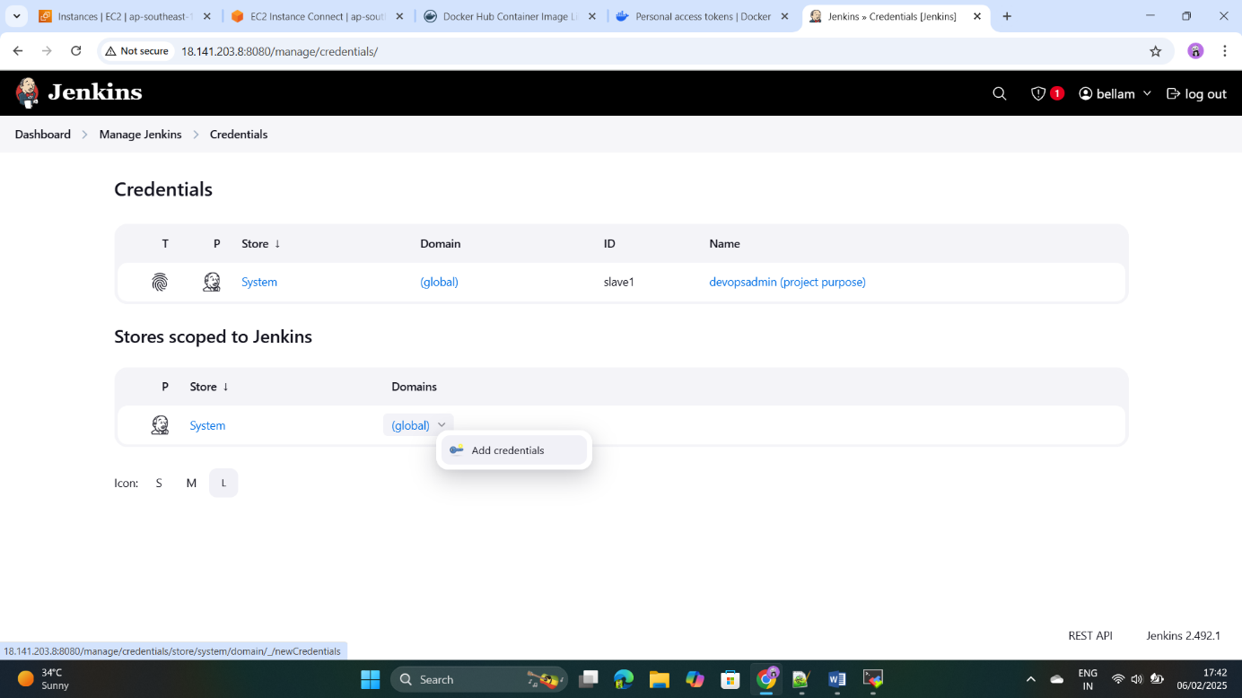

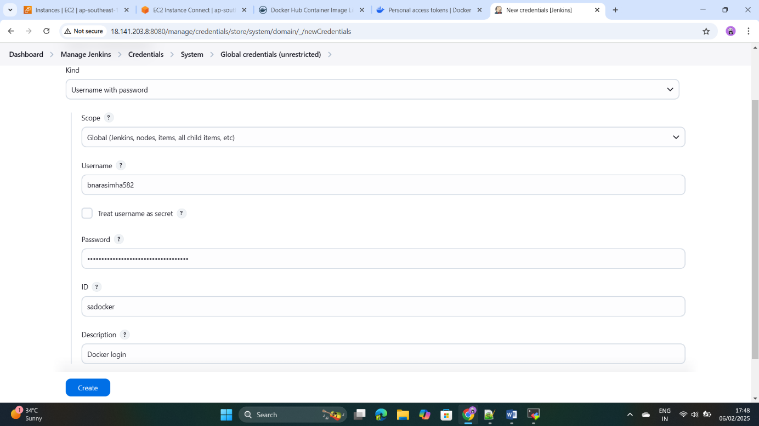Step42: - Add the username and password as we copy from the ++++++-docker hub to paste it here and click on create.

Step43: - Save the credentials for dockerhub login & image pushing.

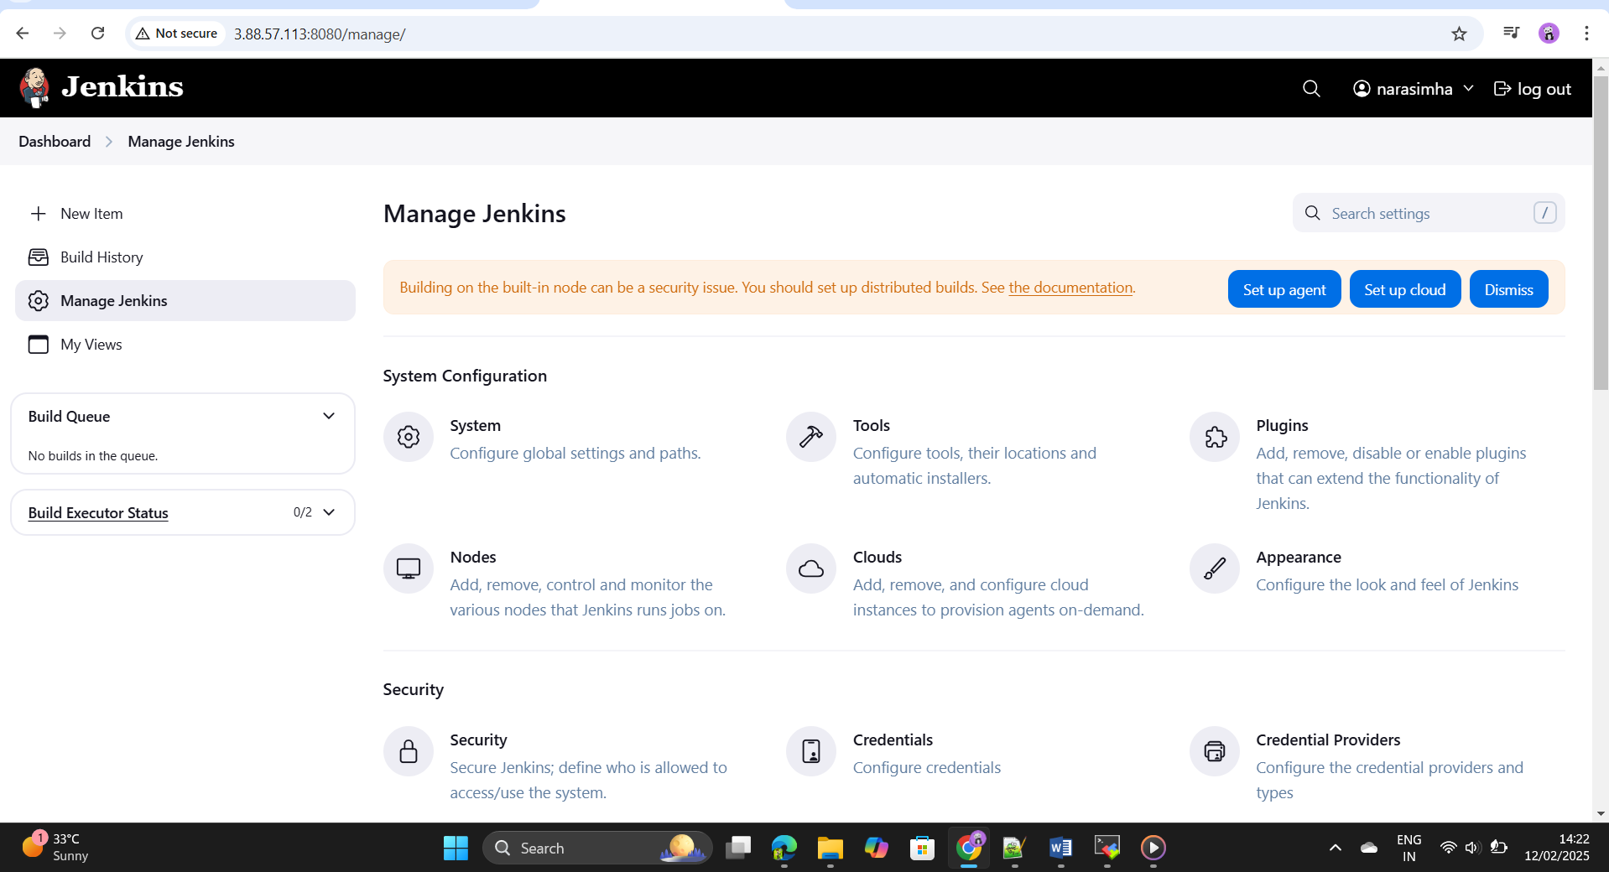Step44: - Add the post build action to the Jenkins pipeline as a email ++++++-notification regarding the pipeline status got to the Jenkins +++++++system configuration.

Step45: - Add the Email notification and save it.

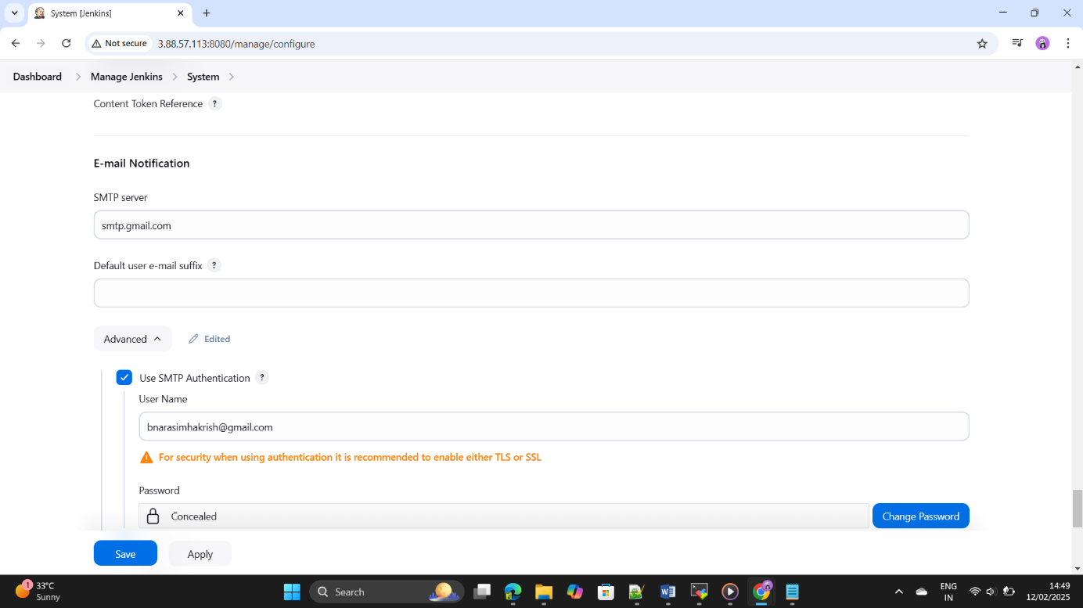

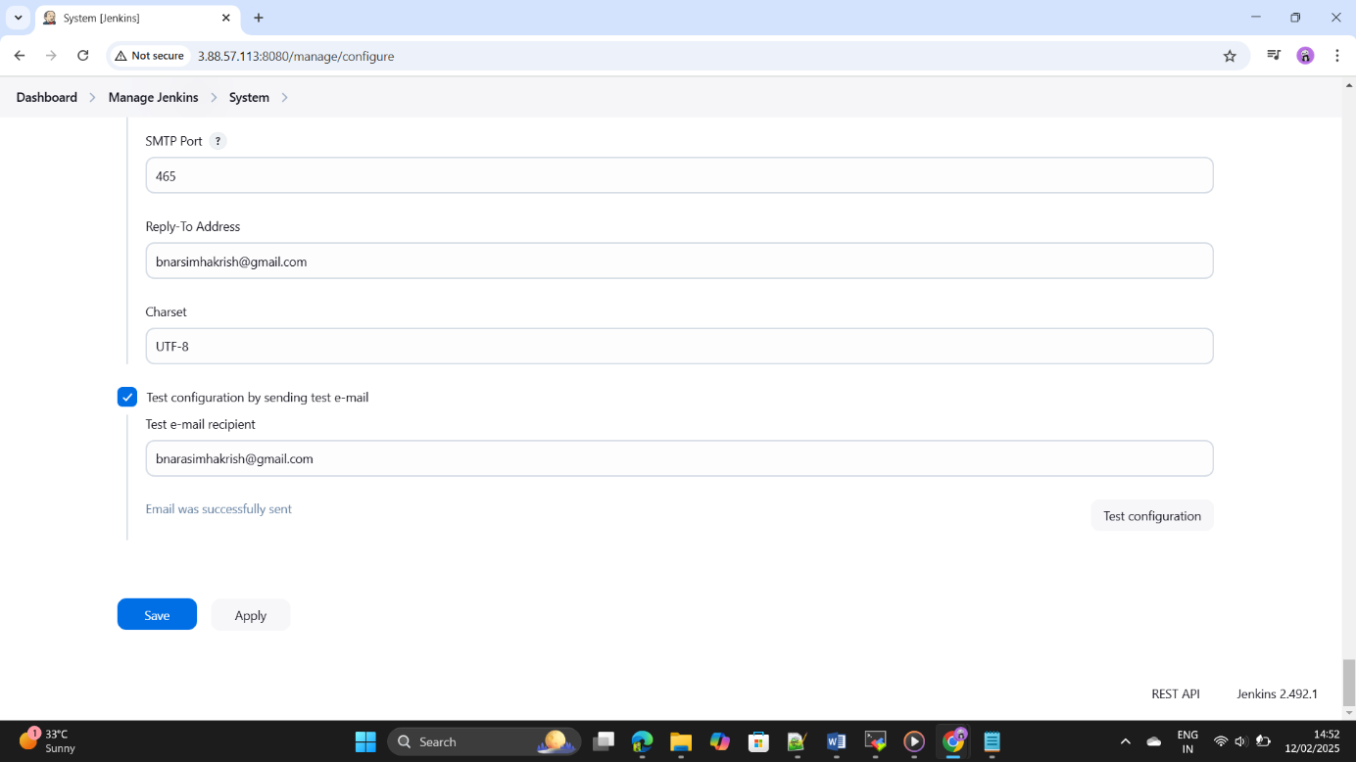Step46: - Create the password in the gmail(go to the manage and click on 2 step verification and add the app password and copy the password and paste it here and click on the test configuration and save it.)

Step47: - Intstalll the kubernets for the pods deployment.

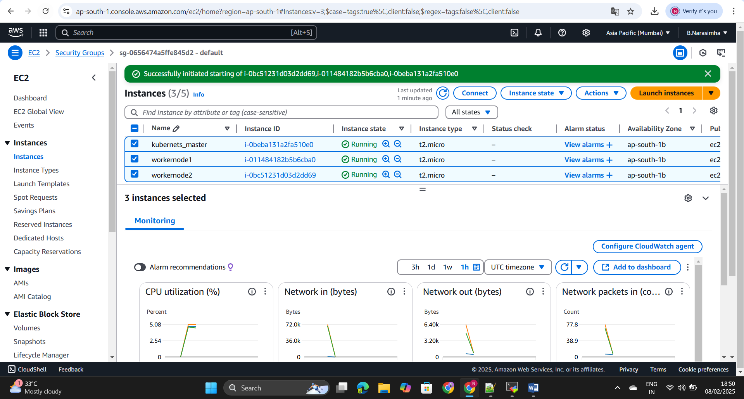Step48: - We have to add the kubernet master node to the Jenkins master ++++++node for that install the kubernets and its worker nodes.

Step49: - Connect the 3 instances and update and change the host name ++++++++by using the command as –

+++++++sudo hostnamectl set-hostname "kmaster-node"

+++++++exec bash

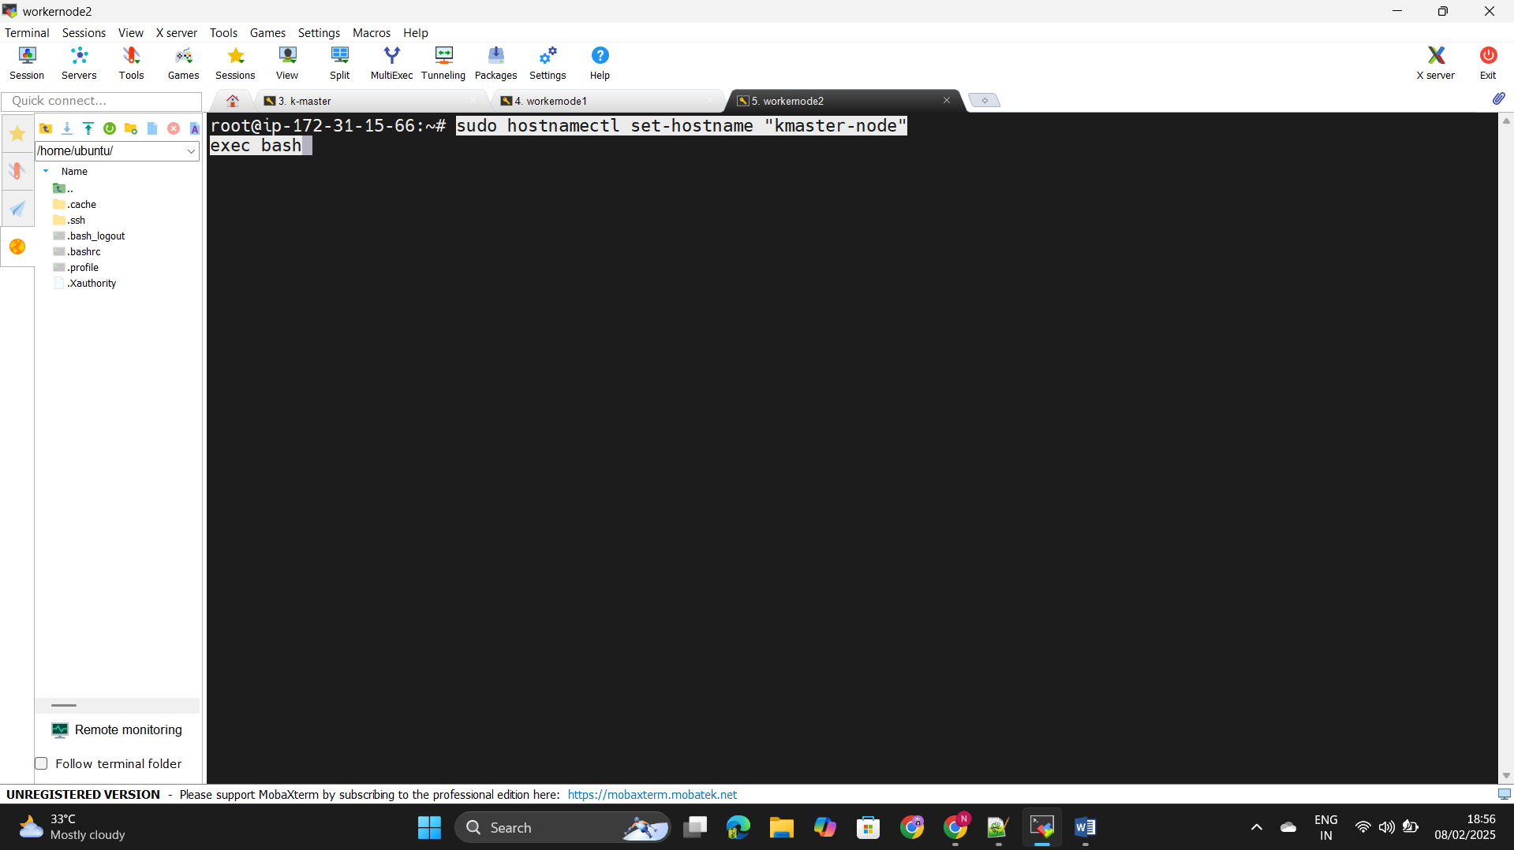

Step50: - Disable the swap on both machines by using command –

sudo swapoff -a

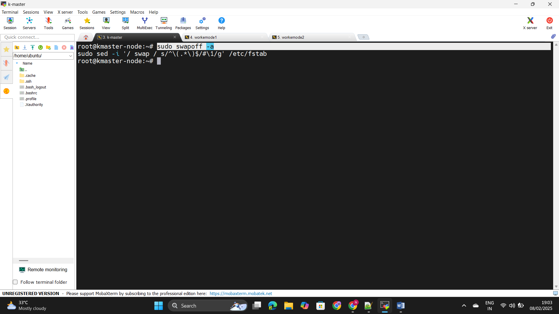+++++++sudo sed -i '/ swap / s/^\(.*\)$/#\1/g' /etc/fstab

Step51: - Install docker by using command –

+++++++ sudo apt install docker.io

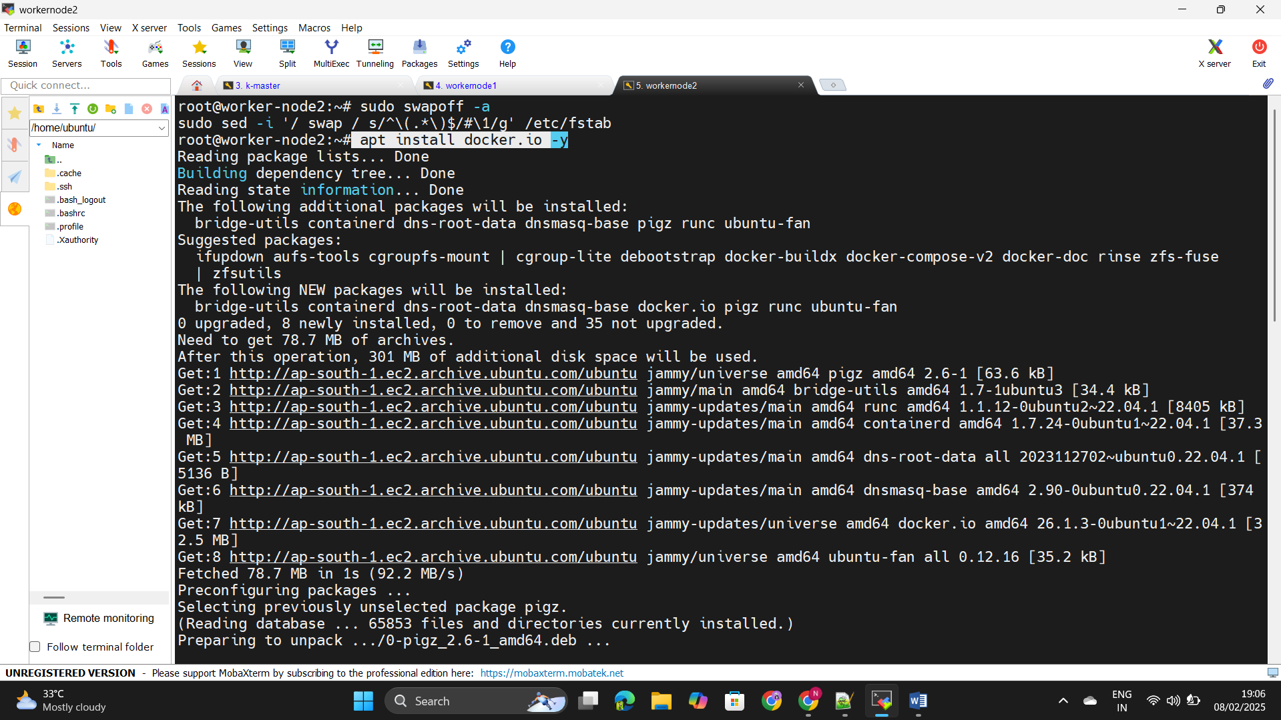

Step52: - install the container –D by following some steps as +++++++configure the net filters by using the below command

+++++++sudo modprobe overlay

+++++++sudo modprobe br_netfilter

+++++++cat <<EOF | sudo tee /etc/modules-+++++++load.d/containerd.conf

+++++++overlay

+++++++br_netfilter

+++++++EOF

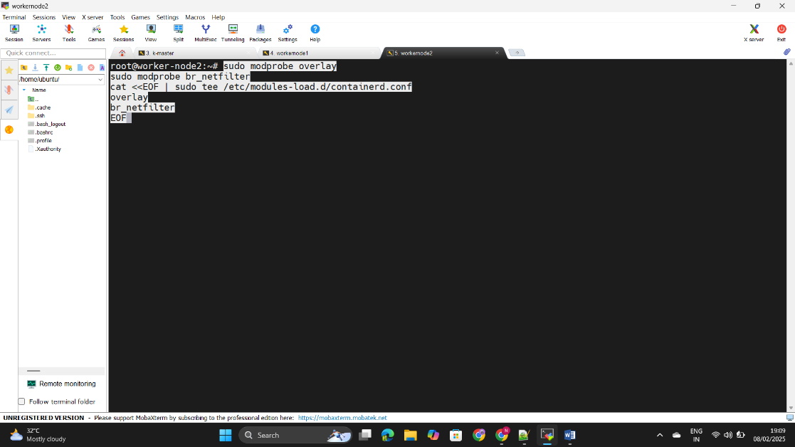

Step53: - now Configure the IP6 table ref by using below command. +++++++++++++sudo tee /etc/sysctl.d/kubernetes.conf<<EOF

++++++net.bridge.bridge-nf-call-ip6tables = 1

++++++net.bridge.bridge-nf-call-iptables = 1

++++++net.ipv4.ip_forward = 1

EOF

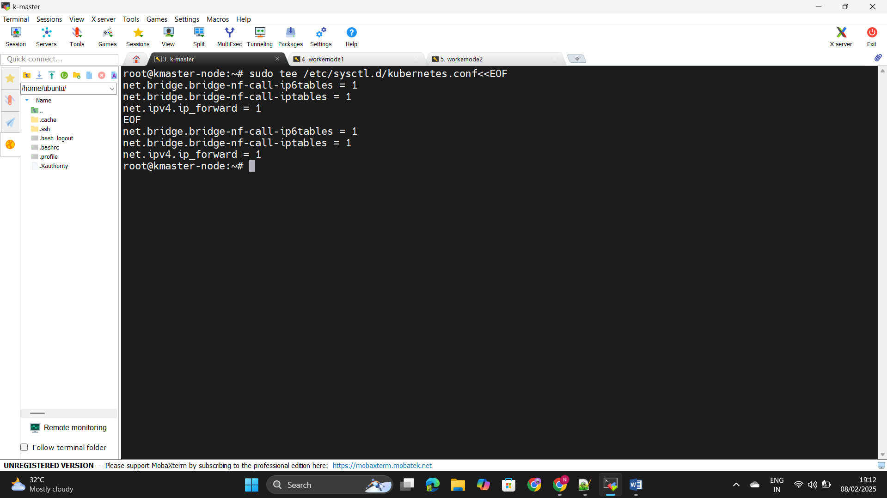

Step54: - Download the Containers by using curl command as below

++++++ curl -fsSL https://download.docker.com/linux/ubuntu/gpg | +++++++sudo apt-key add -

+++++++sudo add-apt-repository "deb [arch=amd64] +++++++https://download.docker.com/linux/ubuntu $(lsb_release +++++++-cs) stable"

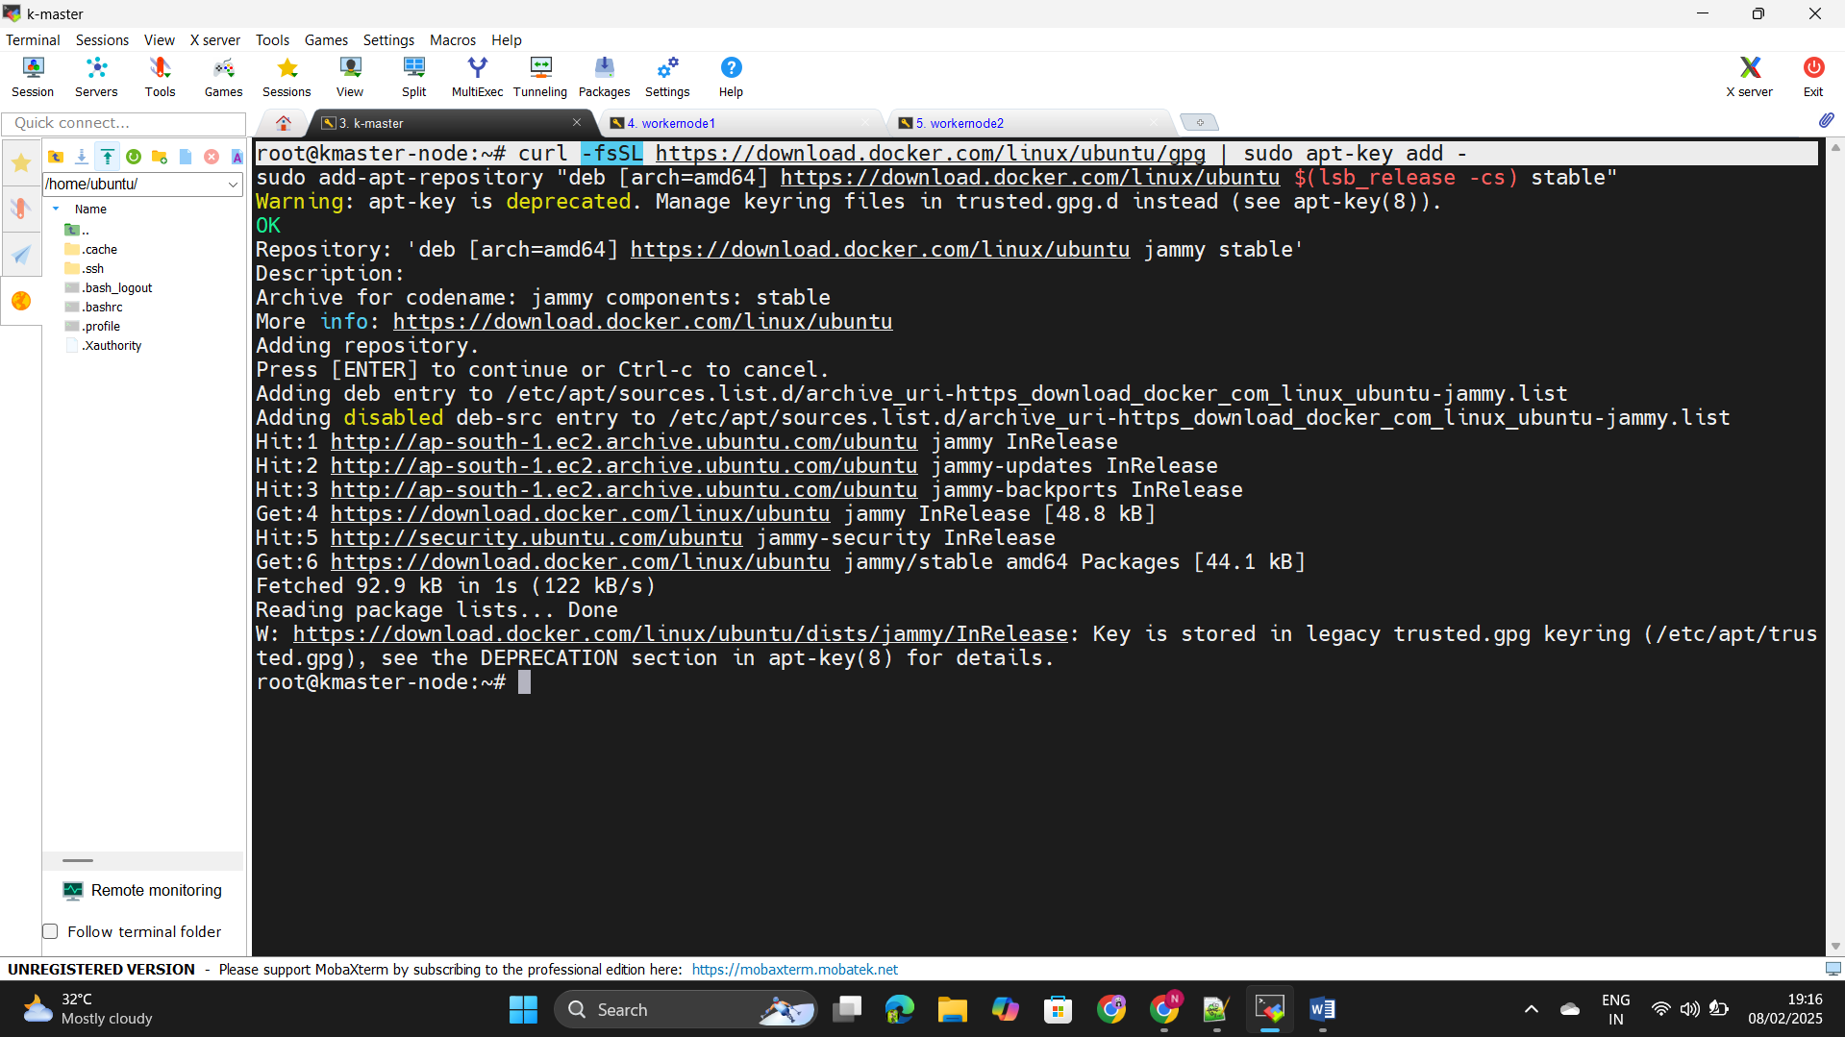

Step55: - Install the Container –D by using below command.

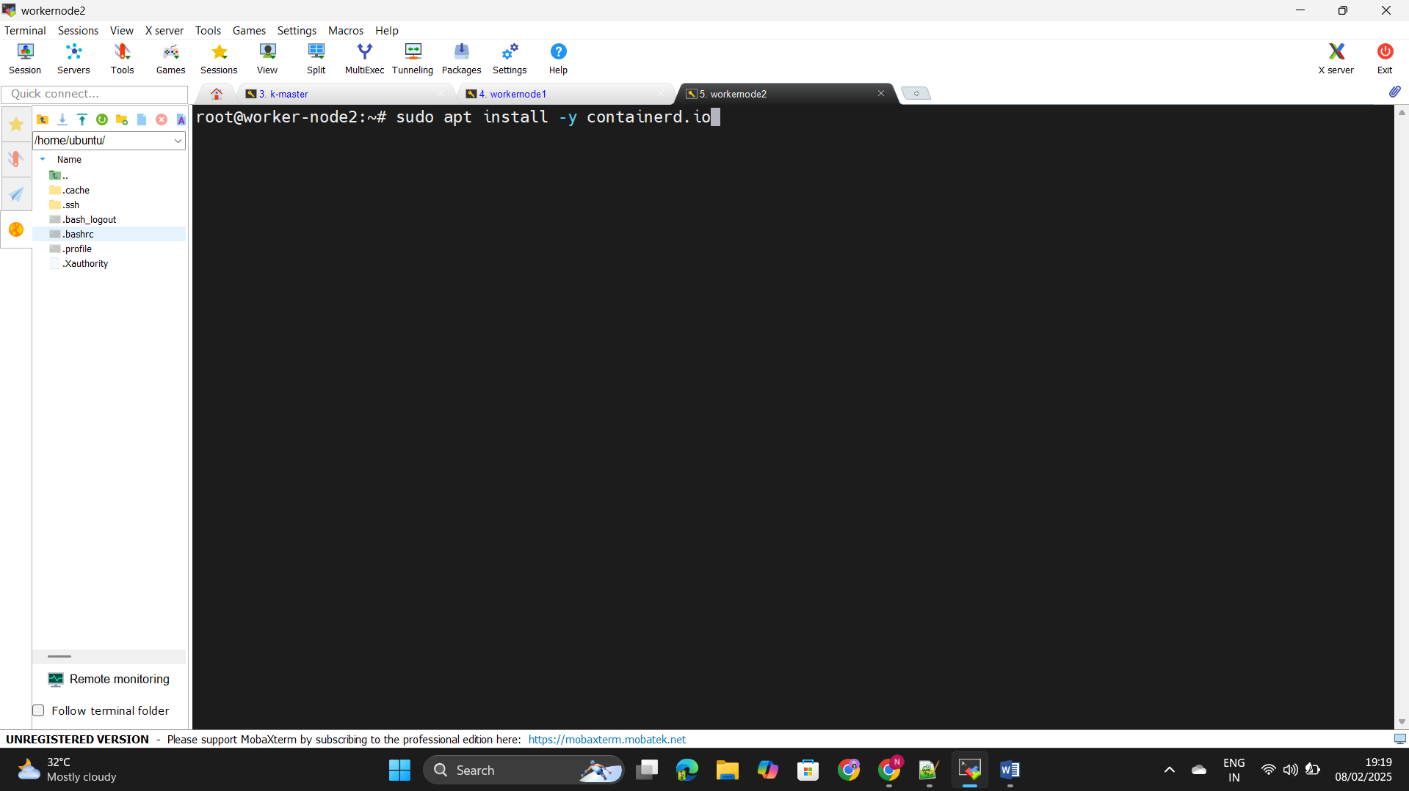++++++sudo apt install -y containerd.io

Step56: - Configure the .toml file by using the below command as-

++++++sudo mkdir -p /etc/containerd

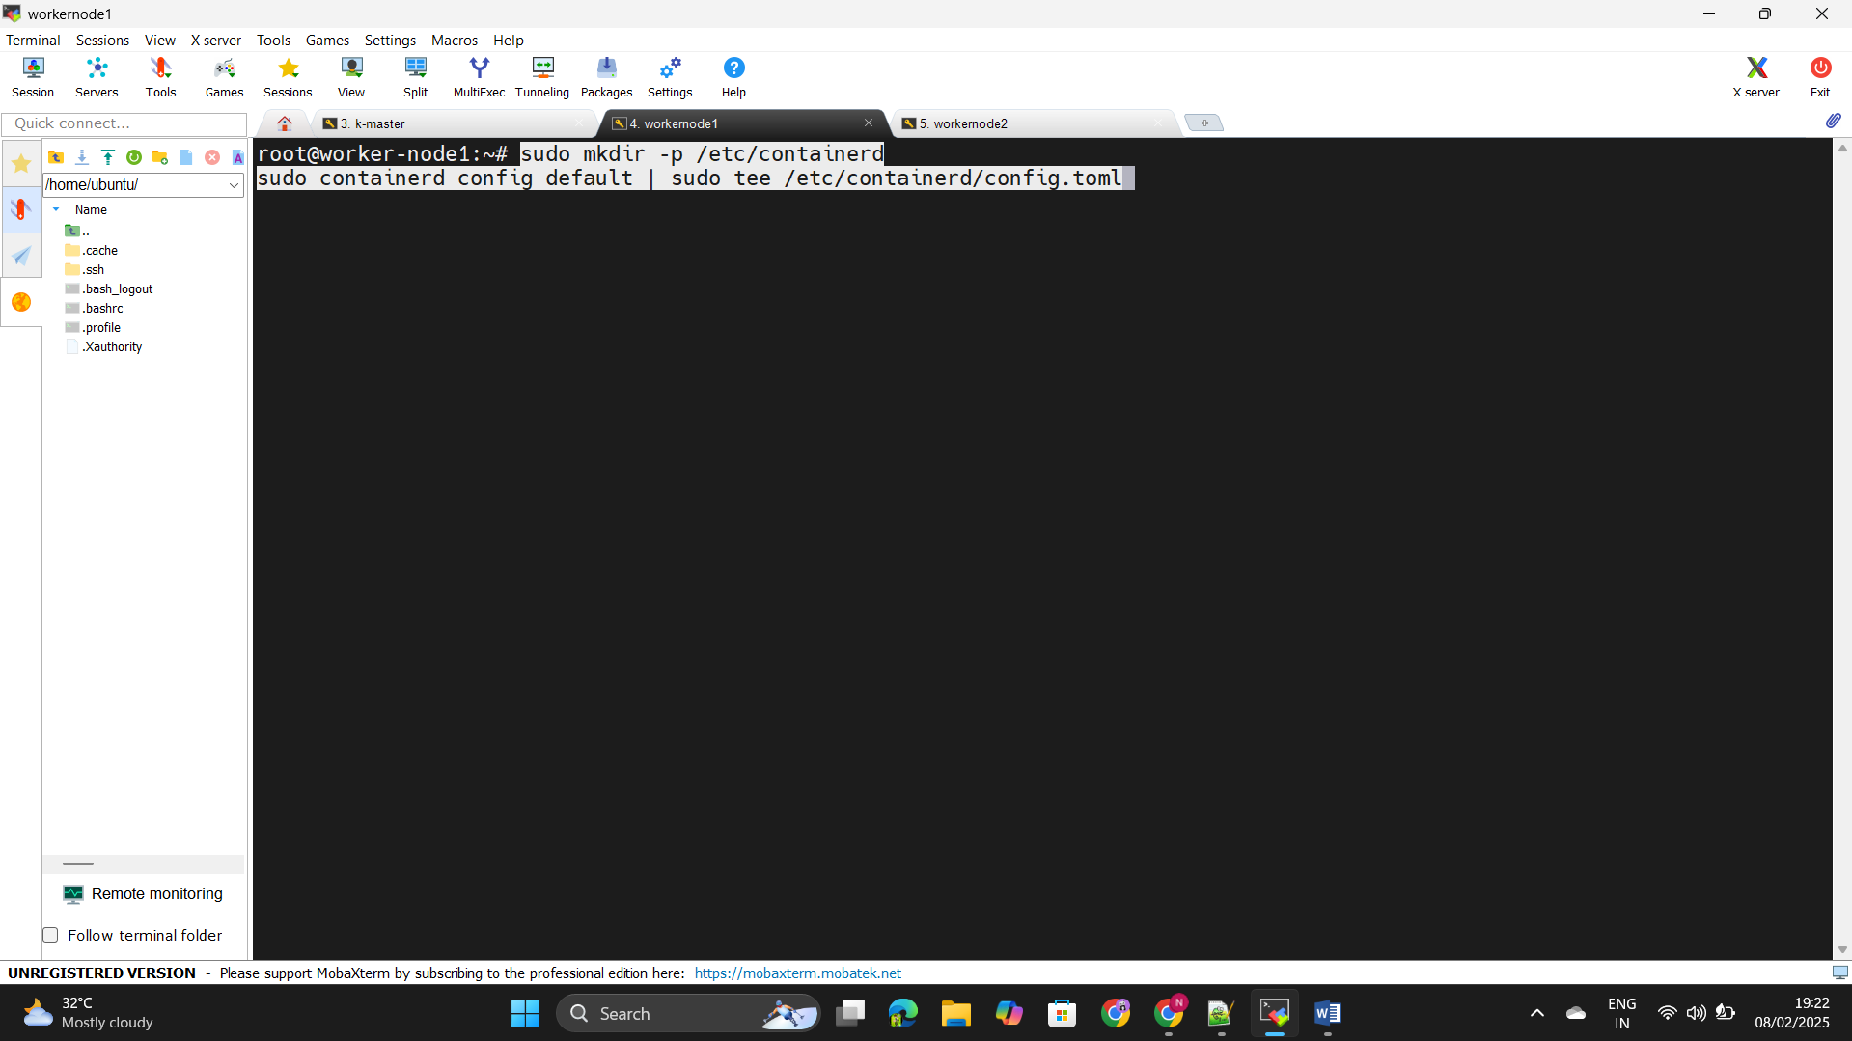++++++sudo containerd config default | sudo tee ++++++/etc/containerd/config.toml

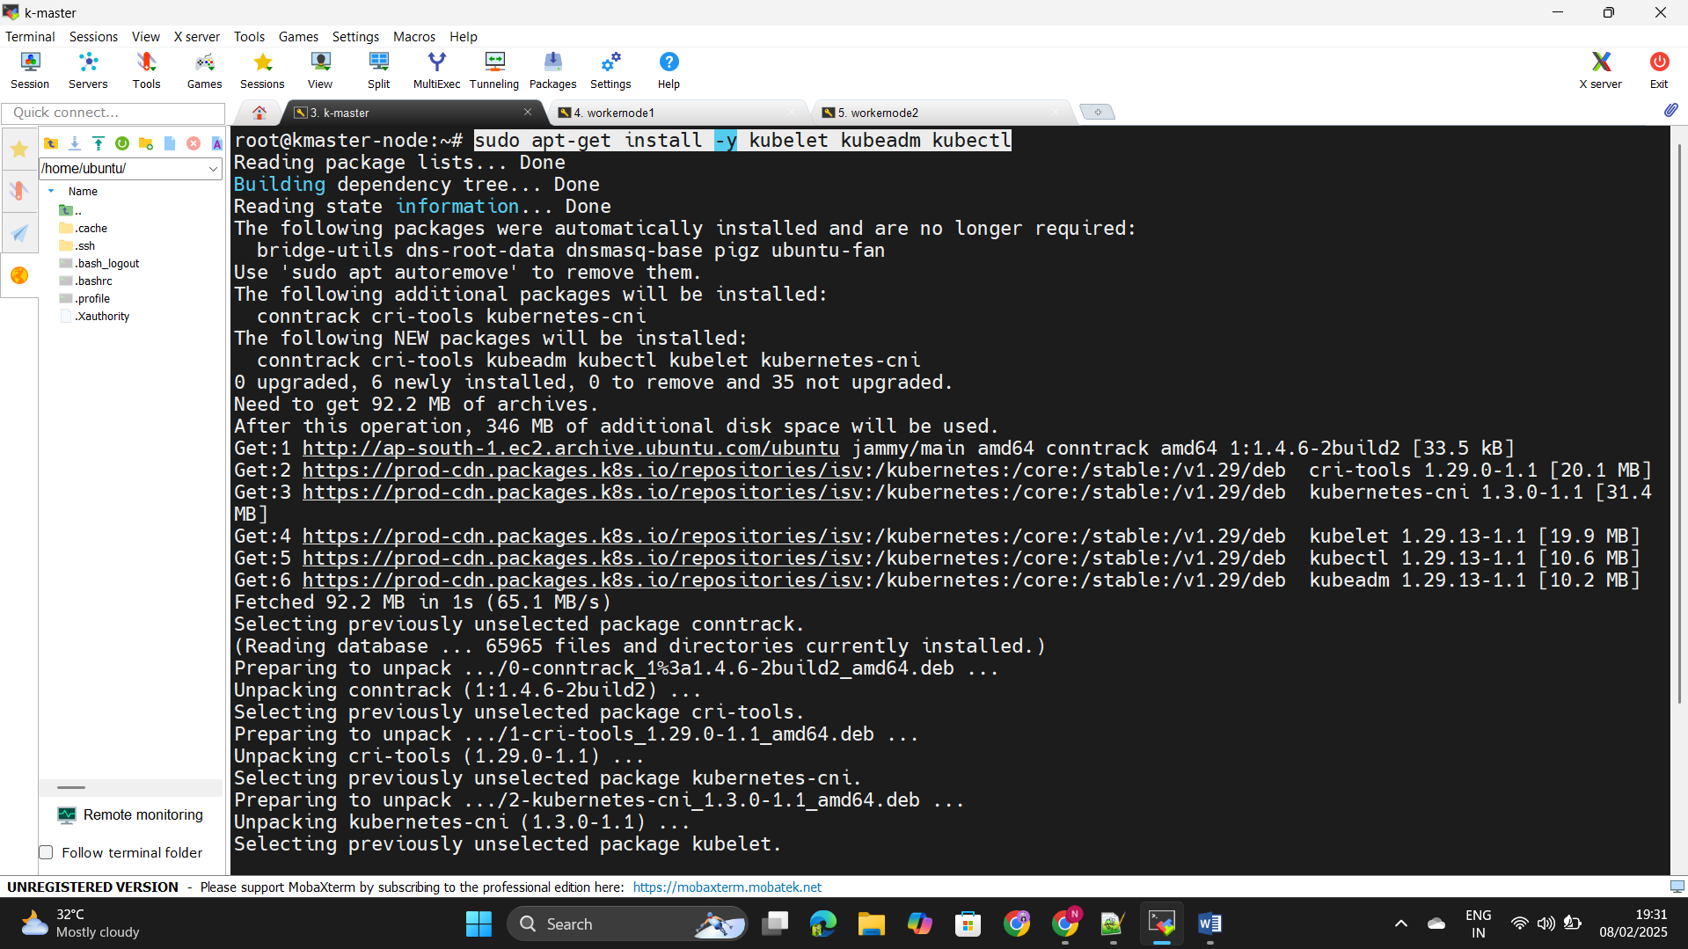Step57: - Install the kubeadm,kubelet,kubectl by using the below ++++++command - sudo apt-get install -y kubelet kubeadm kubectl

Step58: - Execute the below command in the Masternode only

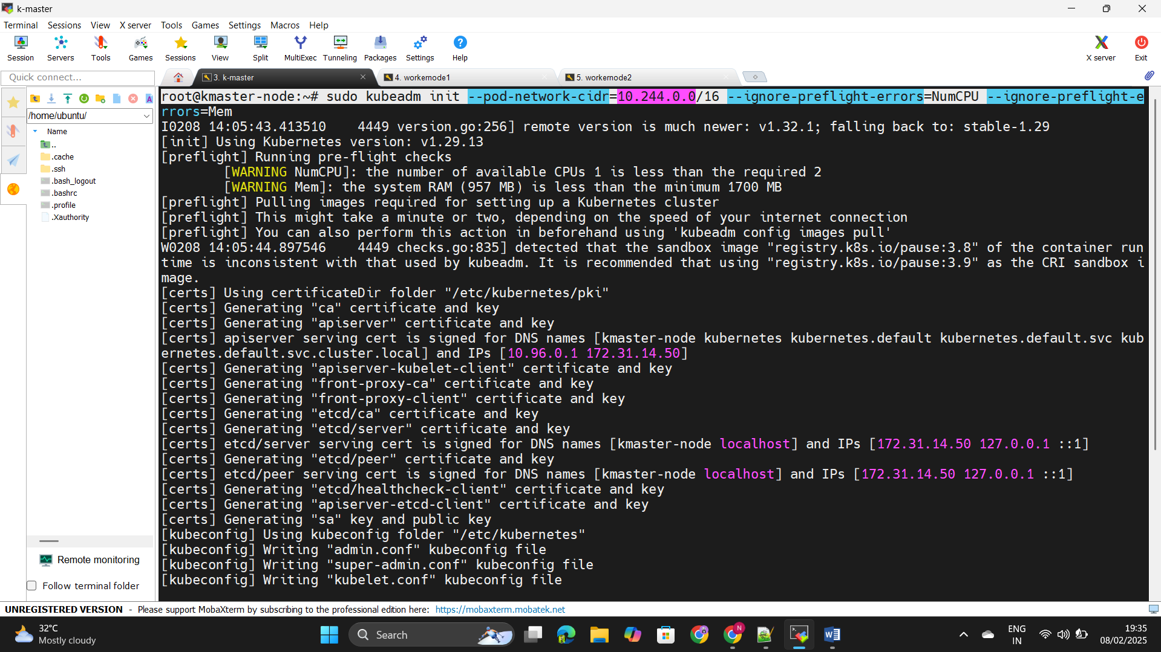++++++sudo kubeadm init --pod-network-cidr=10.244.0.0/16 --++++++ignore-preflight-errors=NumCPU --ignore-preflight-++++++errors=Mem

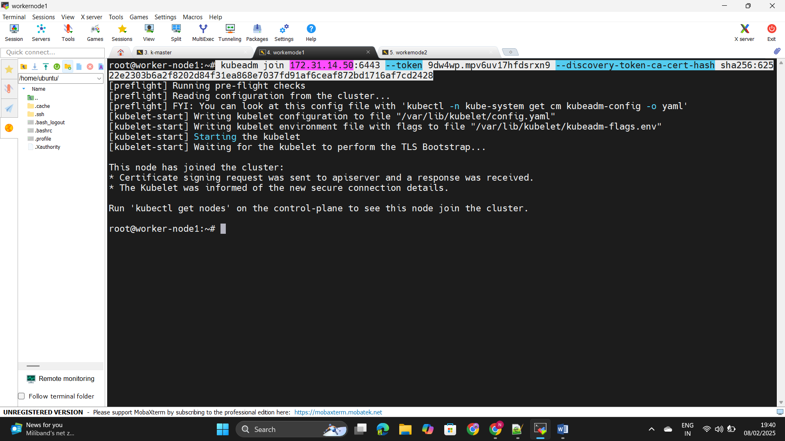Step59: - Join the kubeadm join in the workernode.

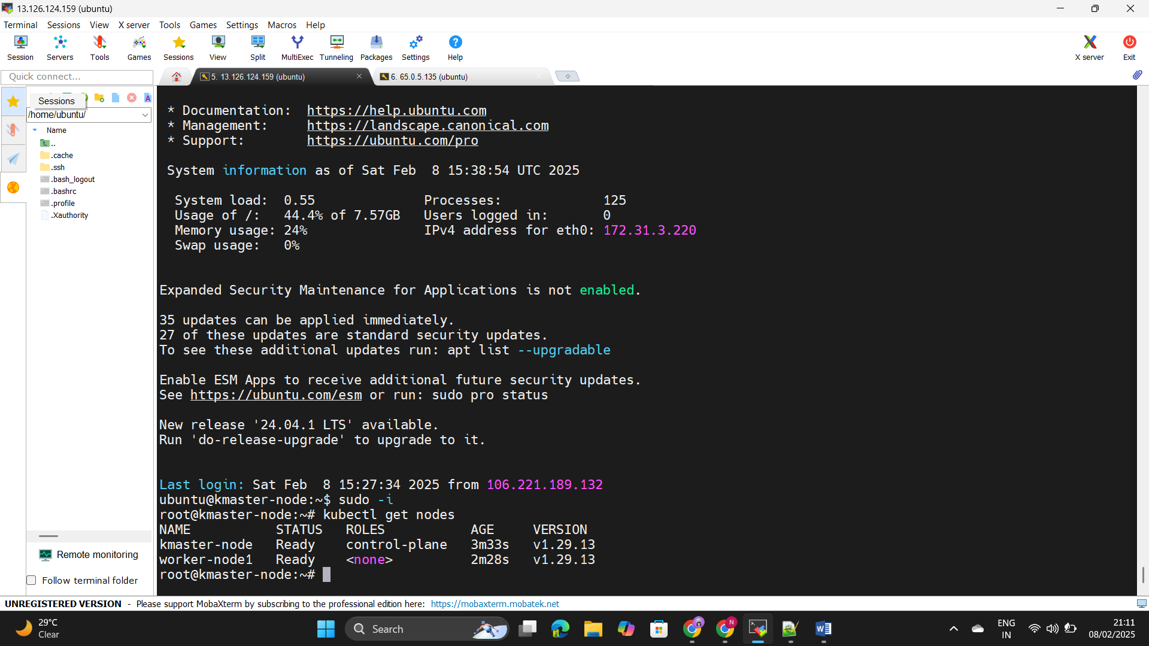Step60: - Join the worker node to the master node by using kubeadm +++++++join command.

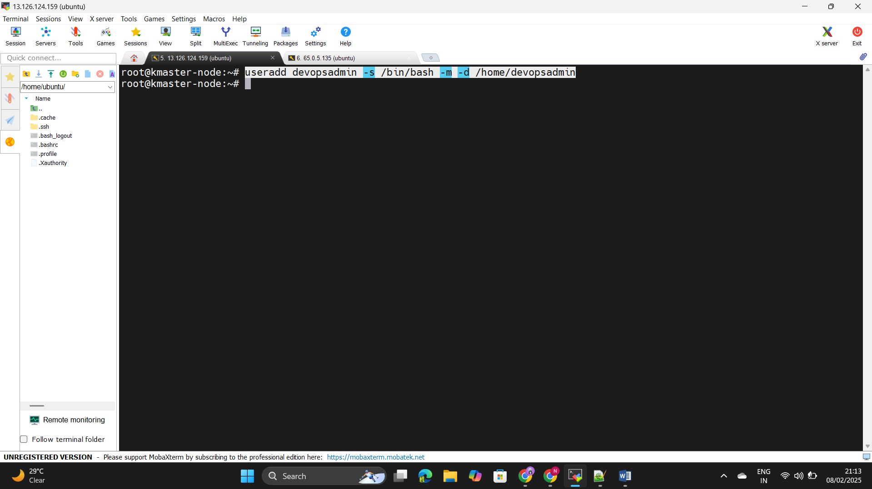Step61: - Create the user in the Master node by using below ++++++command- useradd devopsadmin -s /bin/bash -m -d +++++++/home/devopsadmin

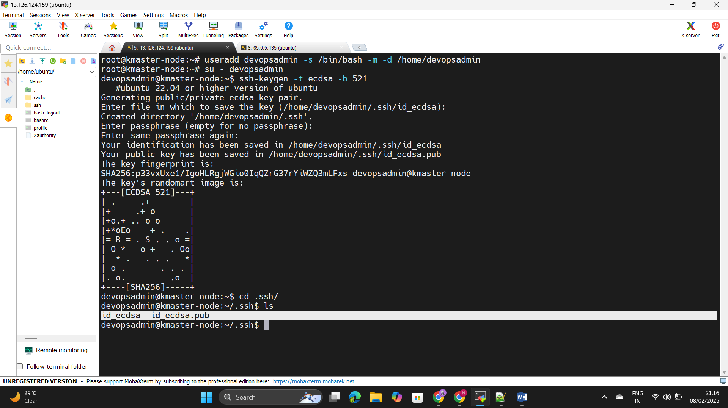Step62: - Create the ssh keypair by using command as - ssh-keygen +++++++-t ecdsa -b 521.

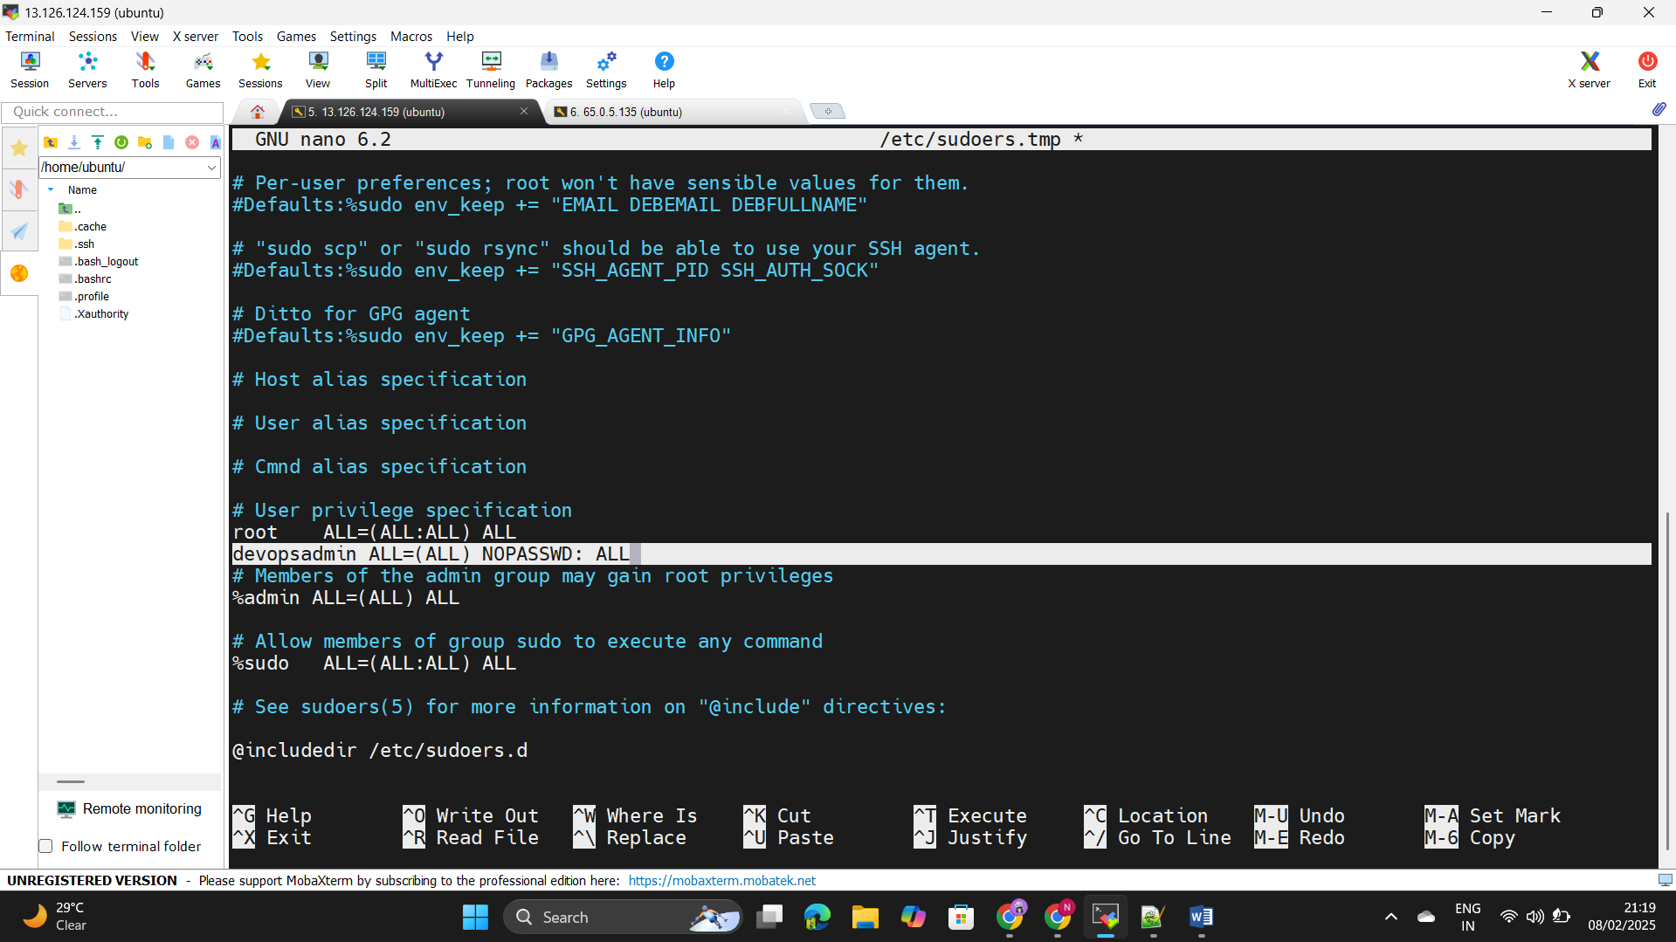 Step63: - Give the full access to the user by editing the Visudo file +++++++as - devopsadmin ALL=(ALL) NOPASSWD: ALL.

Step64: - Go to the user and copy paste the below code for the +++++++kubernet access to the user

mkdir -p $HOME/.kube

++++sudo cp -i /etc/kubernetes/admin.conf $HOME/.kube/config

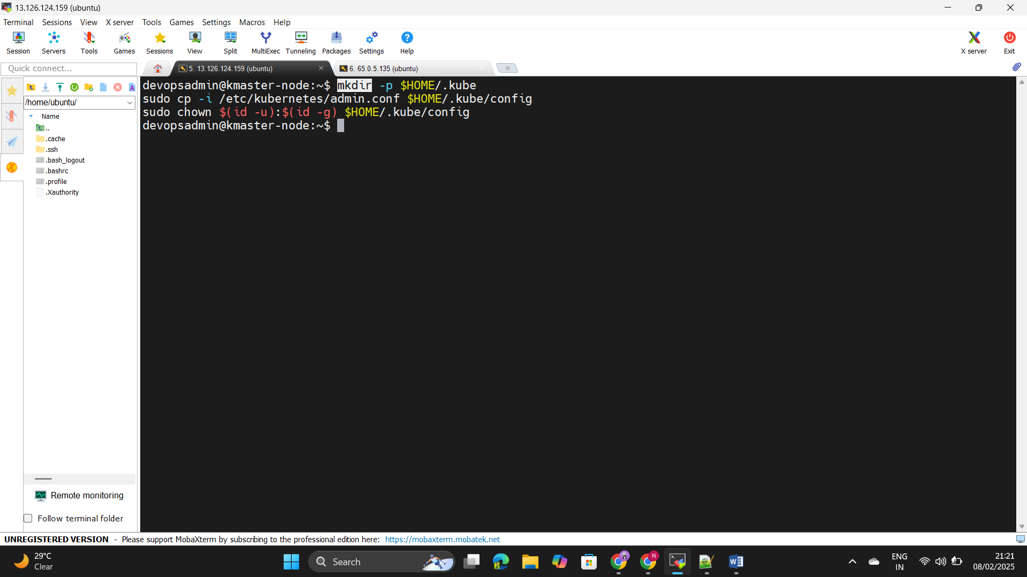++++sudo chown $(id -u):$(id -g) $HOME/.kube/config

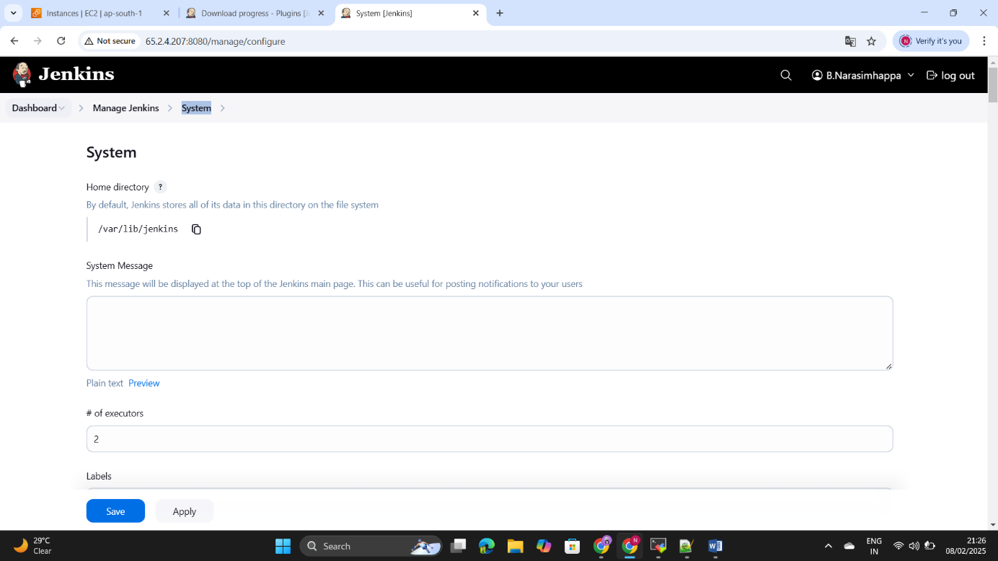Step65: - Go to the Jenkins master and install the publish over ssh ++++++through plugins and go to the manage Jenkins under ++++++system configuration.

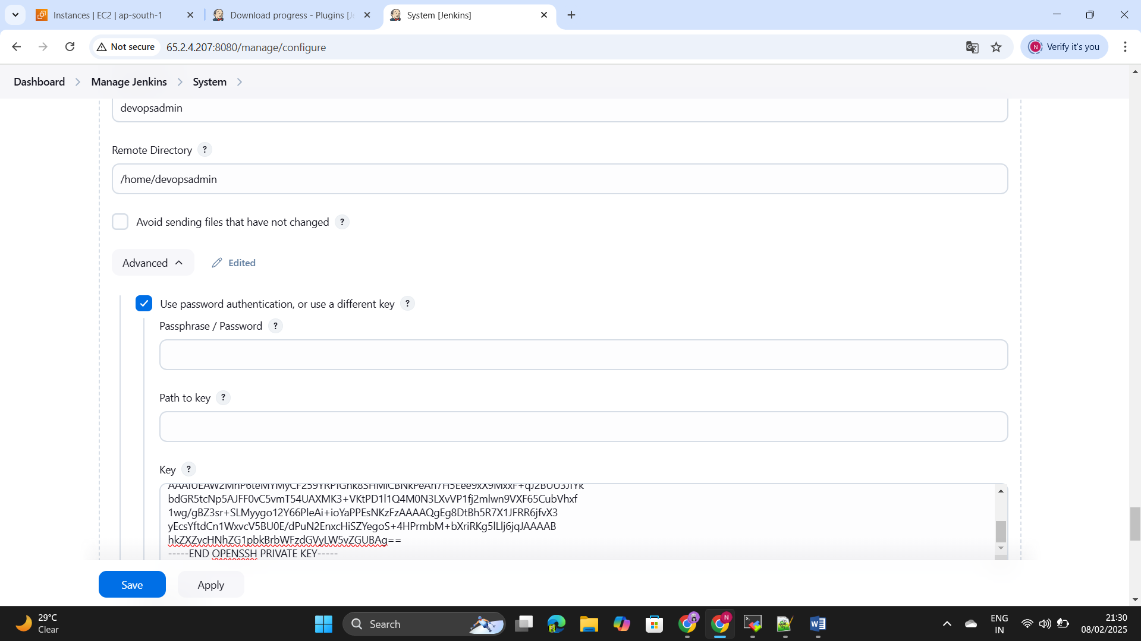Step66: - Add the kubernet master node by using the ssh connection  
++++++(copy paste the private key of the user and paste here and +++++++save it).

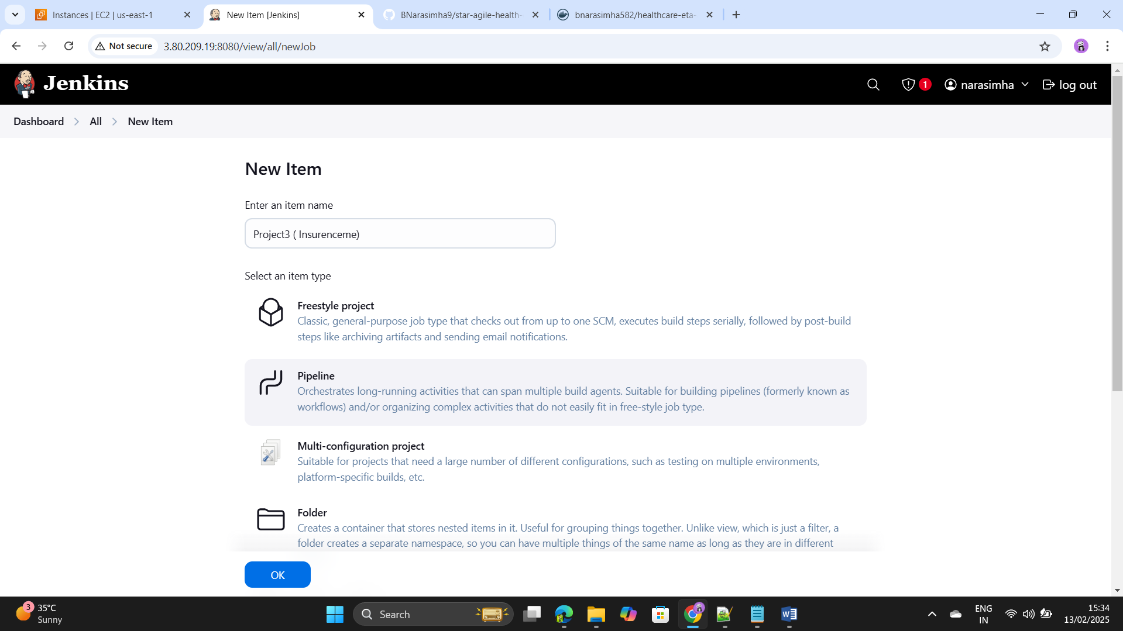Step67: - Create the Pipeline.

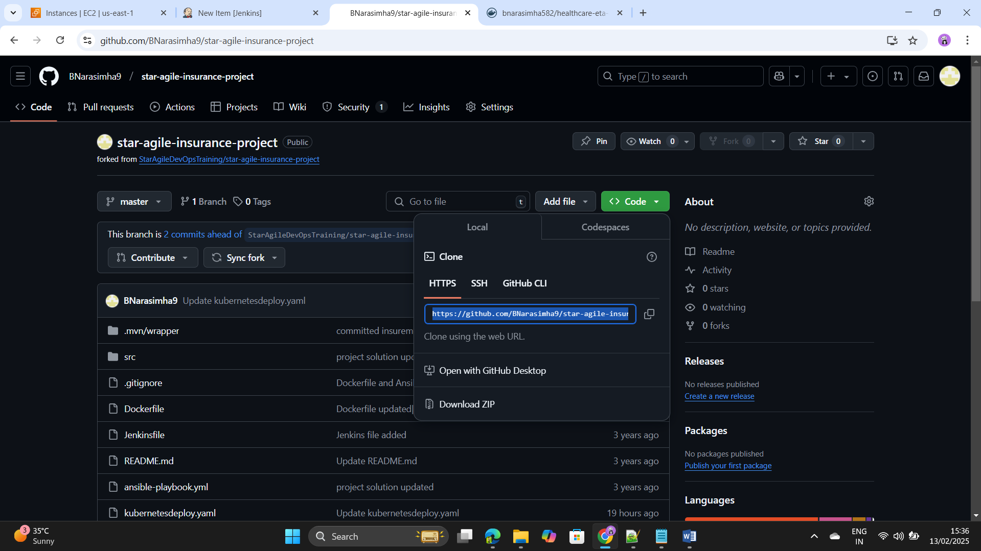Step68: - Add the below pipeline code in the Pipeline by using the ++++++sniper Generator.(ADD the source code url)

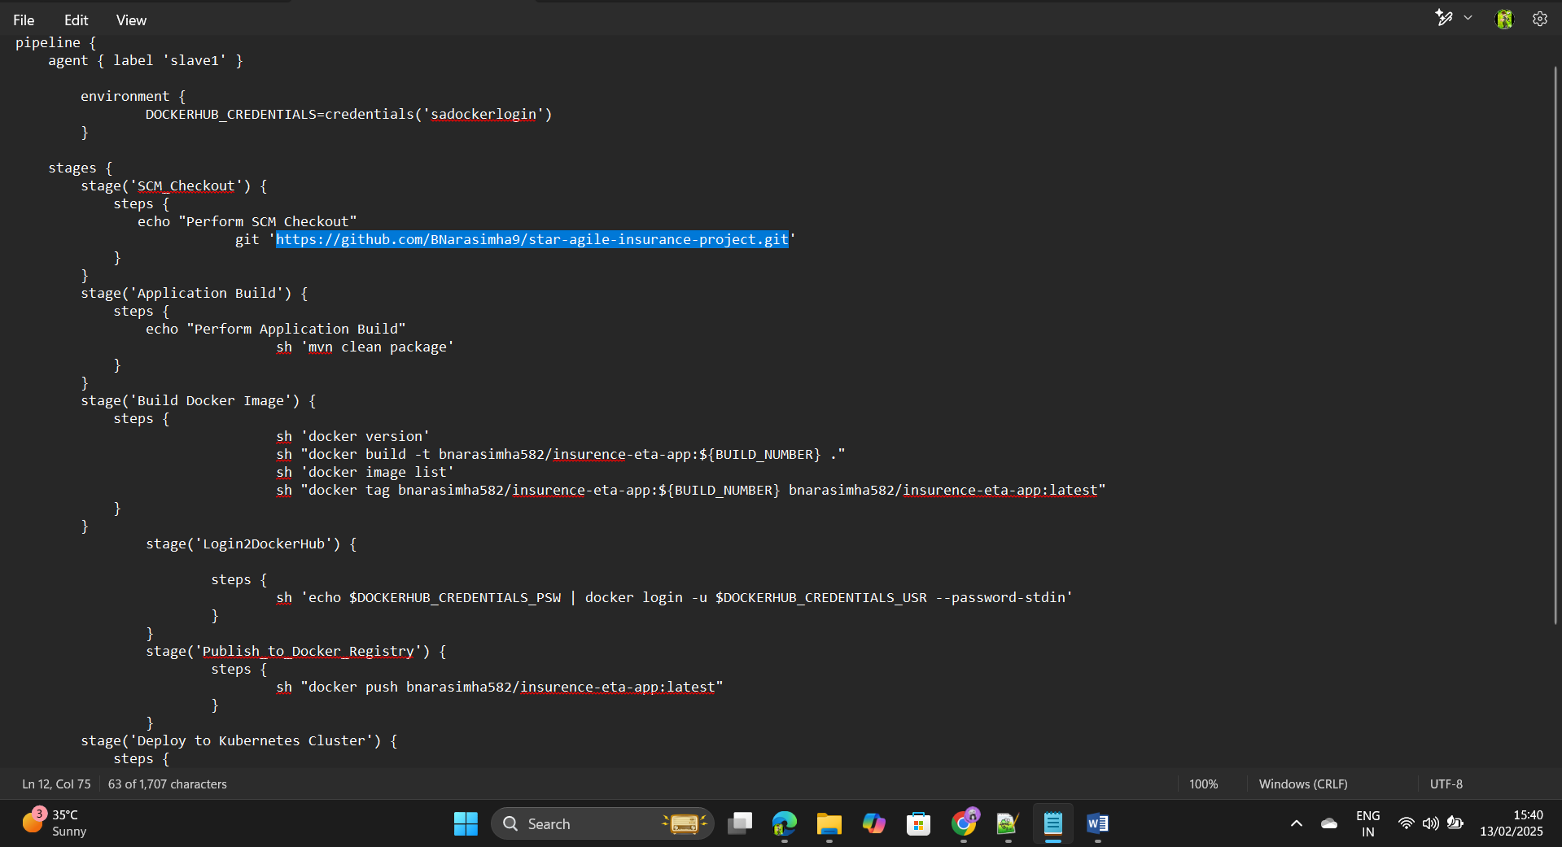

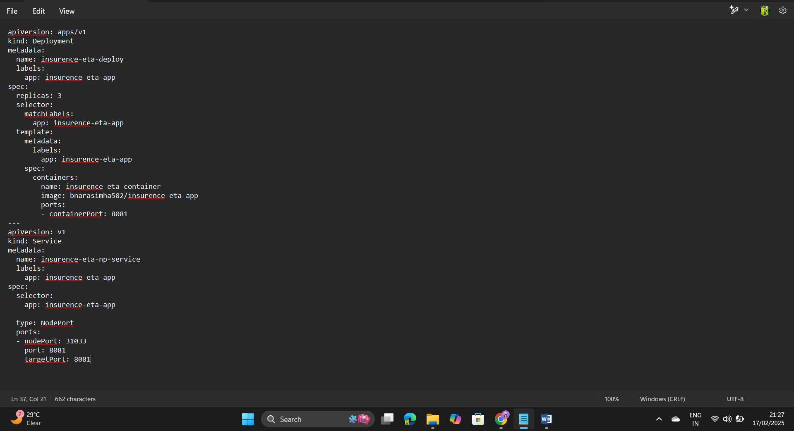Step69: - Create the .yaml file for the kubernets pods deoployment.

Step70: - Add the docker credentials as a environment and deploy ++++++the pods in the kubernets by using publish over ssh ++++++connection in the sniper generator.

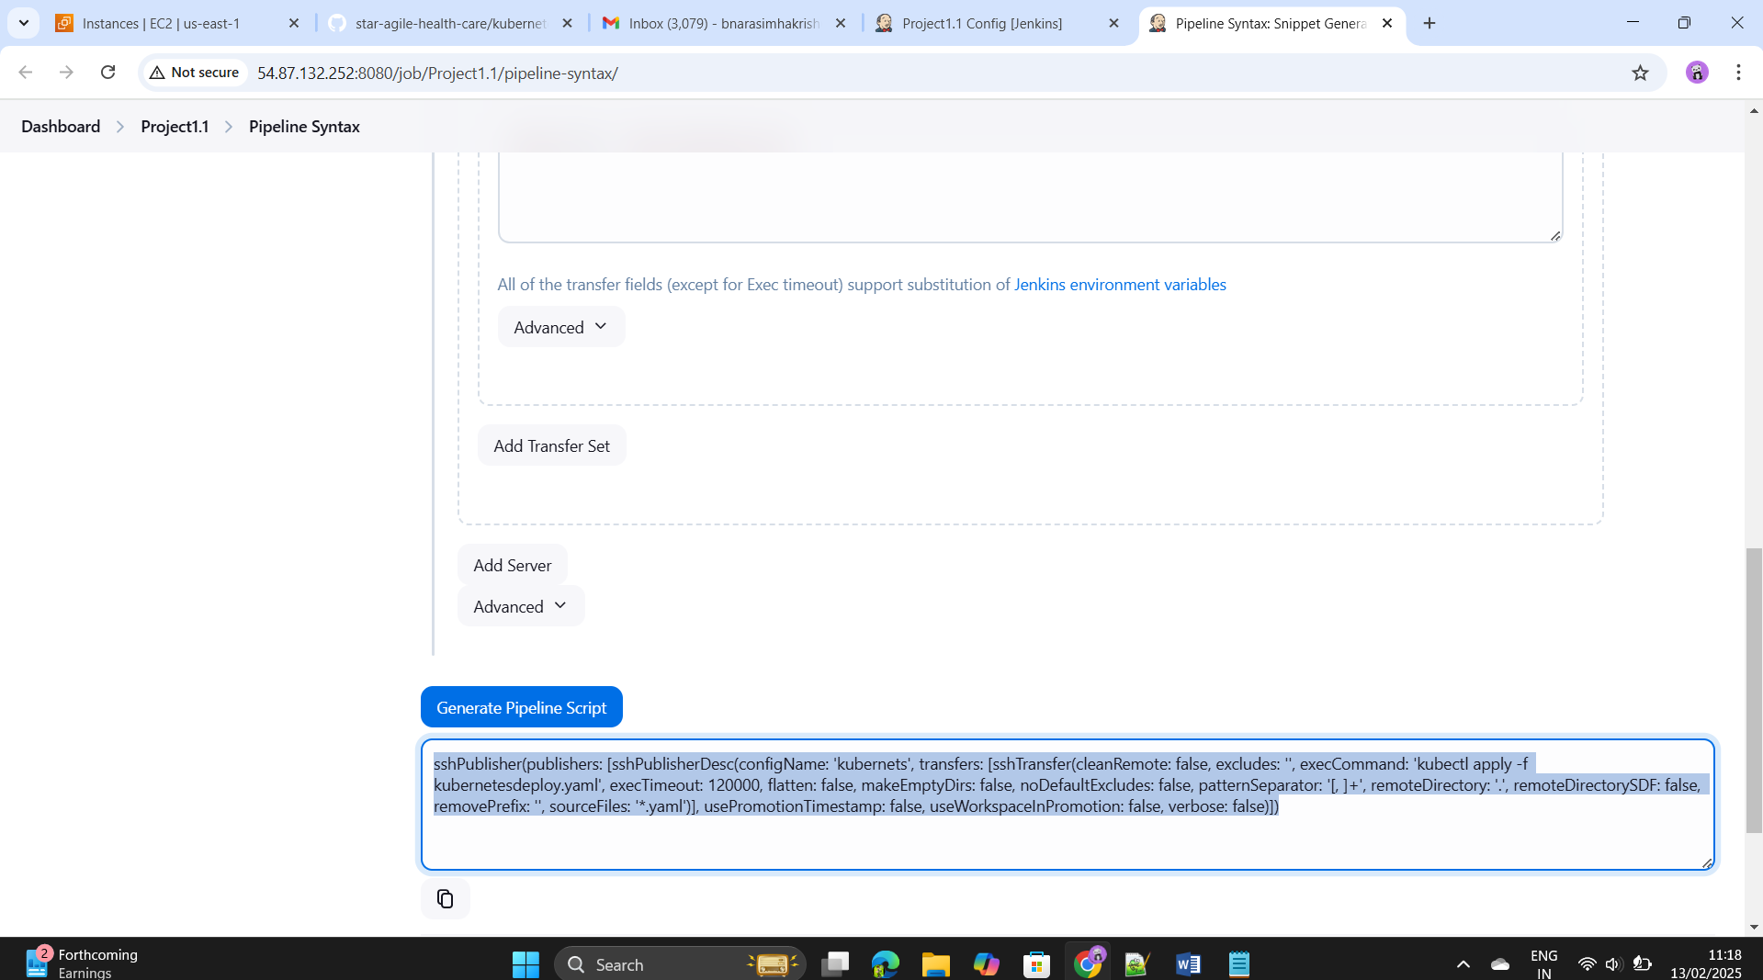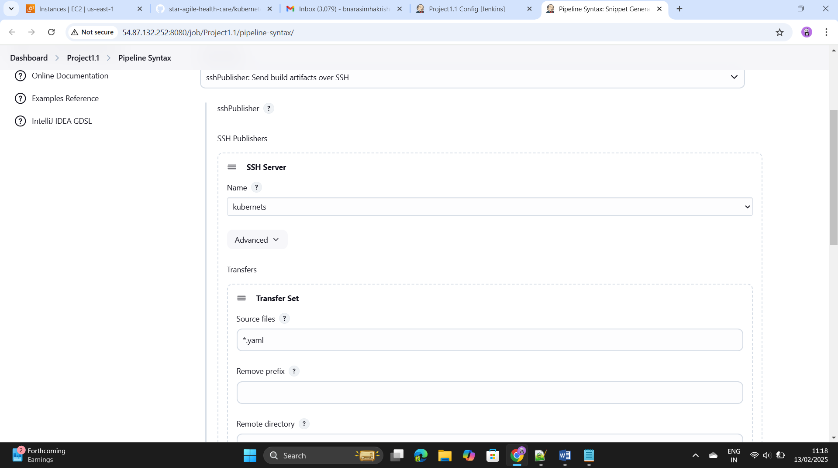

Step71: - Paste in the Deployment step.

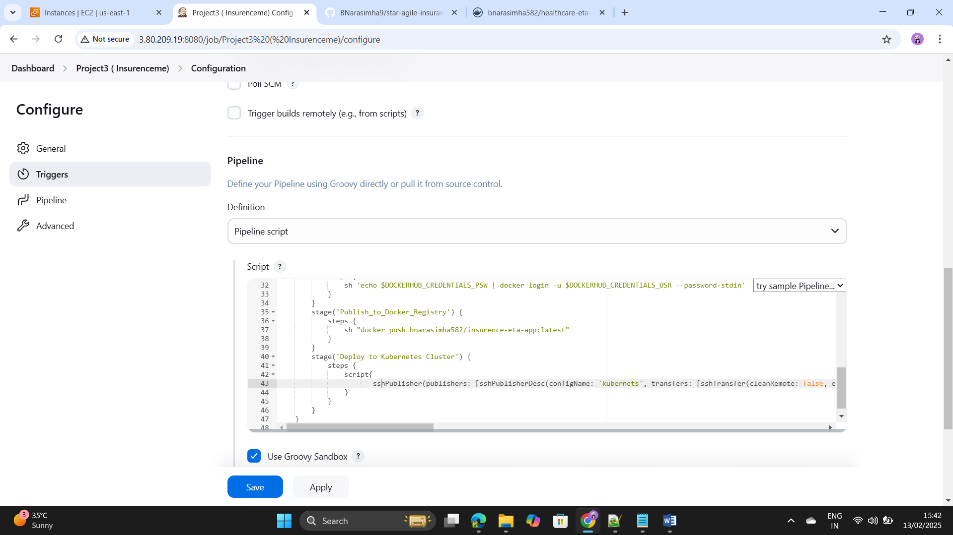

Step72: - add the post build action to this mail and send the status.

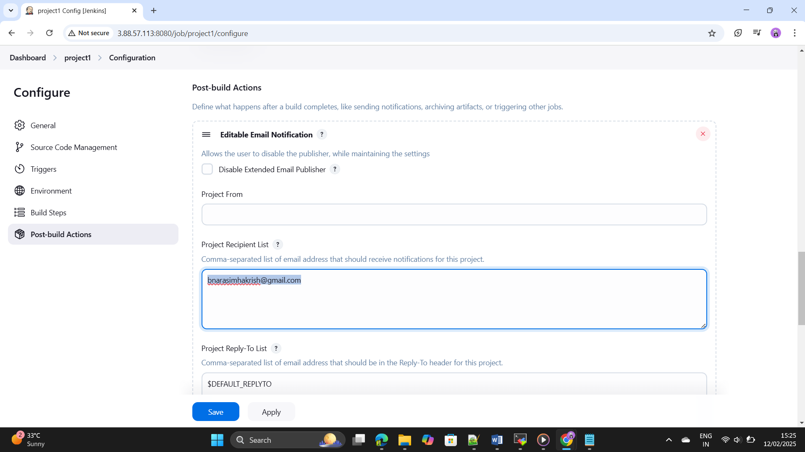

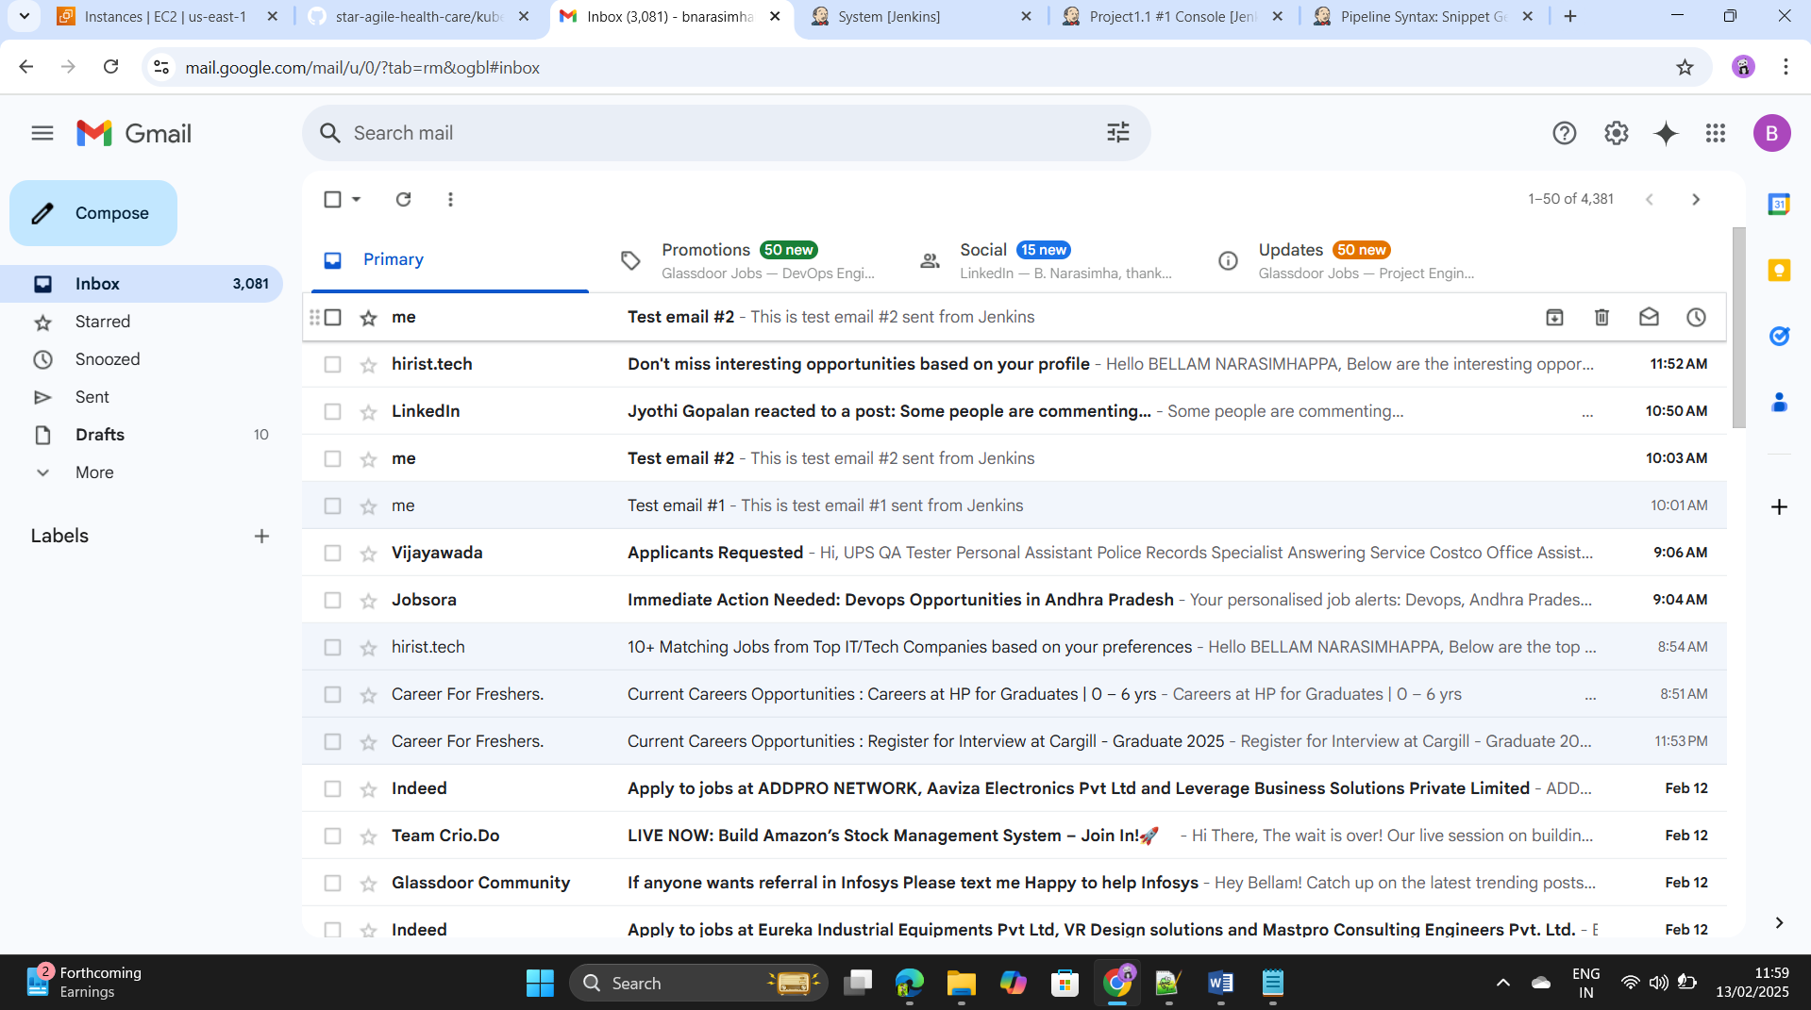

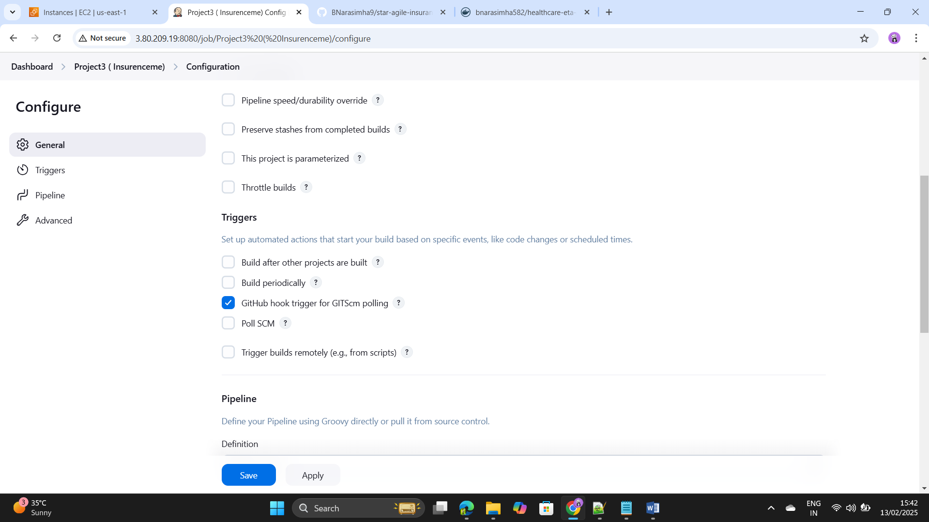Step73: - Go to triggers in the pipeline and add the github hook.

Step74: - Go to the git hub and settings and add the github ++++++-webhook by using Jenkins url.

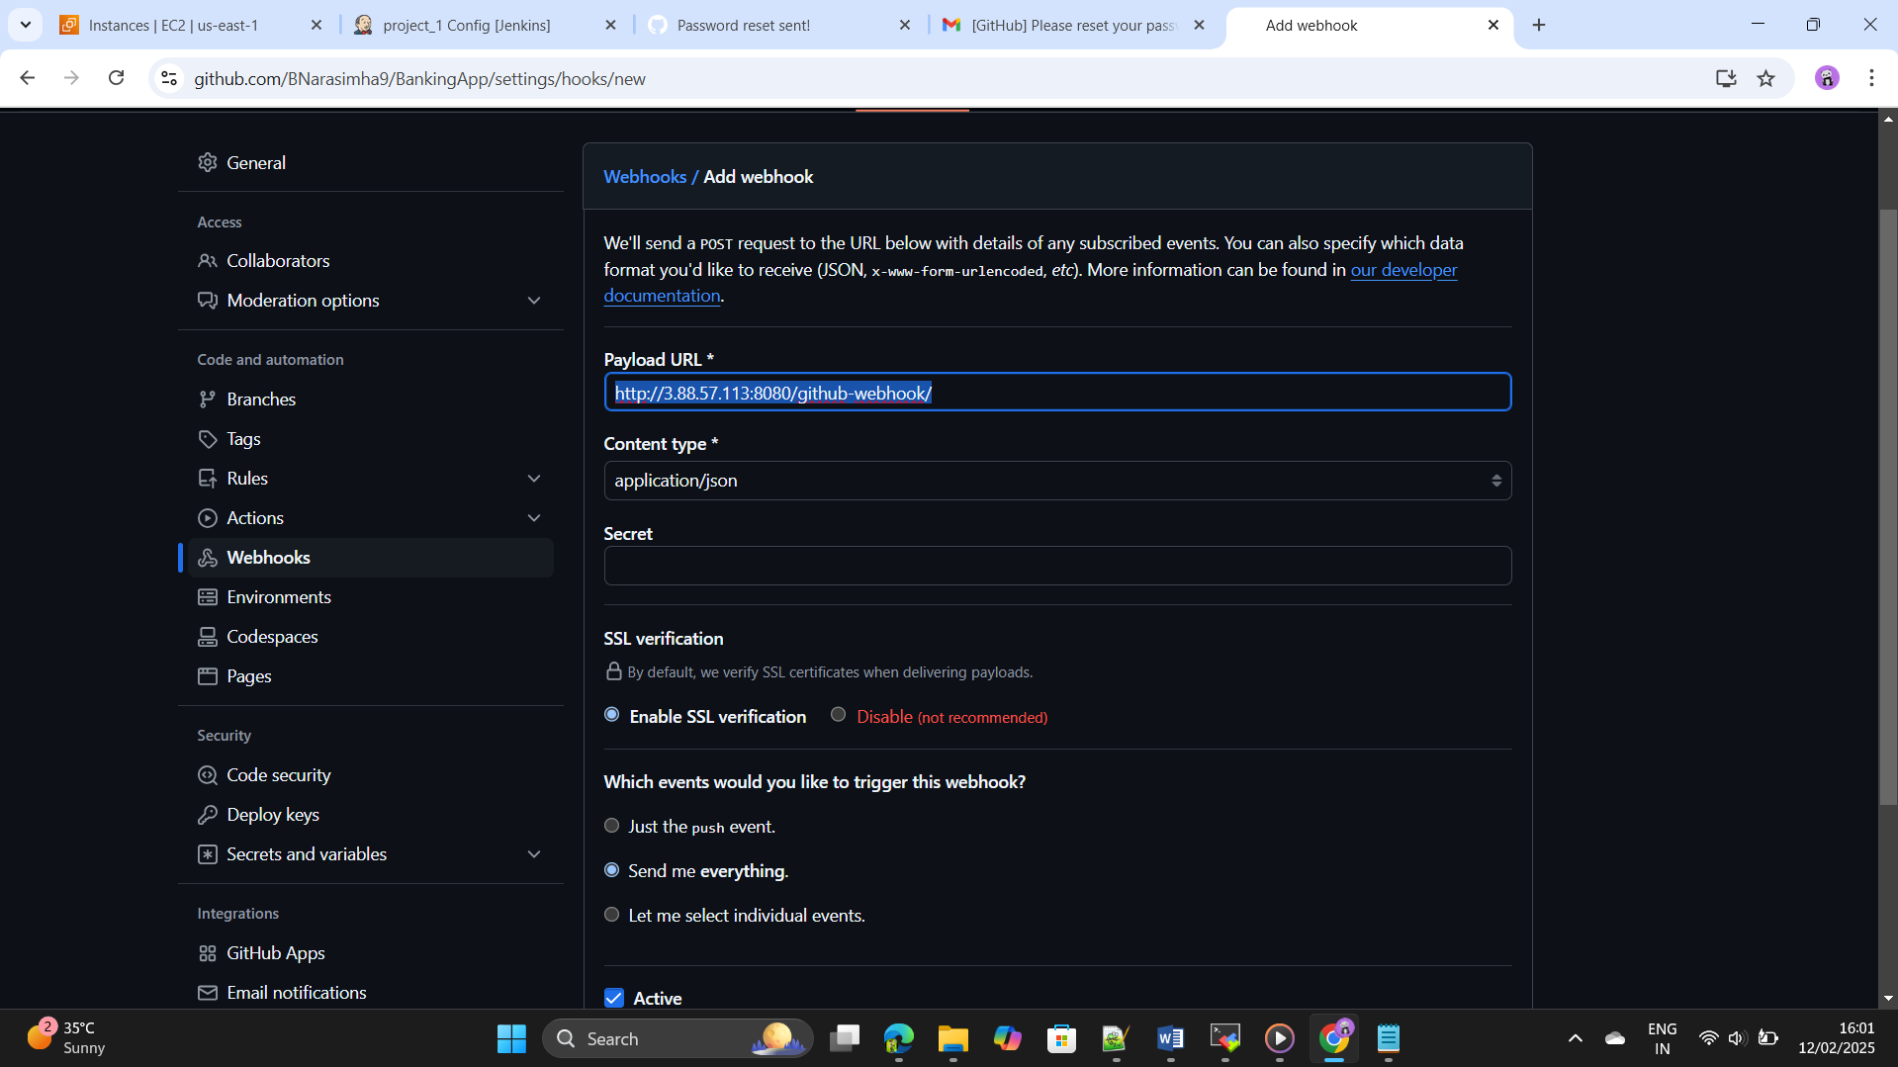

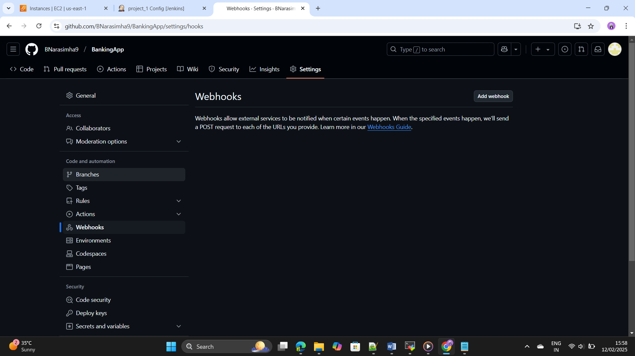Step75: - If any changes are happened in the repository it will ++++++--------------automatically updated in the production server by using github ++++++-webhook.

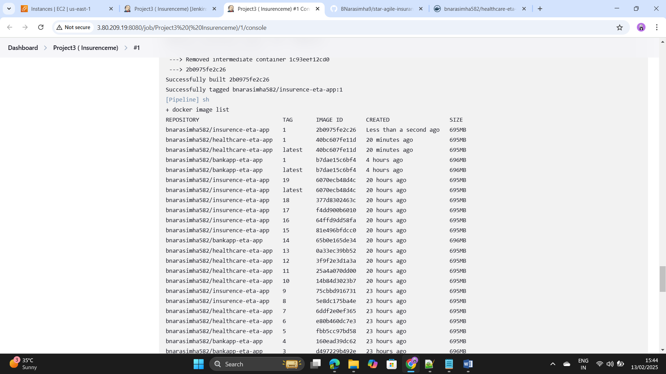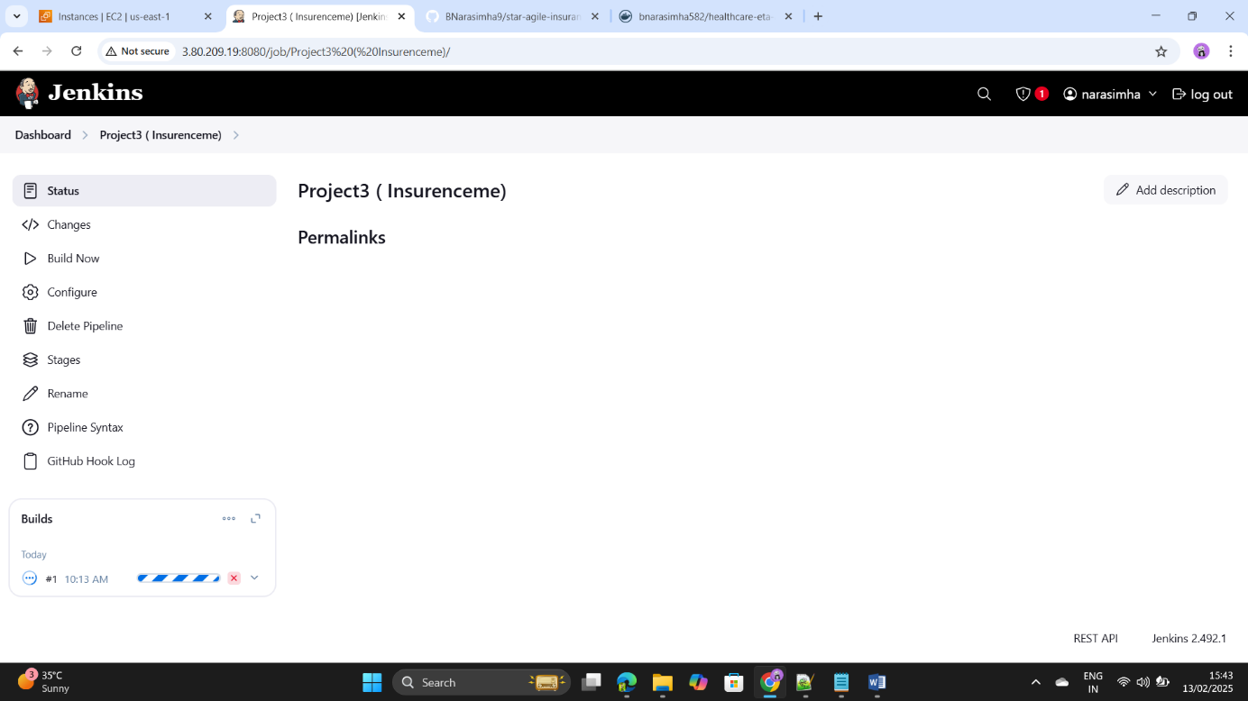Step76: - Save and apply the code click on build now.

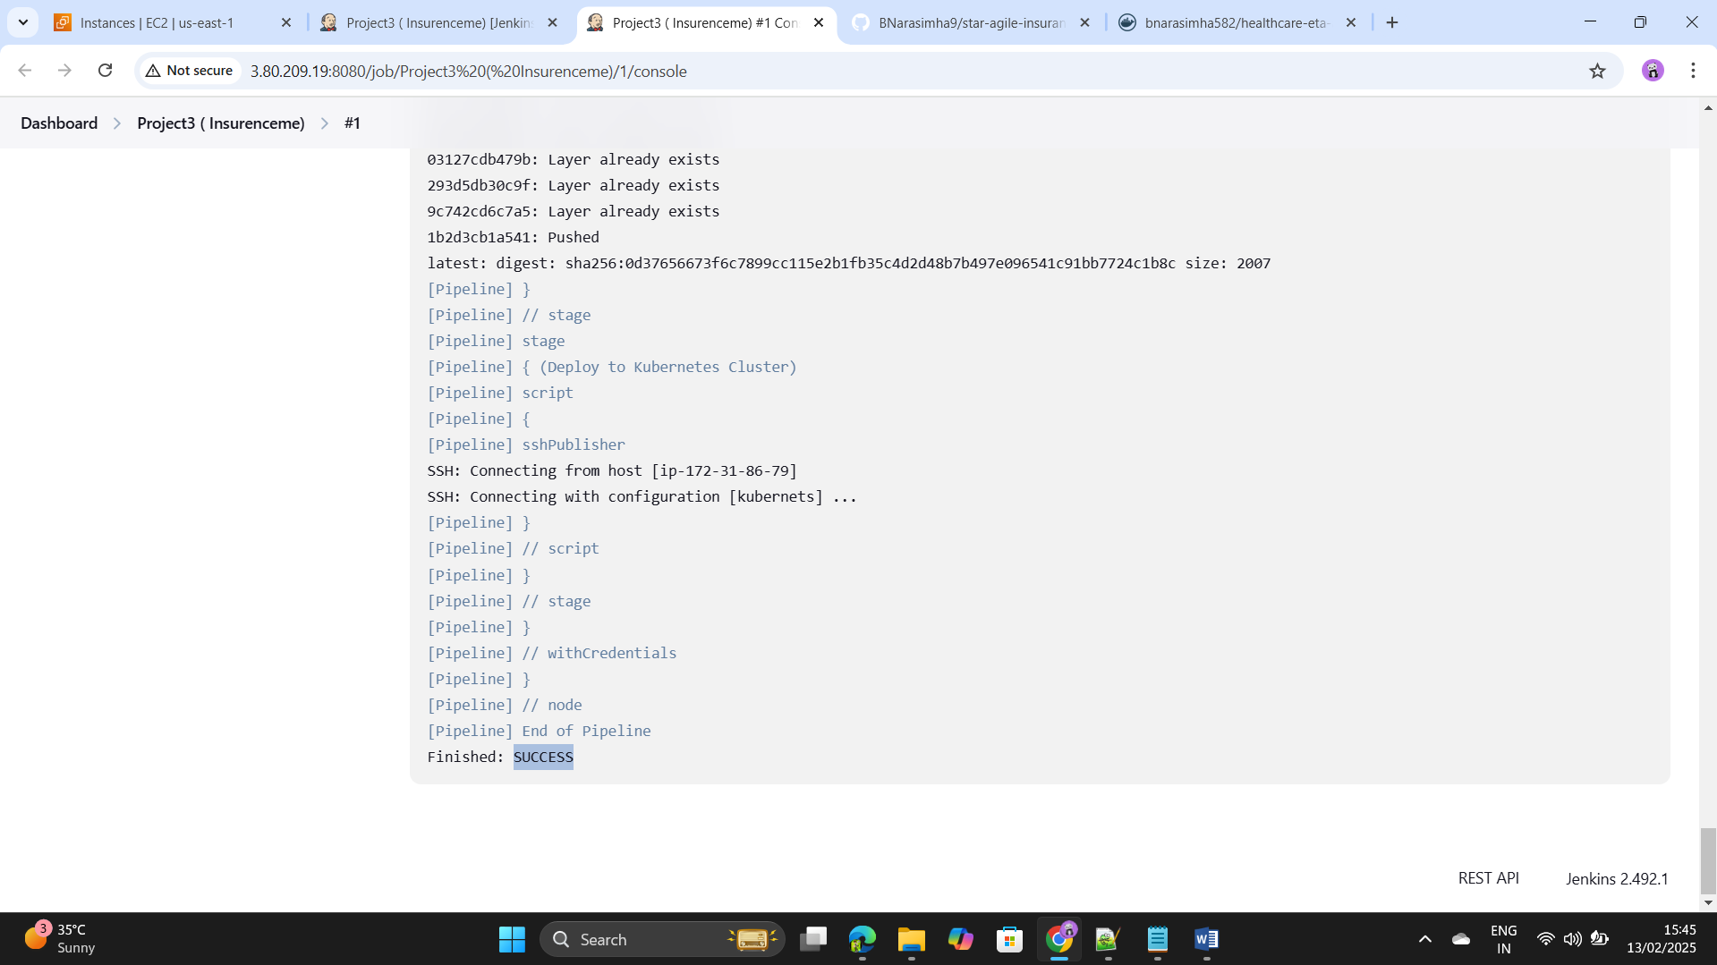

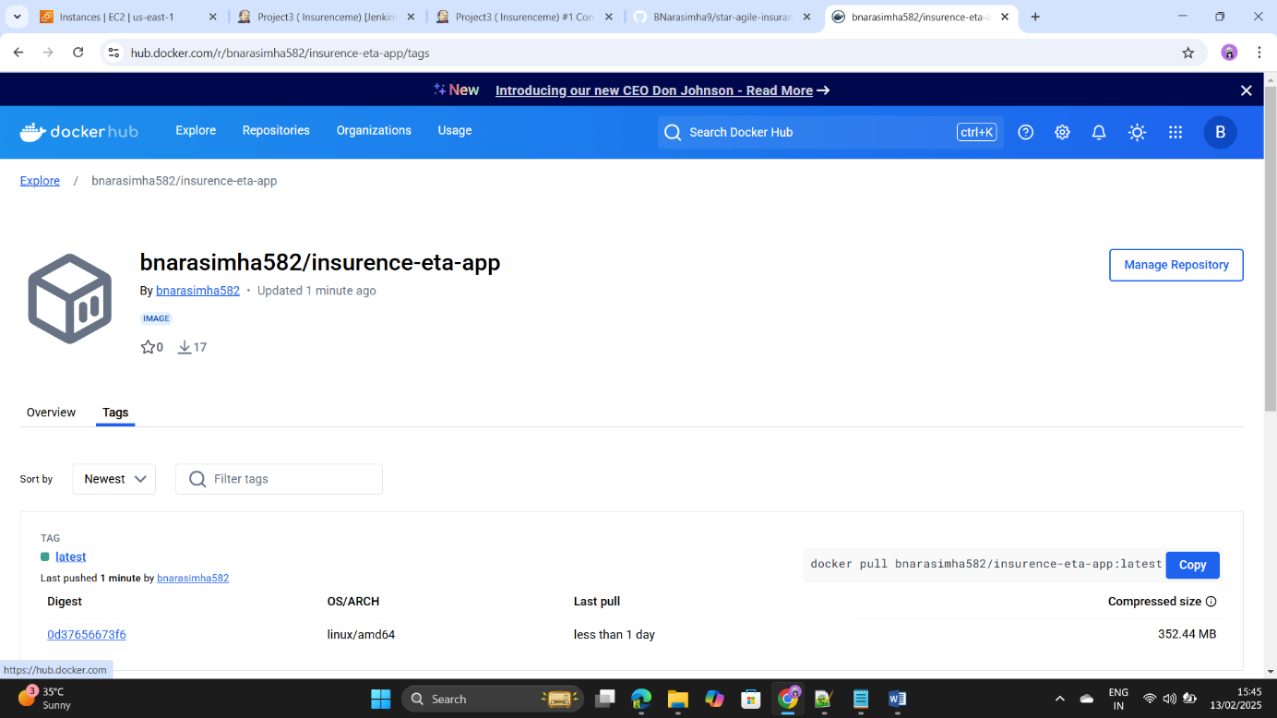Step77: - Go to the docker hub we can see there a repository has ++++++been created as bank-app successfully.

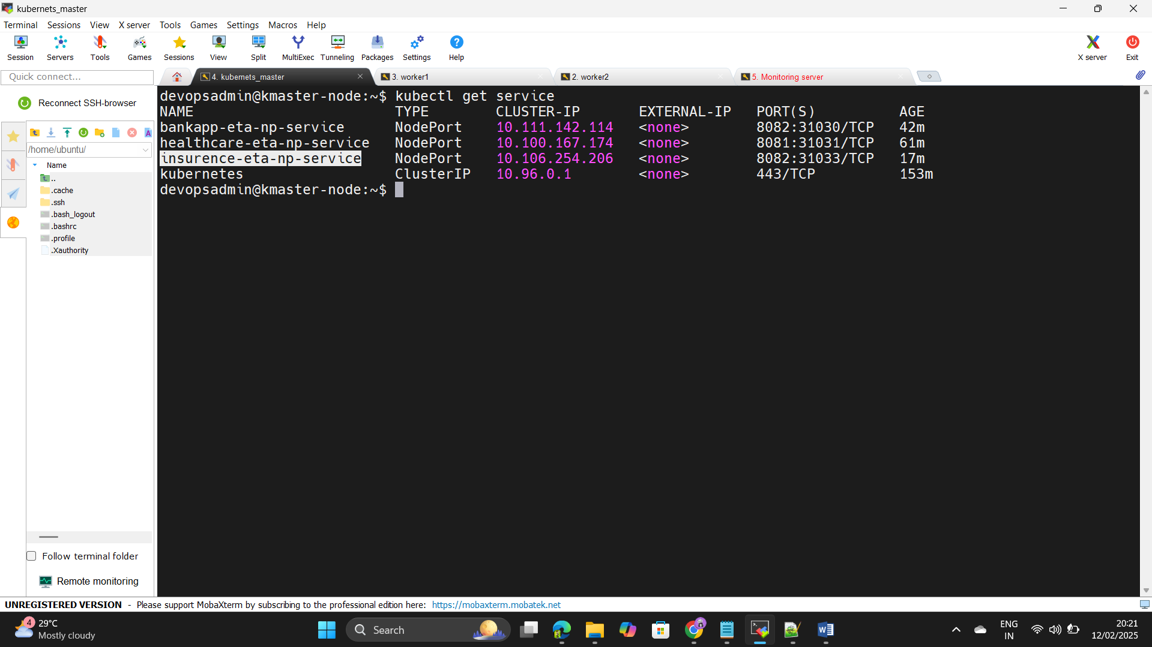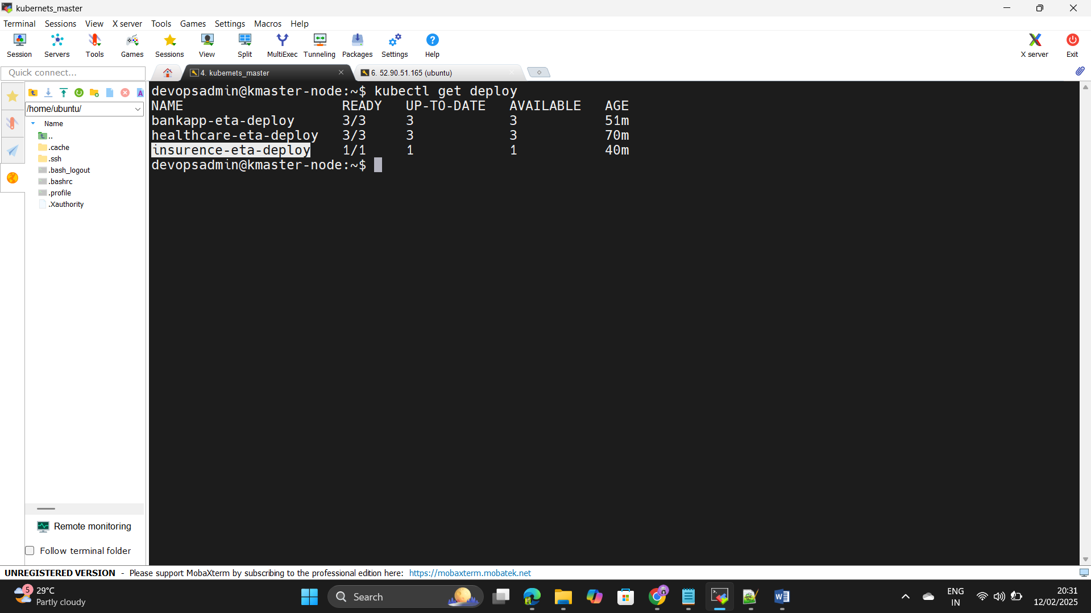Step78: - Go to the kubernets and we can see the pods are deployd ++++++-or not by using kubectl get deploy.

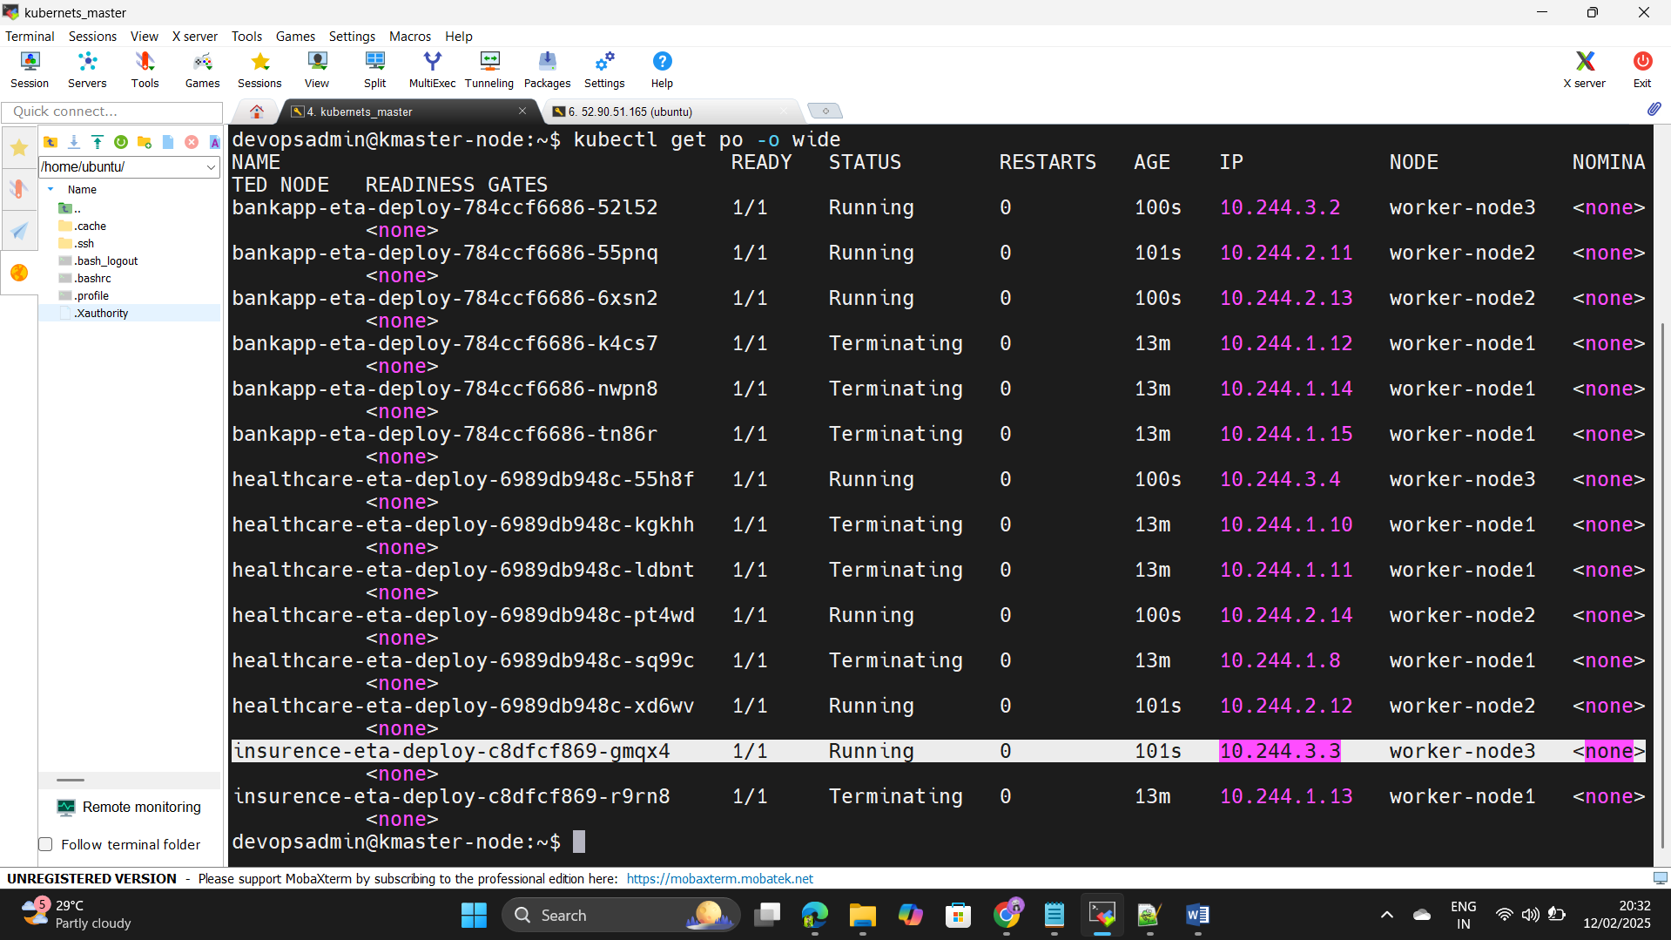

Step79: - Copt the Ip address of the Workernode and paste in the ++++++-browser as a node port as mentioned above.







Step80: - If any deployments are or changes happen in the git hub repository by using github webhook it will automatically trigger the changes and tested and build in the build server and if the build is successful it is pushed to the production server the refence img should be saved in the docker hub , All these things are happen automatically by using CICD pipeline in DevOps as done as successfully.

Step81: - Now we have test the production servers are working ++++++properly or monitor the servers by using Promethus and ++++++Grafana.

Step82: - Then Install the Prometheus in the another ec2 instance or +++++++use the same build server for the monitoring.

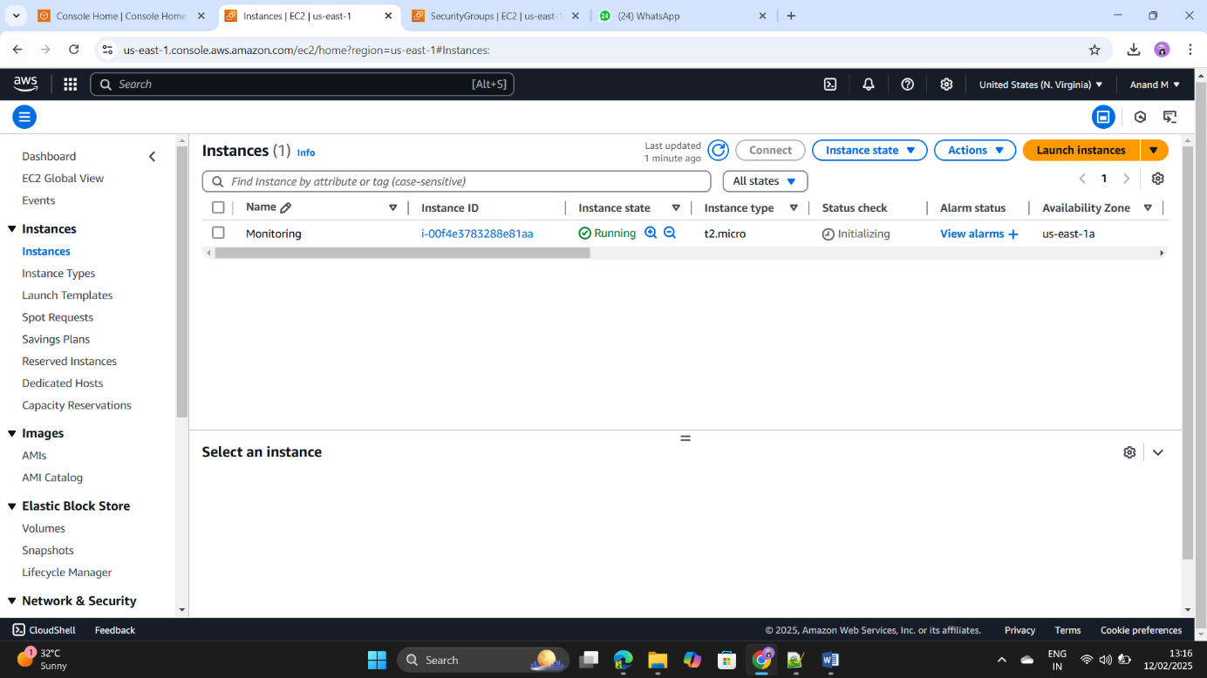

Step83: - Install the by using below

url< <https://prometheus.io/download/>>.

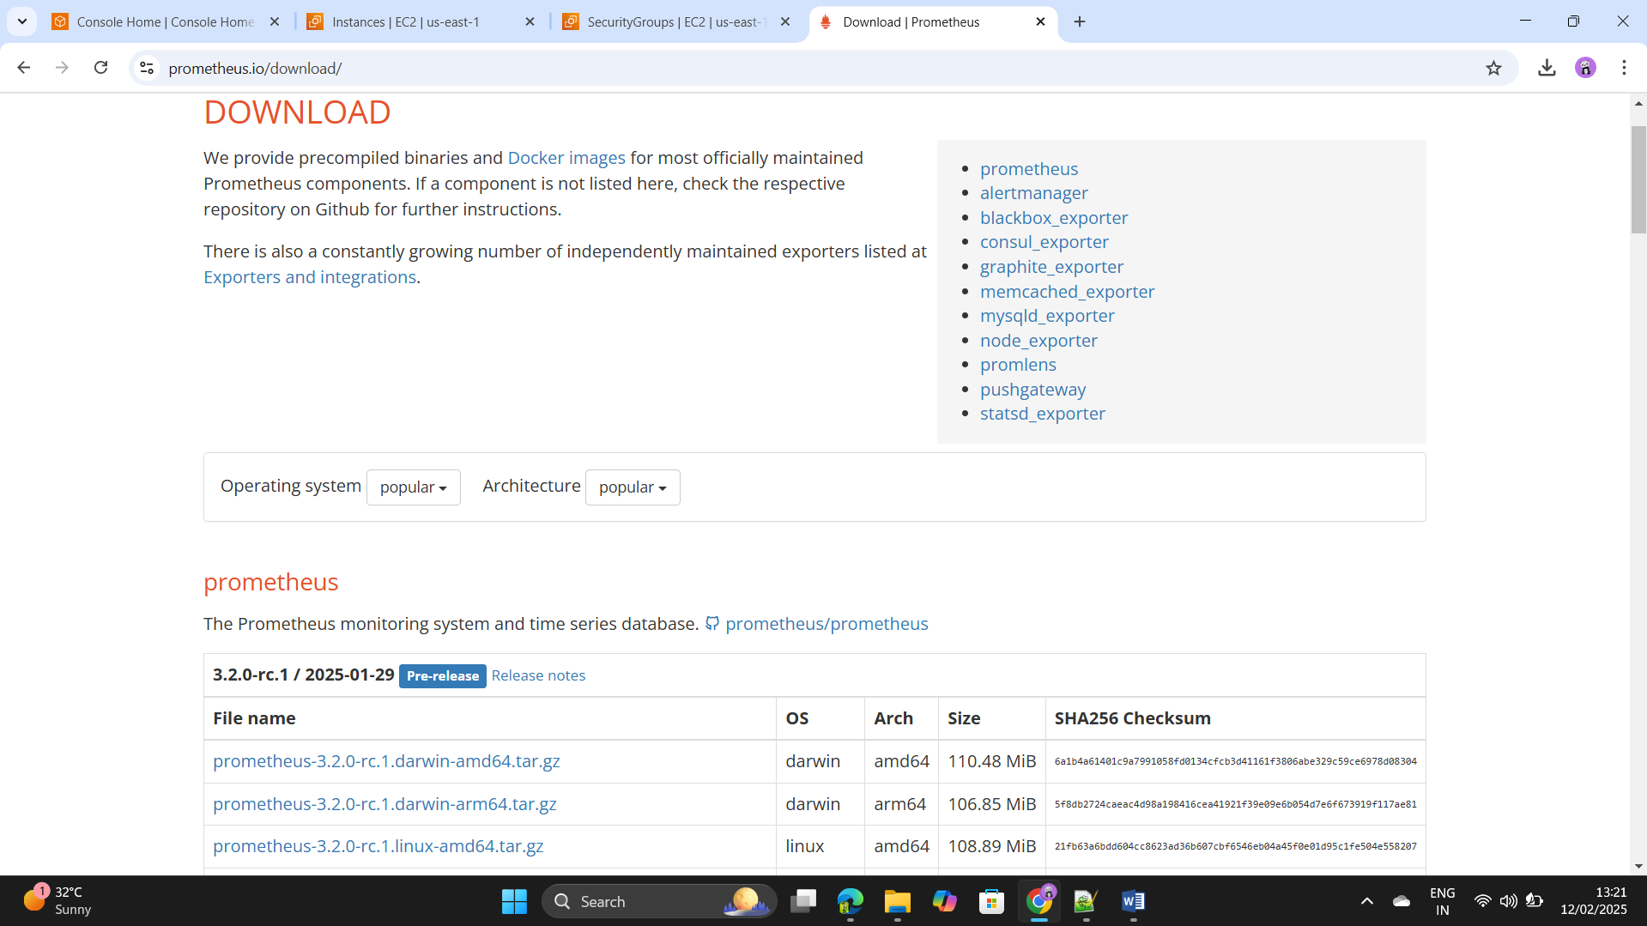

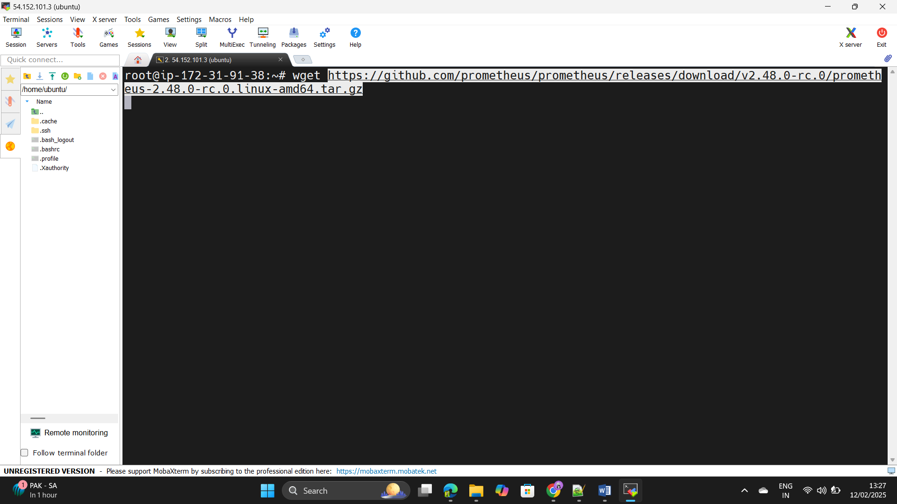Step84: - Copt the link address and paste in the instance as use the +++++++command as – wget.

Step85: - Extract the file by using the tar –zxvf <file name>.

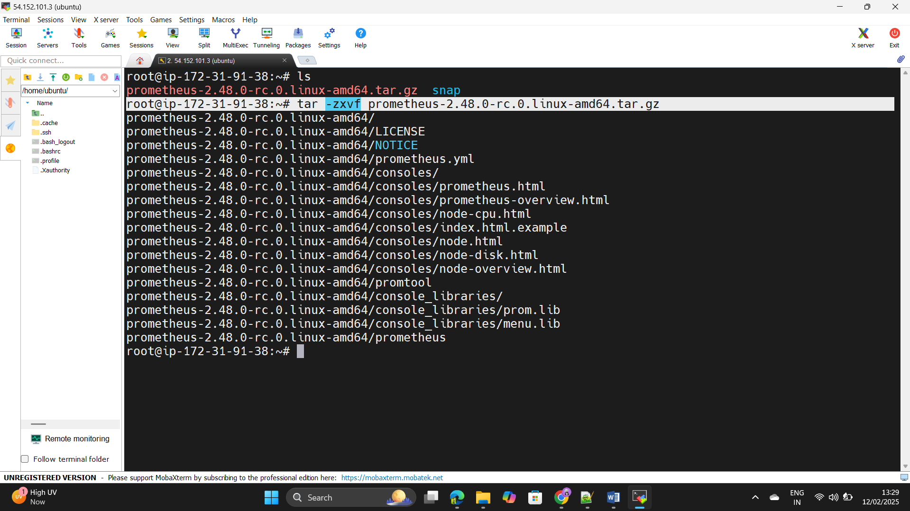

Step86: - Create the file for the Prometheus activation as a service +++++++use the command as –

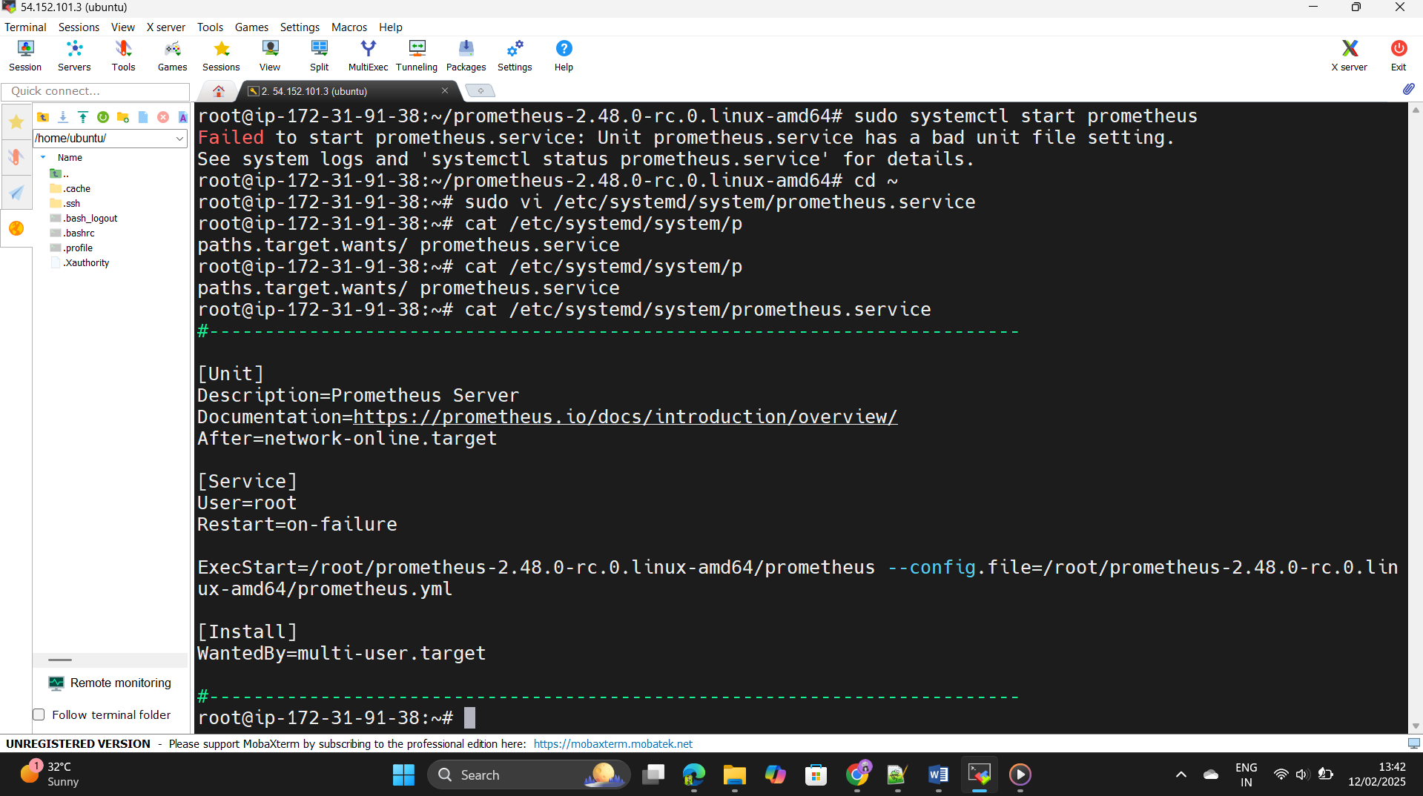+++++++ vi /etc/systemd/system/prometheus.service.

Step87: - Add the unit file in that and run the Prometheus by using ++++++port number 9090.

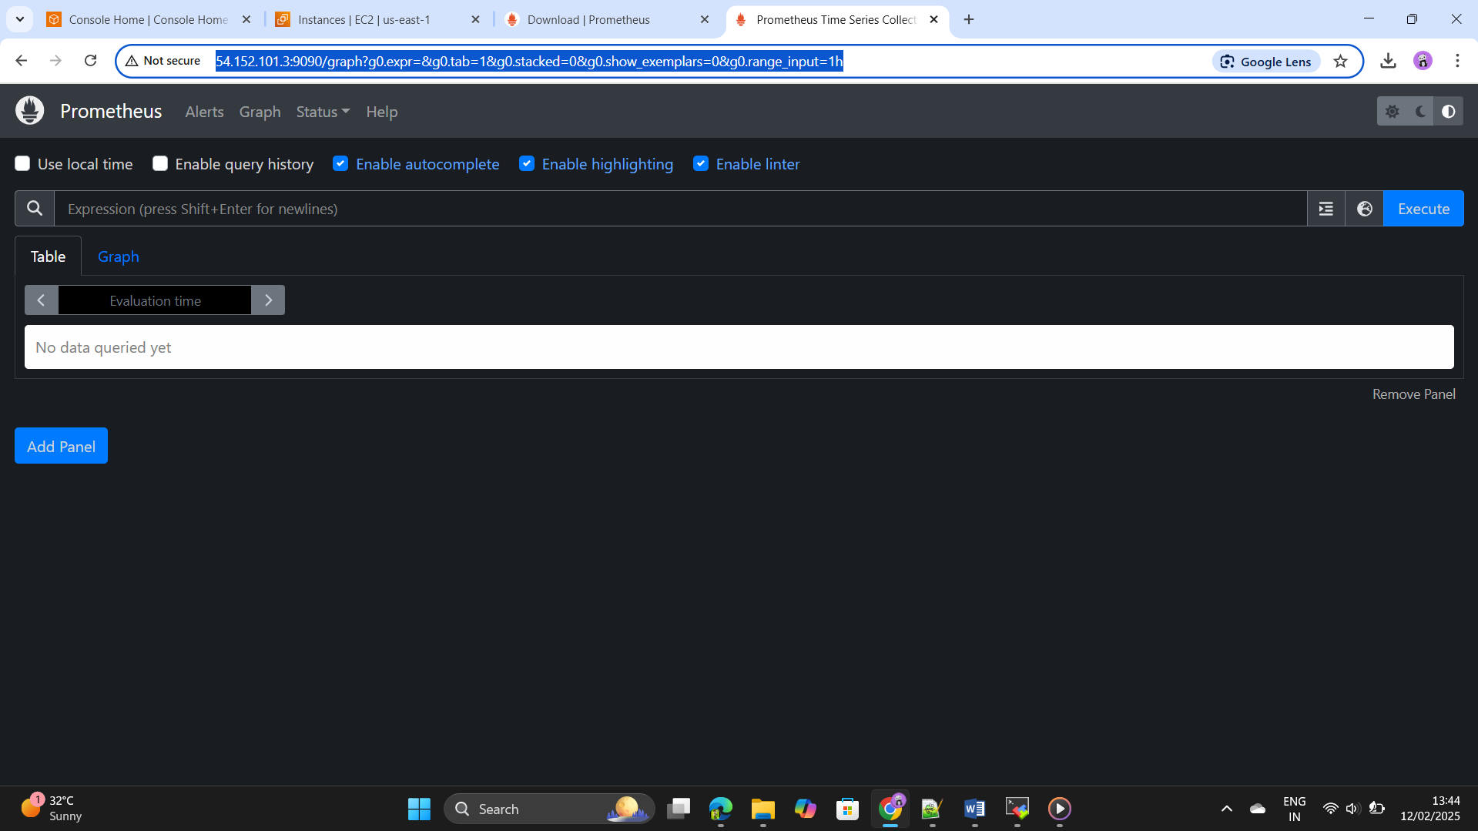

Step88: - Install grafana in the same instance,click on the below url

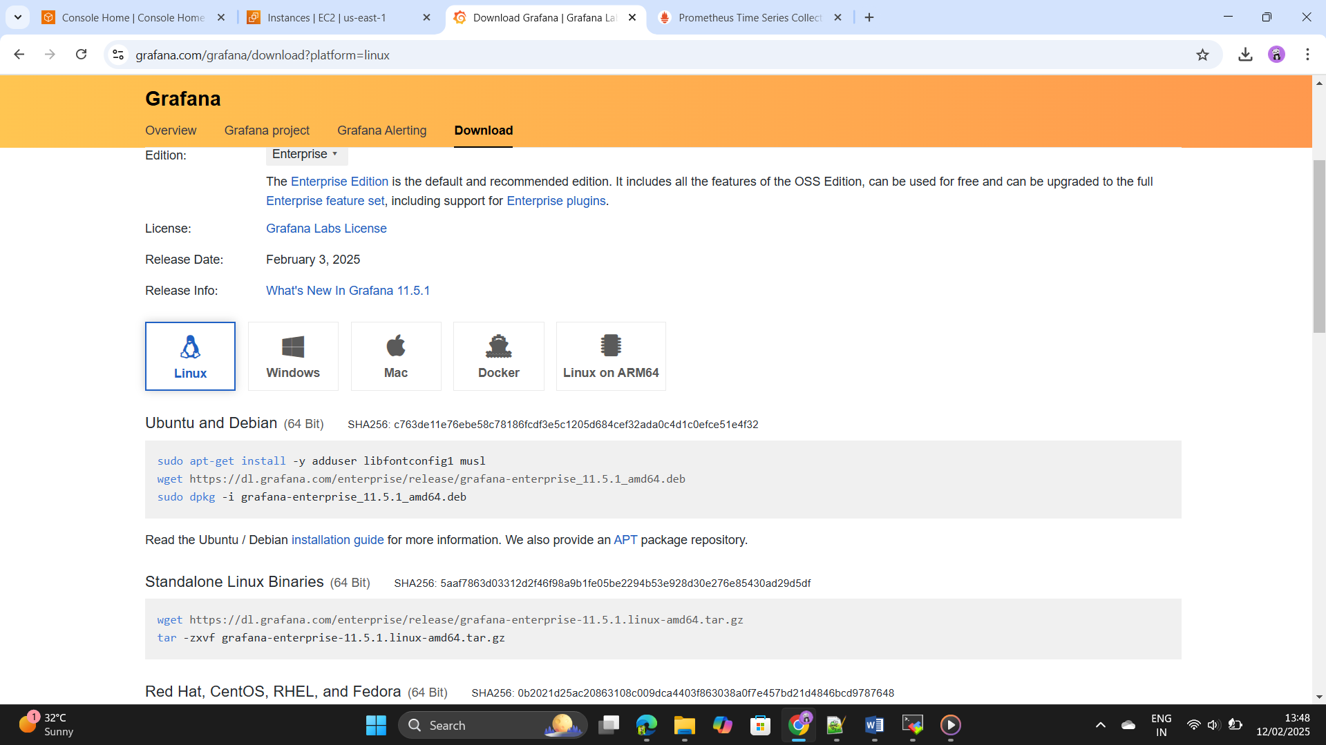 <https://grafana.com/grafana/download>.

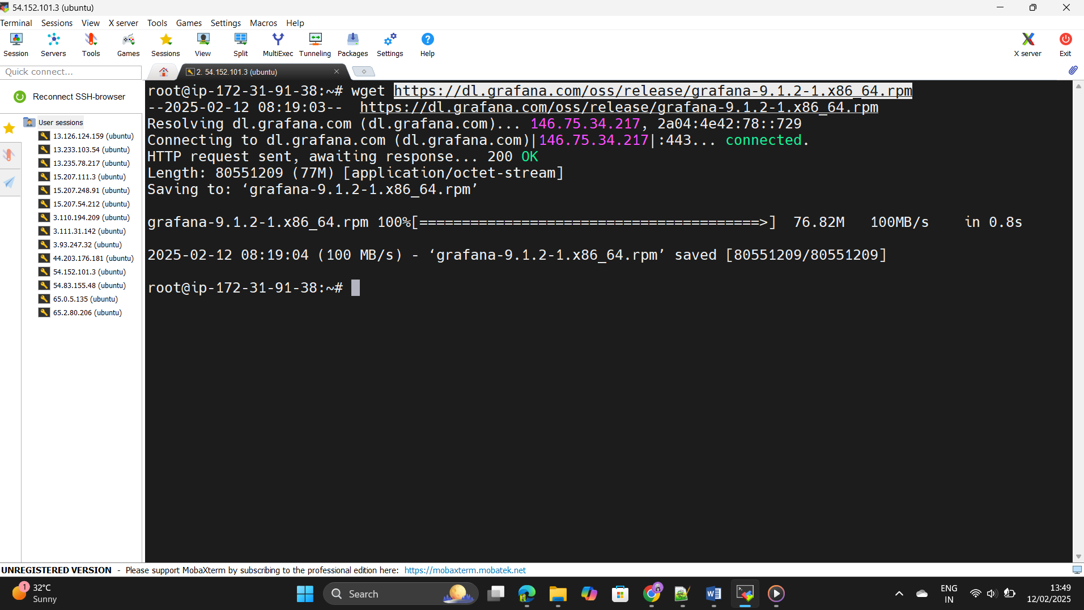Step89: - Install the grafana by using command as wget<url>.

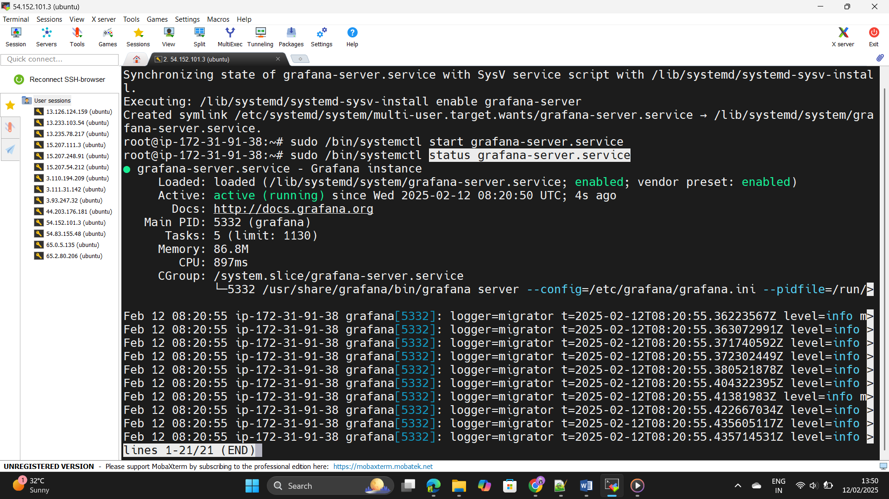

Step90: - Copy paste the Public Ip address of the instance as port ++++++-number is 3000 we can see grafana is started.

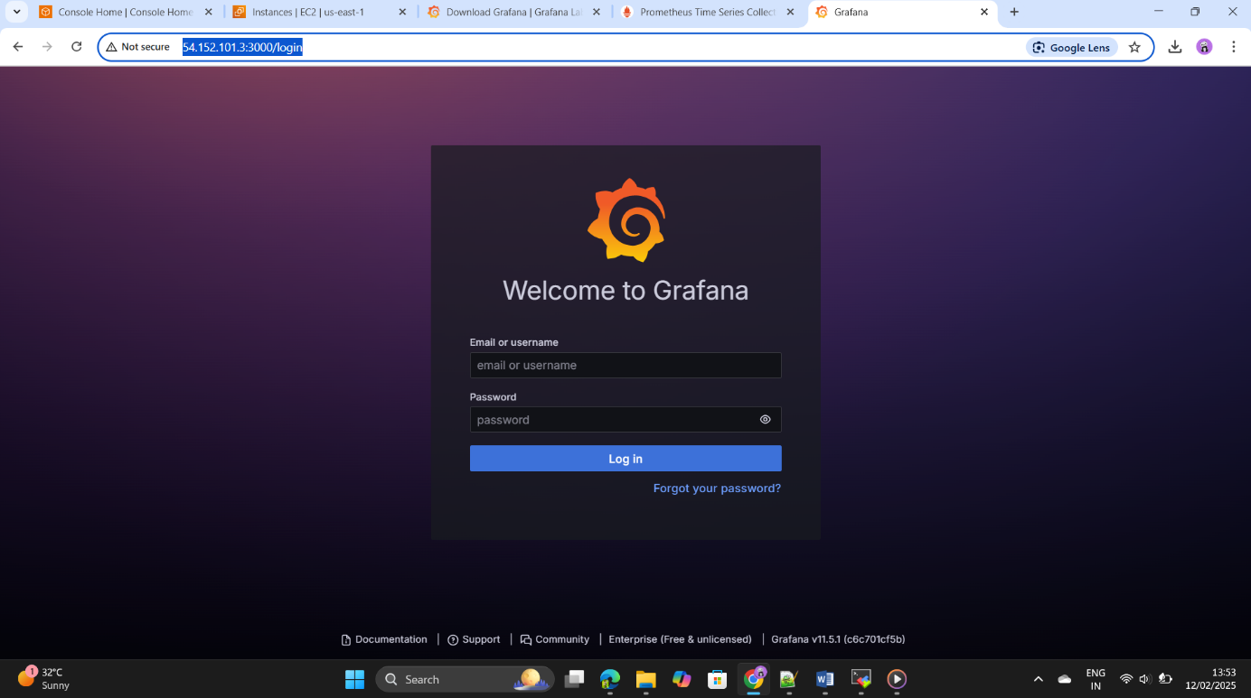

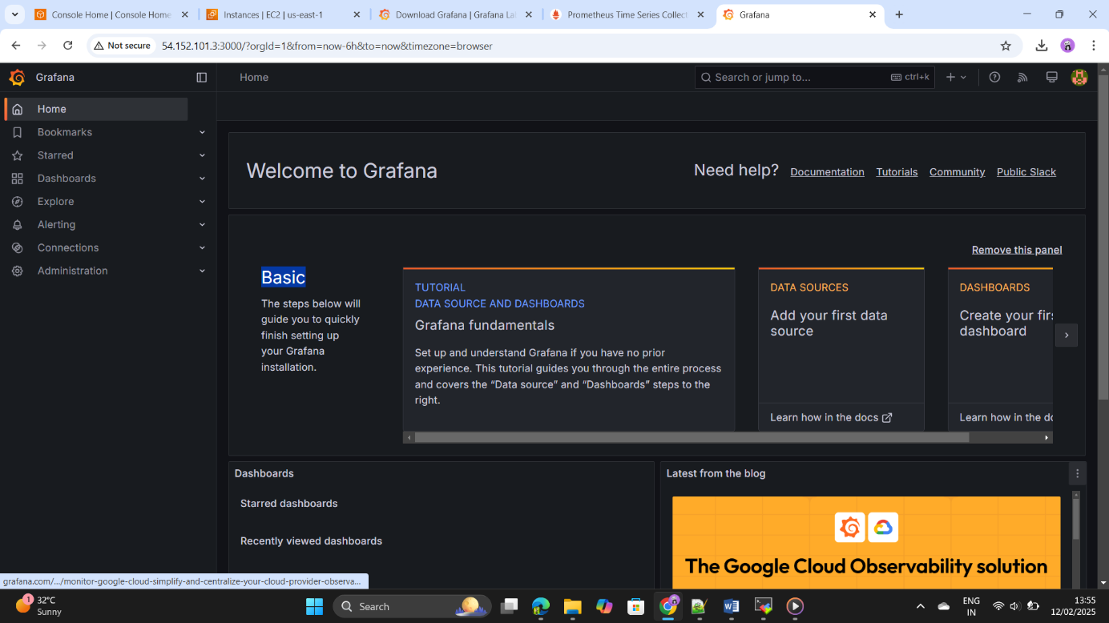Step91: - Integrate both Prometheus in the grafana click on the data ++++++-source and add the Prometheus url and save it.

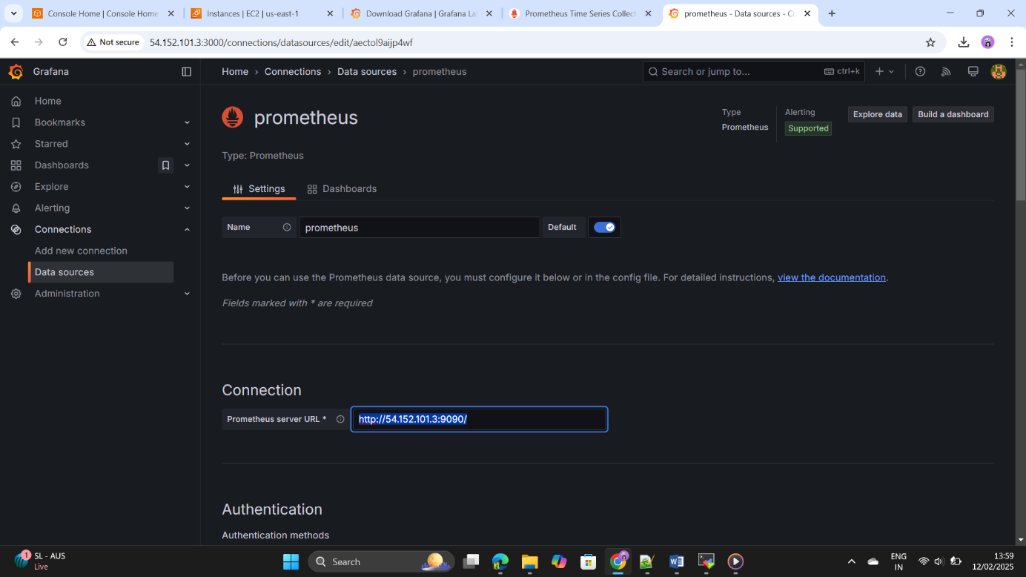

Step92: - Prometheus and Grafana integration is done successfully.

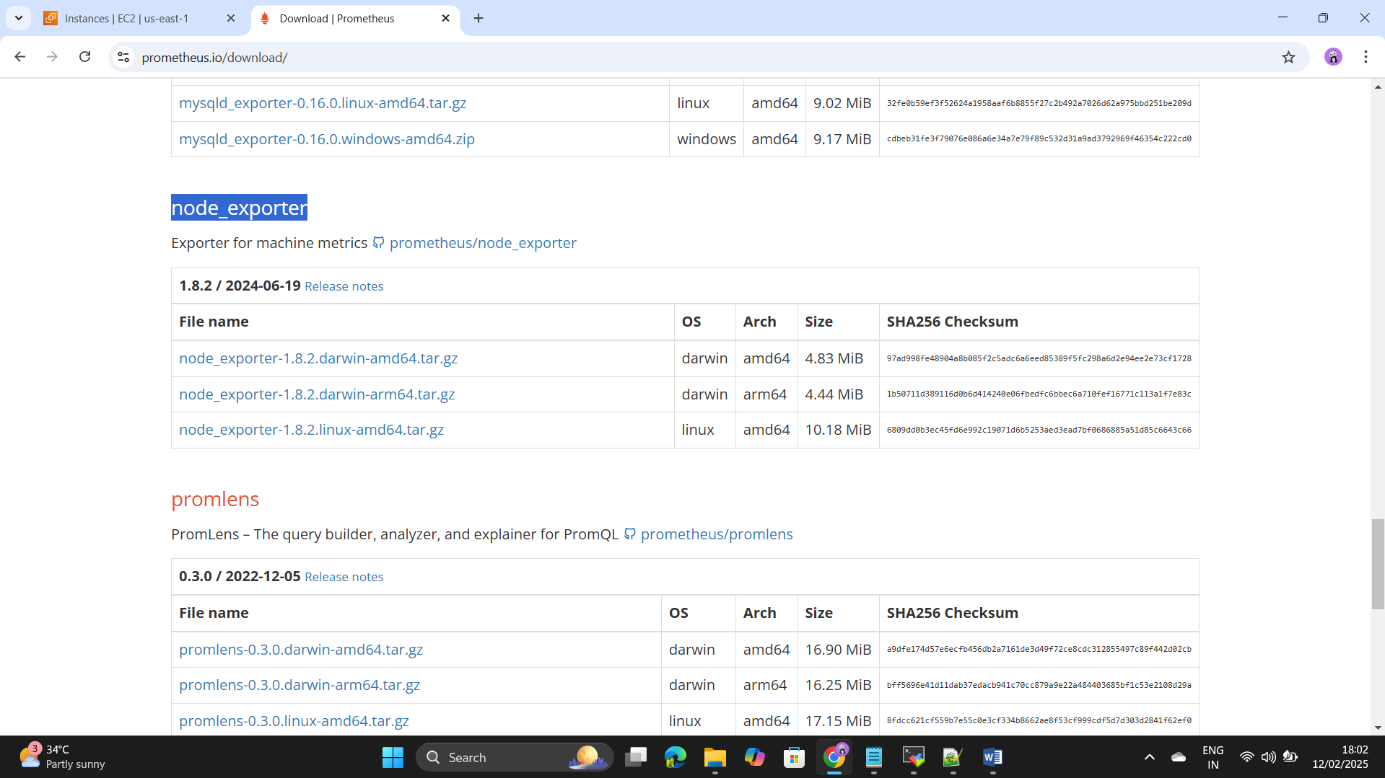Step93: - ADD the target servers in the Prometheus for the monitoring.

Step94: - Add the link in the production servers as kubernets ++++++Workernodes by using wget command& extract the file by ++++++using tar command.

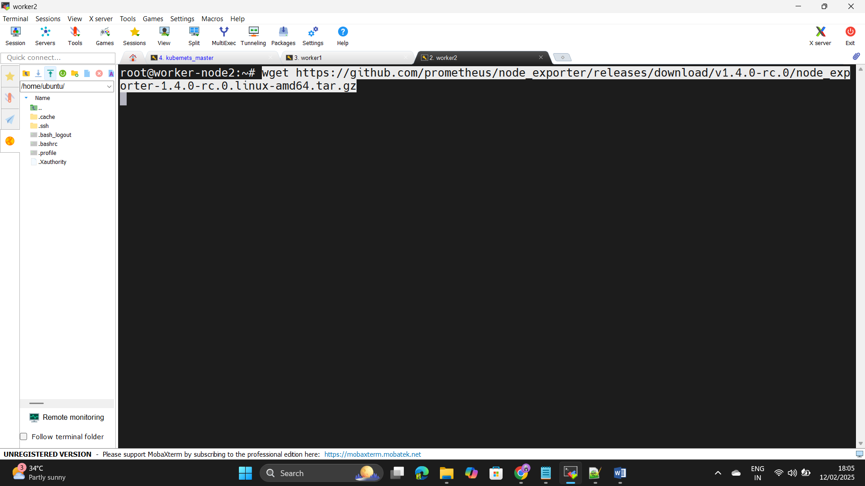

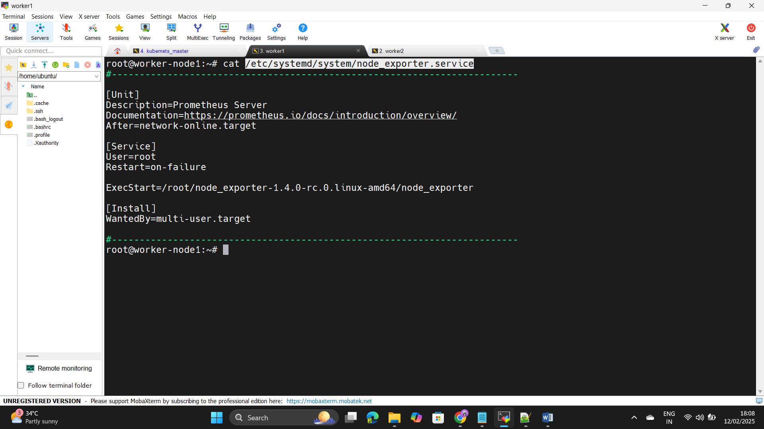Step95: - Edit the following file and add the service file in that and ++++++save it.

Step96: - Go to the monitoring server and go to the directory

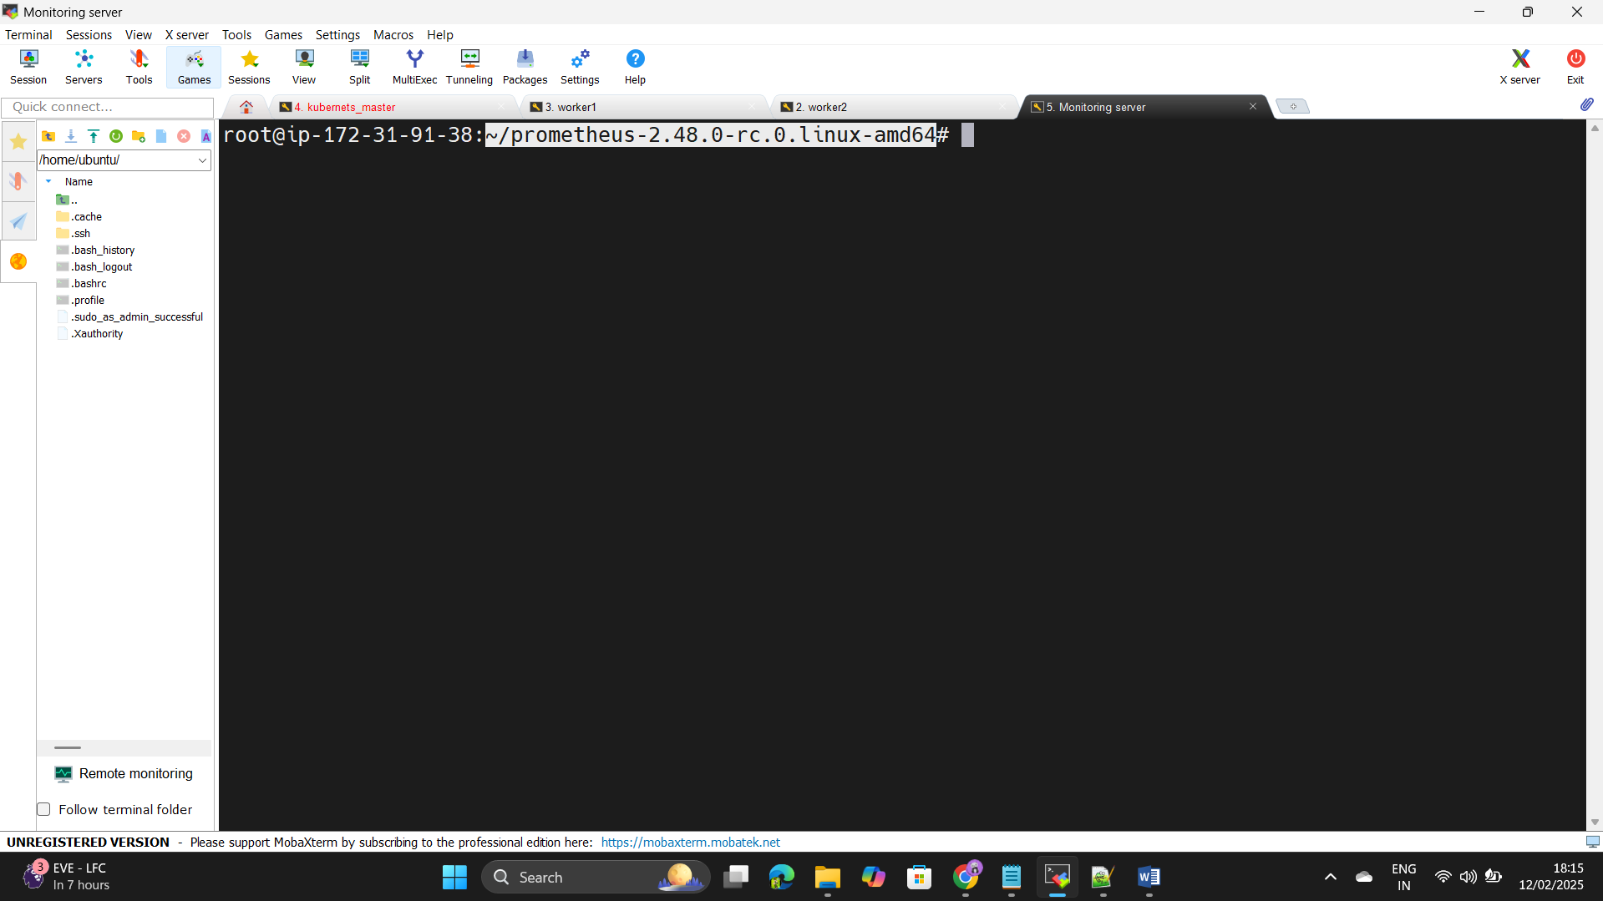cd /root/prometheus-2.38.0.linux-amd64.

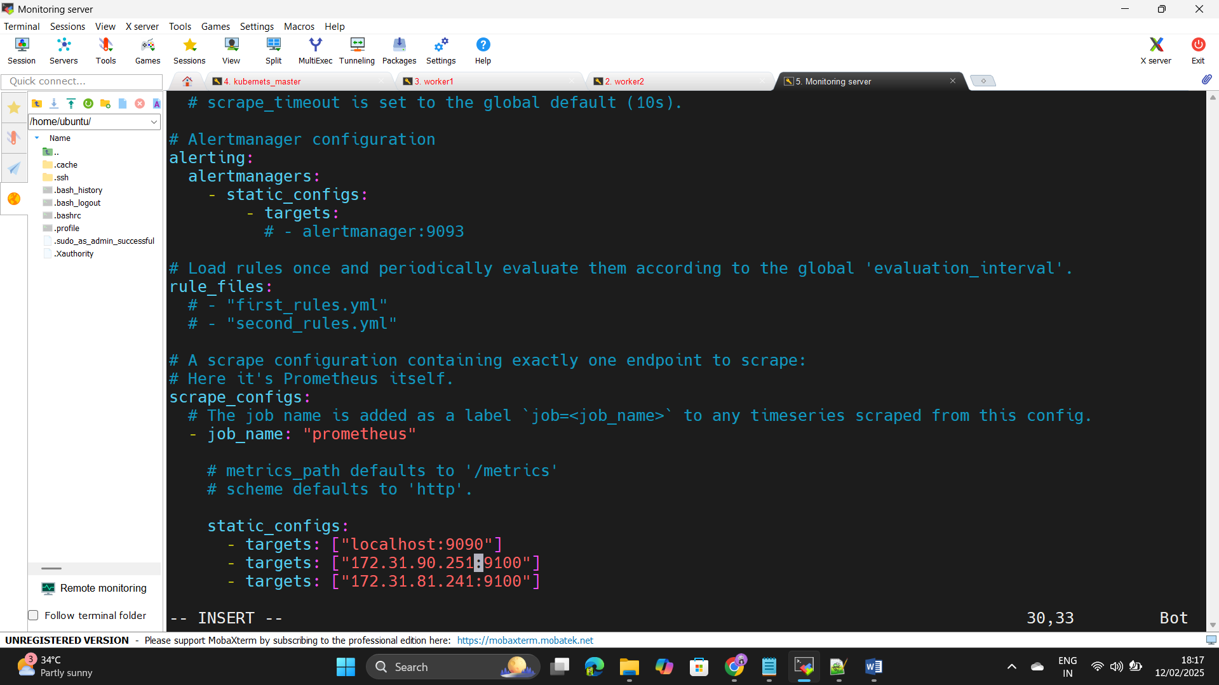Step97: - Edit the vi prometheus.yml this file and add the private ip ++++++-address of the 2 target servers and save it.

Step98: - copy paste the Target server ip address with port as 9100.

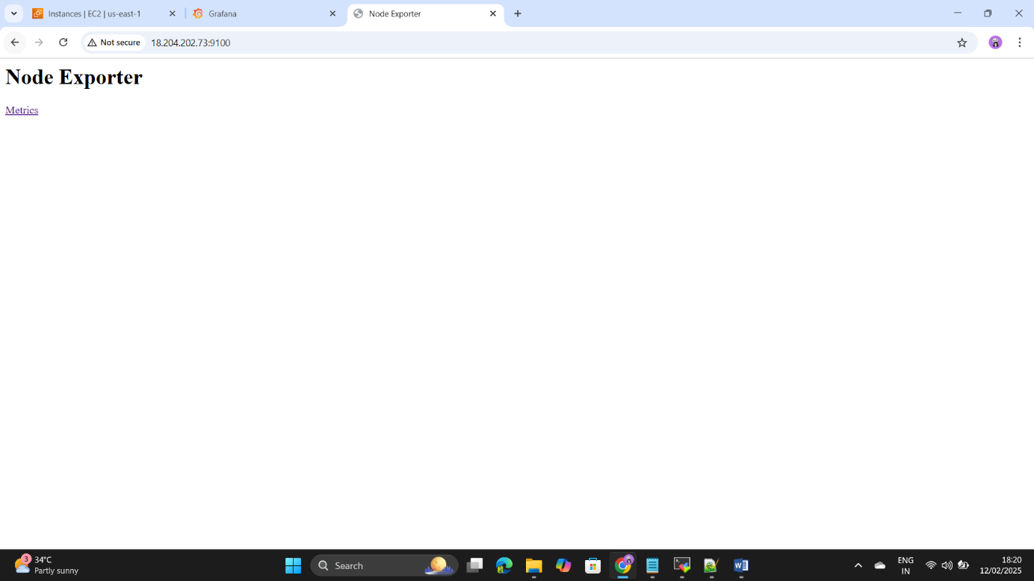

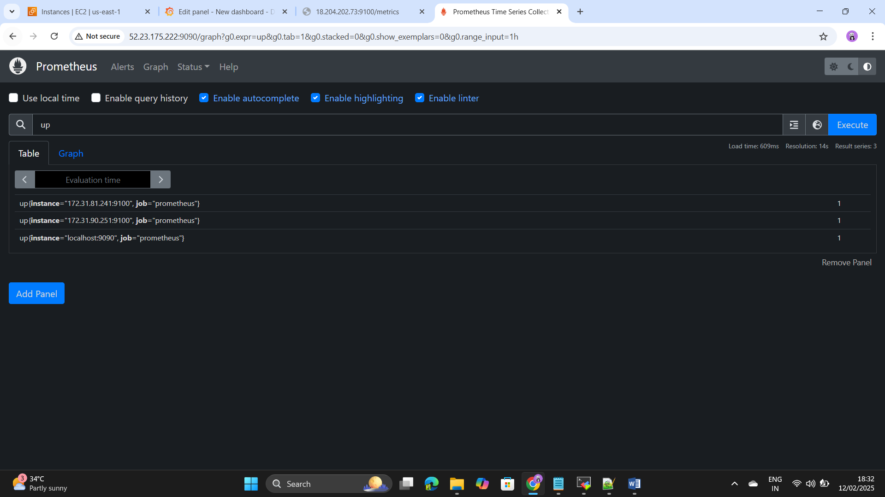Step99: - We can see the target servers in the Prometheus.

Step100: - Go to the grafana and add this code < 100 - (avg by (instance) (rate(node_cpu_seconds_total{mode="idle"}[5m])) * 100)> for the CPU utilization.

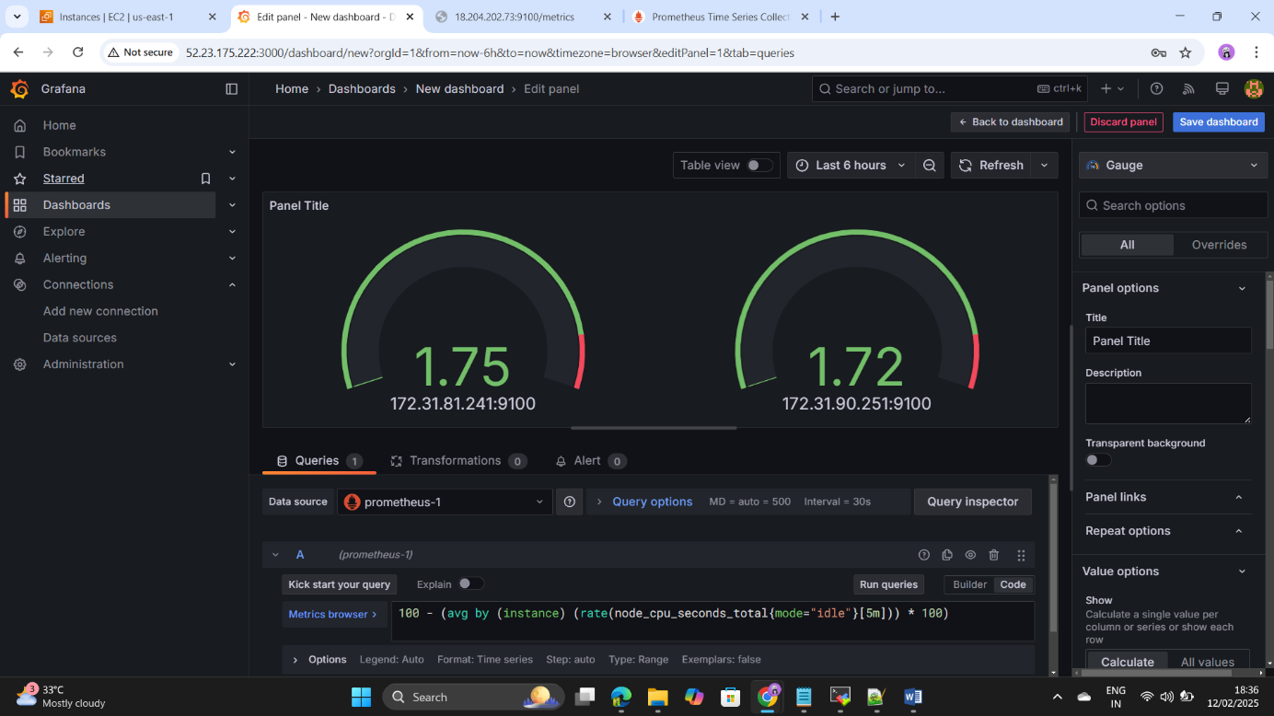

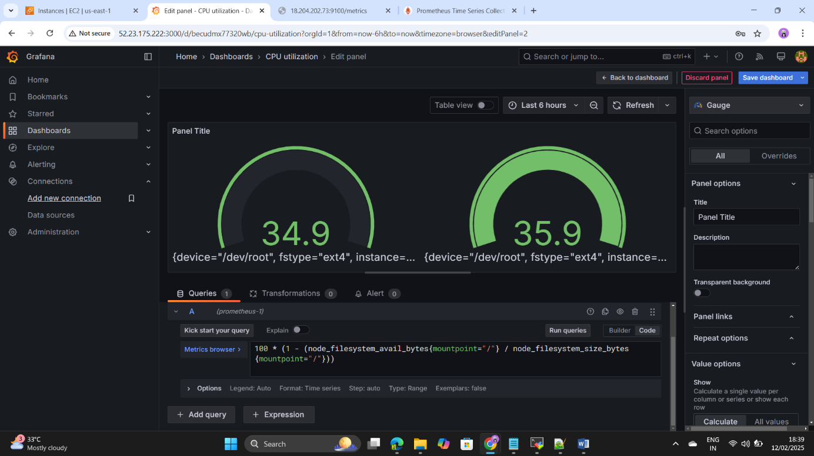Step101: - Add the below code for the disk space utilization< 100 * (1 - (node_filesystem_avail_bytes{mountpoint="/"} / node_filesystem_size_bytes{mountpoint="/"}))>.

Step102: - Add the below code for the Total available memory.

100 - (avg by (instance) (rate(node_cpu_seconds_total{mode="idle"}[5m])) * 100)

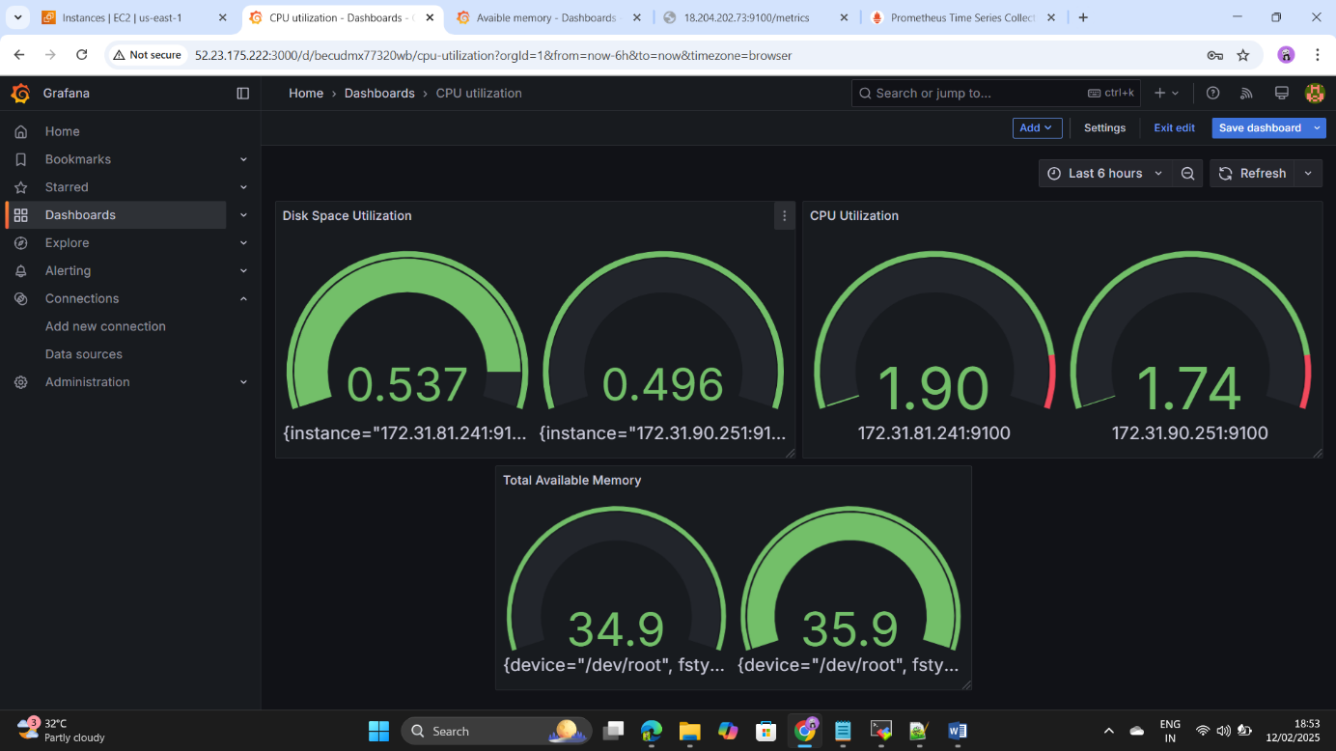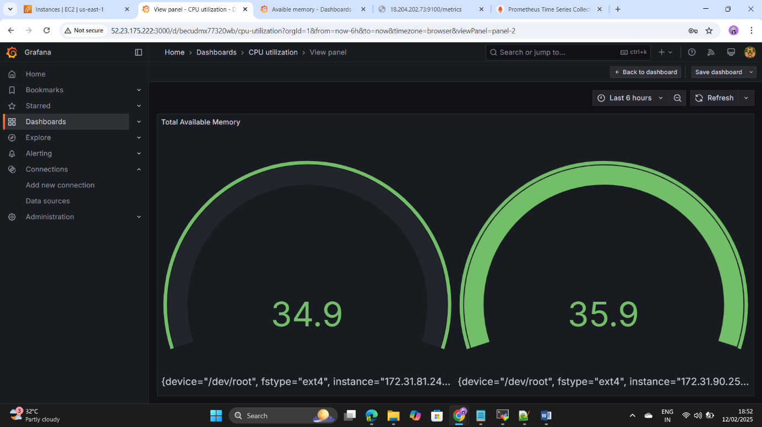

Step103:- Click on Refresh the dashboard we can see the

1.Disk Space utilization

2.CPU Utilization

3. Total Availble Memory

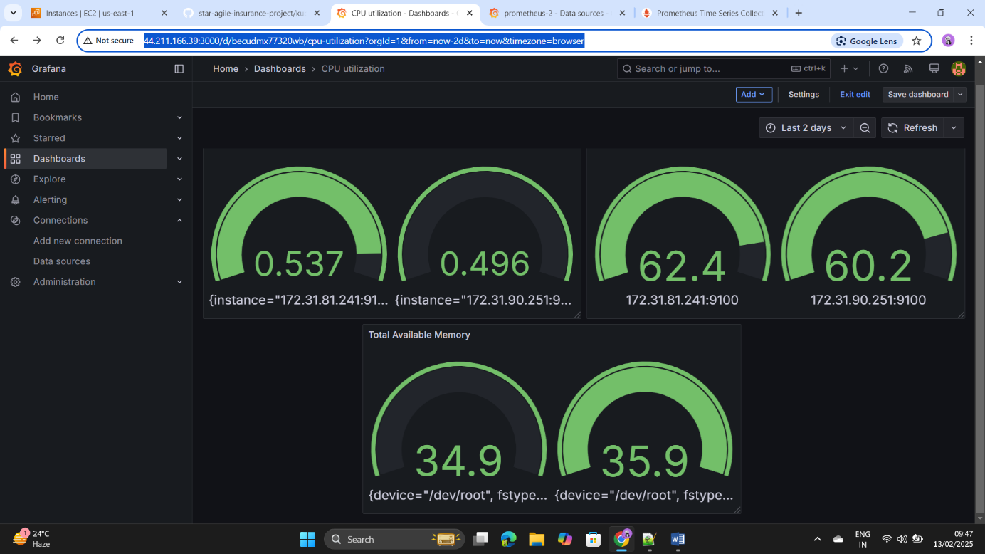

Step104:- Monitoring of the test of the production servers ,creating +++++++the dashboards has been done successfully.

Step105:- Insurence Me project has been done Successfully.

